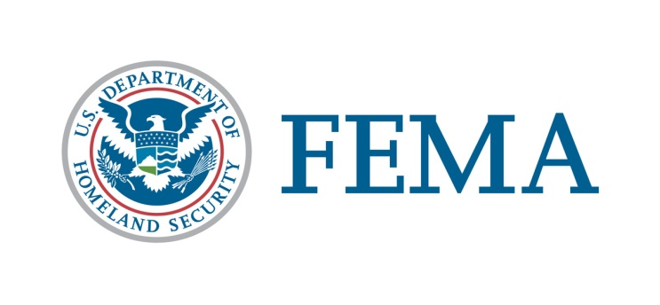

Duplication of Benefits
Hazard Mitigation Grant Program

What is duplication of benefits (DOB) in an acquisition project?
“Duplication of Benefits” means being paid more than once for the same thing. Federal laws prohibit a property owner from receiving funds from more than one source for the same item.
In the case of property acquisitions, property owners usually receive assistance from the federal government, a settlement from their insurance company, assistance from the State Other Needs Assistance (ONA) Grant Program, Small Business Administration (SBA) loans and assistance from other sources. These funds are provided to assist in making repairs to structural damages, as well as to help offset the loss of personal property.
If a property owner were to receive money through an acquisition project, those funds used to make repairs to structural damages, as mentioned above, would be considered a “duplication of benefits”.
Why would DOB be important to me?
When a community chooses to purchase flood-damaged homes at their pre-flood value, the federal government must ensure that funds paid for structural repairs were spent accordingly and are verified with receipts.

If funds for repair were received and that money was not spent for the intended purpose of making repairs, it must be deducted from the pre-flood purchase offer for the home.
Money received for loss of personal property, such as building contents, is not considered a duplication of benefits because these items are not a part of the structure.
What benefits would be considered in determining DOB deductions?
The following are considered federal benefits and could fall under DOB:
- Insurance (Private and National Flood Insurance)
- Disaster Housing Assistance
- SBA and other federal loans
- State Other Needs Assistance (ONA) Grants
- Volunteer agency assistance
- Cora Brown Fund
- All other forms of additional assistance for structural repairs.

Are non-federal payments considered under DOB?
Yes, funds received from any source and designated for structural repairs could be considered under duplication of benefits.

What if I have made repairs to the property?
If repairs have been completed, you have paid the repair costs in the full amount of the funds received, and you can produce receipts or other documentation, then no deductions would be made for DOB. Funds received for structural repairs, but not used for this purpose, would be deducted.
How would DOB affect the amount I would receive for my property?
The following are examples of how the final purchase offer is determined for the sale of your property.
(Duplication of Benefits will only be adjusted against the Structural Value of the agreed upon purchase price of the property.)
EXAMPLE
Land Value (Appraised*) | $15,000
Structural Value (Appraised*) | $90,000
Total Purchase Price | $105,000
Flood Insurance funds
received | <$30,000>
Emergency Repair funds
received (Disaster Housing) | <$2,000>
Receipts for Repairs | $0
Total of DOB | <$32,000>
Structural Value | $90,000
Less Total DOB | <$32,000>
Balance to property owner | $58,000
for structure
Payment for land value | $15,000
Total Payment at closing | $73,000

*As per FEMA’s Unified Hazard Mitigation Assistance Grant Program, Section A.11.2 Valuation Methodologies. PEMA requires and appraisal from a state certified residential/general appraiser.

Am I receiving less money for my house?
No, you are not. Based on the example, you have already received funds from the National Flood Insurance Program and Emergency Repair funds from the Federal Emergency Management Agency.
Therefore, the total received when the property is sold will be the balance remaining after these two amounts are subtracted.
In other words, you may receive only $73,000 at closing, but you have previously received $32,000, which has not been spent for repairs (if you can document that you have spent the money to make repairs, it is not deducted). You are actually receiving $105,000 for your flood-damaged house.
Summarized resources information taken from Sec. 312 of the Stafford Act (42 USC §5155) and 44 CFR §206.191

