E/L/G 0300 Intermediate Incident Command System for Expanding Incidents, ICS 300

Student Manual
April 2019
Version 1.0
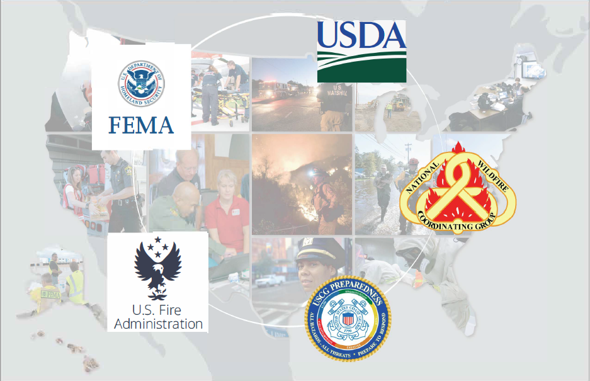

This page intentionally left blank.

Table of Contents
Unit 1: Course Introduction 5
Supplemental Materials 13
Unit 2: ICS Fundamentals Review 17
Supplemental Materials 37
Unit 3: Initial Actions for Unified Command 45
Supplemental Materials 67
Unit 4: Implementing an Operational Planning Process 73
Supplemental Materials 88
Unit 5: Planning Process, IAP, and Operations Briefs 93
Supplemental Materials 111
Unit 6: Incident Resource Management 123
Supplemental Materials 147
Unit 7: Demobilization, Transfer of Command, Closeout, and Transition to Recovery 167
Supplemental Materials 185
Unit 8: Course Summary 197

This page intentionally left blank.

Unit 1: Course Introduction
Student Manual

This page intentionally left blank.

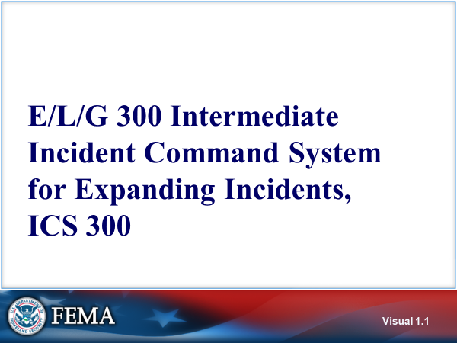 Visual 1. | E/l/g 300: INTERMEDIATE incident command system FOR EXPANDING INCIDENTS, ics 300
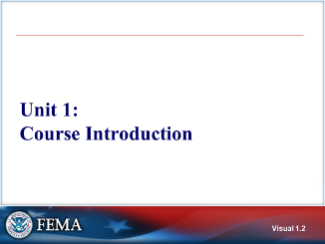  Visual 1. | UNIT 1: COURSE INTRODUCTION
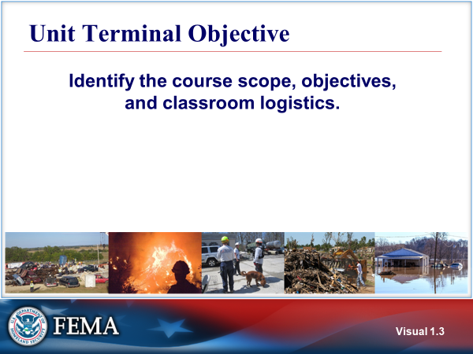  Visual 1. | UNIT TERMINAL OBJECTIVE  Identify the course scope, objectives, and classroom logistics.
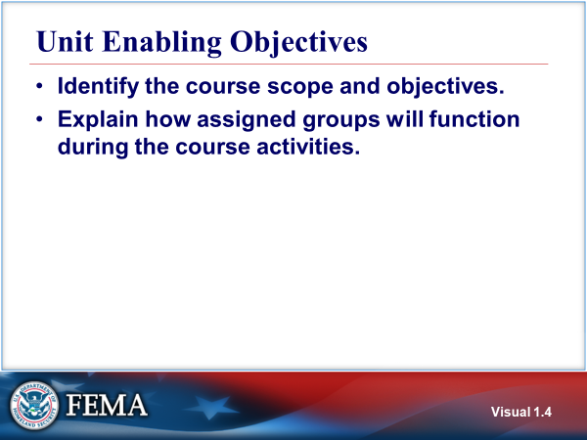  Visual 1. | UNIT ENABLING OBJECTIVES  - Identify the course scope and objectives.  - Explain how assigned groups will function during the course activities.  The pretest and final exam are based on the Unit Enabling Objectives from Units 2 – 7.
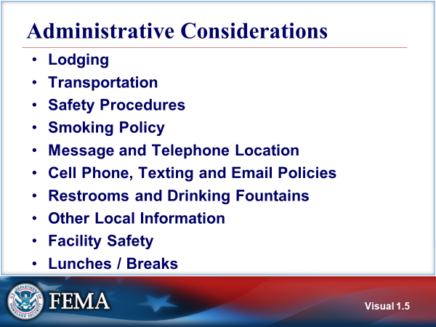  Visual 1. | administrative considerations
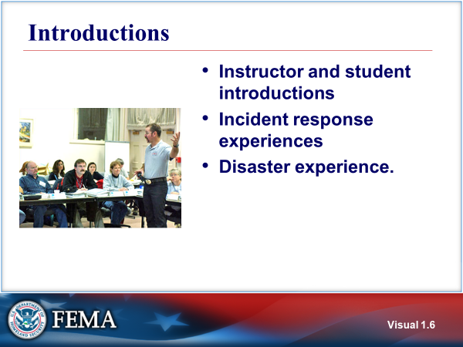  Visual 1. | INTRODUCTIONS  The instructor gives an overview of their personal experience and the agencies in which they have worked.  You will be asked to introduce yourself and provide an overview of your incident response experiences and ICS background.  After the introductions, the instructor will administer the Pretest.
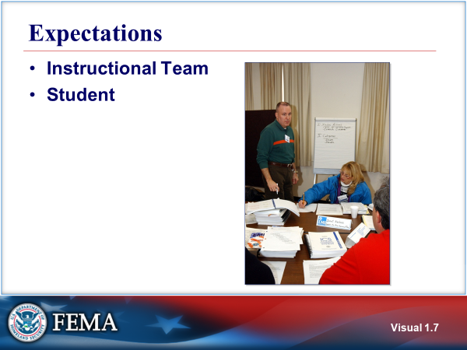  Visual 1. | EXPECTATIONS  Share your expectations for the course.
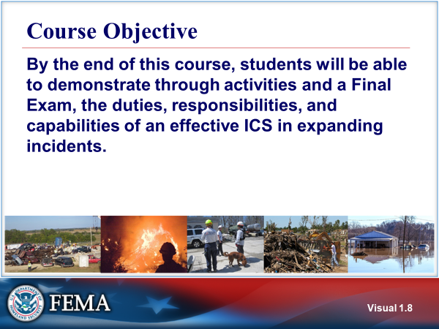  Visual 1. | COURSE OBJECTIVE  By the end of this course, students will be able to demonstrate through activities and a final exam, the duties, responsibilities, and capabilities of an effective ICS in expanding incidents.  The course will outline how the NIMS Command and Coordination component supports the management of expanding incidents as well as describe the incident management processes as prescribed by ICS.  This course has a threaded activity that will give students the opportunity to practice implementing the incident management process and create an Incident Action Plan (IAP) for a simulated expanding incident.
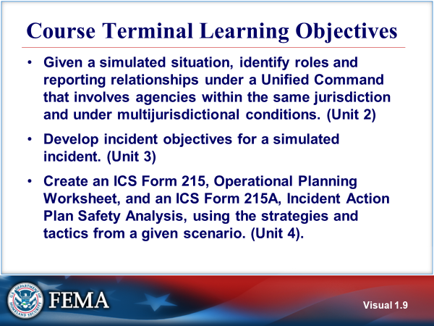  Visual 1. | Course Terminal Learning OBJECTIVES  - Given a simulated situation, identify roles and reporting relationships under a Unified Command that involves agencies within the same jurisdiction and under multijurisdictional conditions. (Unit 2)  - Develop incident objectives for a simulated incident. (Unit 3)  - Create an ICS Form 215, Operational Planning Worksheet, and an ICS Form 215A, Incident Action Plan Safety Analysis, using the strategies and tactics from a given scenario. (Unit 4)
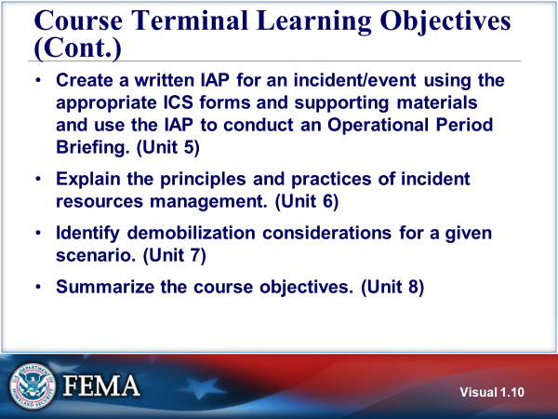  Visual 1. | Course Terminal Learning OBJECTIVES (CONT.)  - Create a written IAP for an incident/event using the appropriate ICS forms and supporting materials and use the IAP to conduct an operational period briefing. (Unit 5)  - Explain the principles and practices of incident resources management. (Unit 6)  - Identify demobilization considerations for a given scenario. (Unit 7)  - Summarize the course objectives. (Unit 8).
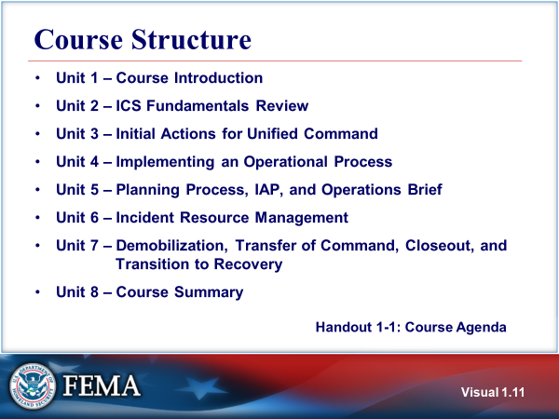  Visual 1. | COURSE STRUCTURE  - Unit 1 – Course Introduction  - Unit 2 – ICS Fundamentals Review  - Unit 3 – Initial Actions for Unified Command  - Unit 4 – Implementing an Operational Process  - Unit 5 – Planning Process, IAP, and Operations Brief  - Unit 6 – Incident Resource Management  - Unit 7 – Demobilization, Transfer of Command, Closeout, and Transition to Recovery  - Unit 8 – Course Summary  The Appendix includes additional course-related information, blank ICS forms, and a glossary.  The Applied Activity Materials section includes the materials, instructions, and debriefing suggestions needed for the applied activities.  Refer to Handout 1-1: Course Agenda.
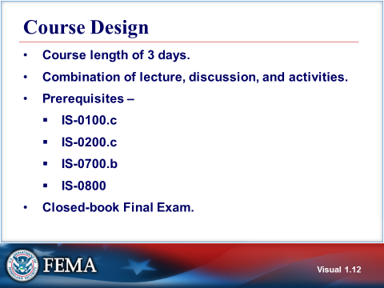  Visual 1. | COURSE DESIGN  The course is scheduled to be 3 days in length. Through a combination of lecture, discussion, and activites, students, upon course completion, will be provided the knowledge to meet the objectives of the course. Student interaction and participation will be integral to this process.  Prerequisites -  - IS-0100.c An Introduction to the Incident Command System, ICS 100  - IS-0200.c Basic Incident Command System for Initial Response, ICS 200  - IS-0700.b An Introduction to the National Incident Management System  - IS-0800 National Response Framework (NRF)  Recommended courses:  - E/L/G 0191 Emergency Operations Center/Incident Command System Interface  - E/L/G 0400 Advanced Incident Command System for Complex Incidents, ICS 400  Closed-Book Final Exam - To receive a certificate of completion for the course, students must obtain a 75% or higher on the final exam. The final exam will be closed-book, one hour will be allotted for its completion, and the final exam’s questions will be based on the Unit Enabling Objectives for Units 2 - 7. Unit 1 will not be tested in the pretest nor the final exam.
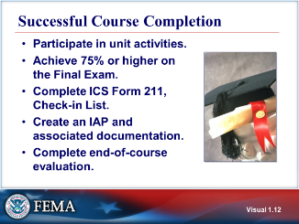  Visual 1. | SUCCESSFUL COURSE COMPLETION  - Participate in unit activities.  - Achieve 75% or higher on the final exam.  - Complete daily check-in.  - Create an IAP and associated documentation.  - Complete end-of-course evaluation.
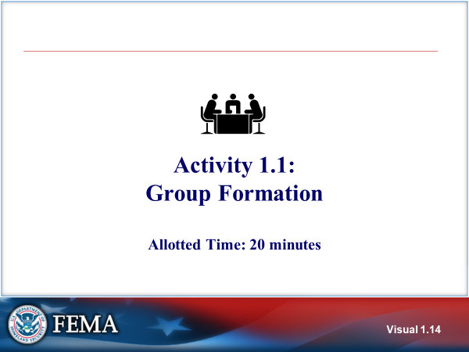  Visual 1. | ACTIVITy 1.1: Group FORMATION  The purpose of this activity is to assign students to groups and to provide the opportunity for the members to introduce themselves, decide how they will operate during activities throughout the course, and how they will complete daily check-in and their group’s ICS Form 214 Activity Log.  Total activity time is 20 minutes, which includes 10 minutes of group discussions and 10 minutes of presenting your group’s operating ground rules.
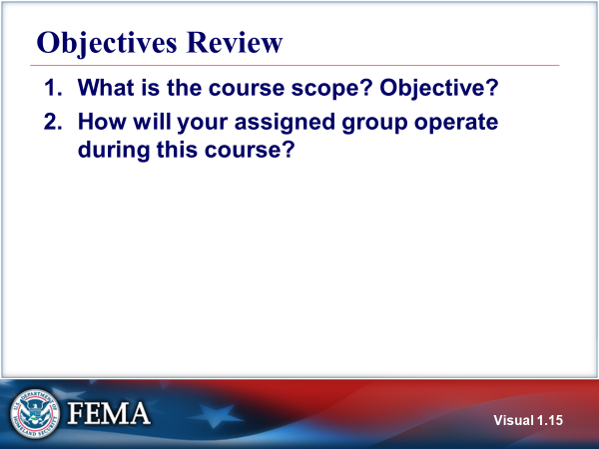  Visual 1. | OBJECTIVES REVIEW  Unit Enabling Objectives  - Identify the course scope and objectives.  - Explain how assigned groups will function during the course activities.

  - Supplemental Materials

This page intentionally left blank.

Handout 1-1: Course Agenda

DAY 1
- Unit 1: Course Introduction
- Unit 2: ICS Fundamentals Review
- Unit 3: Initial Actions for Unified Command

DAY 2

- Unit 4: Implementing an Operational Process
- Unit 5: Planning Process, IAP, and Operations Brief

DAY 3

- Unit 6: Incident Resource Management
- Unit 7: Demobilization, Transfer of Command, Closeout, and Transition to Recovery
- Unit 8: Course Summary

This page intentionally left blank.

Unit 2: ICS Fundamentals Review
Student Manual

This page intentionally left blank.

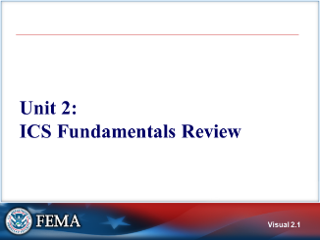 Visual 2.1 | UNIT 2: ICS FUNDAMENTALS REVIEW  Unit 2 is a review of basic ICS organizational and staffing concepts learned in prerequisite courses as well as an overview of the roles and responsibilities of a Unified Command.
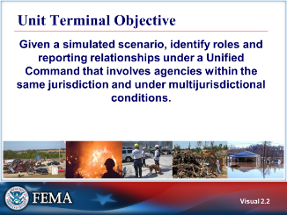  Visual 2.2 | UNIT TERMINAL OBJECTIVE  Given a simulated scenario, identify roles and reporting relationships under a Unified Command that involves agencies within the same jurisdiction and under multijurisdictional conditions.
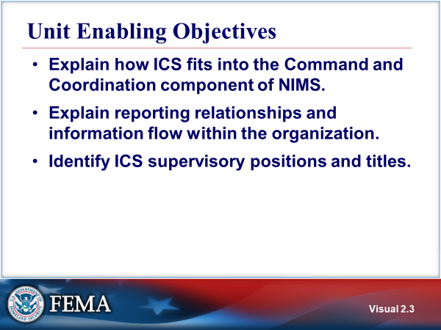  Visual 2.3 | UNIT ENABLING OBJECTIVES  - Explain how ICS fits into the Command and Coordination component of NIMS.  - Explain reporting relationships and information flow within the organization.  - Identify ICS supervisory positions and titles.
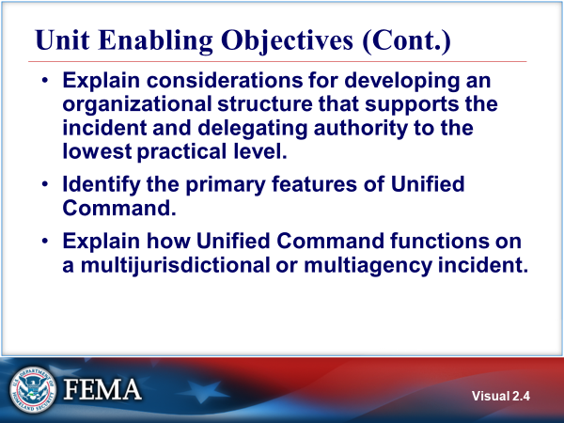  Visual 2.4 | UNIT ENABLING OBJECTIVES (CONT.)  - Explain considerations for developing an organizational structure that supports the incident and delegating authority to the lowest practical level.  - Identify the primary features of Unified Command.  - Explain how Unified Command functions on a multijurisdictional or multiagency incident.
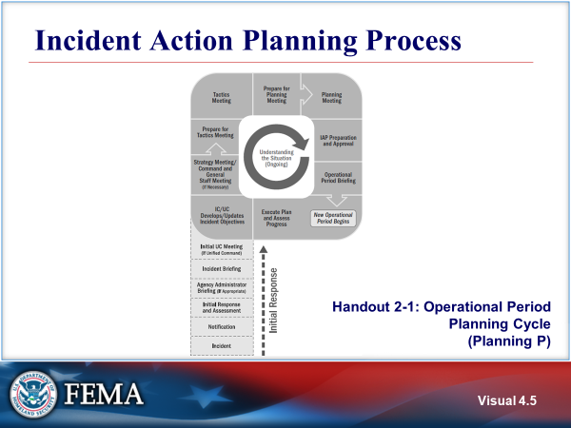 Visual 2.5 | incident action PLANNING process  Refer to Handout 2-1: Operational Period Planning Cycle (Planning P) and review. The Planning “P” is a guide to the process and steps involved in planning for an incident, from the onset of the incident (shown in the “leg” of the “P”) through preparations for the first Operational Period (shown in the “top” of the “P”).  In complex incidents, a formal planning process as illustrated in the visual is used. In less complex incidents or during the initial response, the planning steps are completed in a more flexible manner.  The planning cycle then continues for each successive Operational Period, as shown in the circular part of the “P”.  As illustrated on the visual, the Unified Command conducts an initial Unified Command meeting early in the incident response. Then the Unified Commanders jointly establish objectives for each Operational Period.  The Planning "P" is extremely valuable when preparing for a planned event.  The leg of the “P” describes the initial response period: Once the incident/event begins, the steps are Notifications, Initial Response & Assessment, Agency Adninistrator Briefing (if approprate), Incident Briefing using ICS Form 201, and Initial Incident Command (IC)/Unified Command (UC) Meeting.  At the top of the leg of the “P” is the beginning of the first operational planning period cycle. In this circular sequence, the steps are IC/UC Develop/Update Objectives Meeting, Strategy Meeting/Command and General Staff Meeting (if necessary), Preparing for the Tactics Meeting, Tactics Meeting, Preparing for the Planning Meeting, Planning Meeting, IAP Prep & Approval, and Operations Briefing.  At this point a new Operational Period begins. The next step is Execute Plan & Assess Progress, after which the cycle begins again.
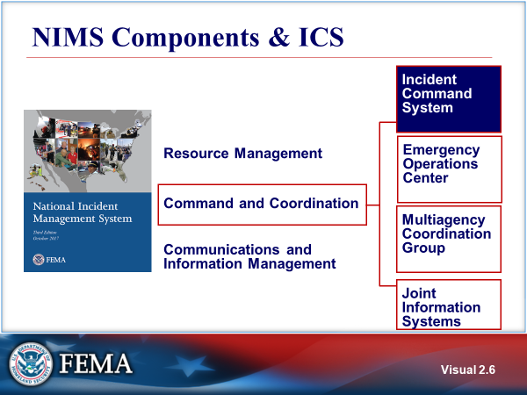  Visual 2.6 | NIMS COMPONENTS & ICS  ICS is only one facet of NIMS. NIMS integrates existing best practices into a consistent, nationwide approach to domestic incident management that is applicable at all jurisdictional levels and across functional disciplines in an all-hazards context.  These components represent a building-block approach to incident management. The application of the guidance for all three components is vital to successful NIMS implementation.  - Resource Management describes standard mechanisms to systematically manage resources,including personnel, equipment, supplies, teams, and facilities, both before and duringincidents in order to allow organizations to more effectively share resources when needed.  - Command and Coordination describes leadership roles, processes, and recommended organizational structures for incident management at the operational and incident support levels and explains how these structures interact to manage incidents effectively and efficiently.  - Communications and Information Management describes systems and methods that help to ensure that incident personnel and other decision makers have the means and information they need to make and communicate decisions.  Additional information: https://www.fema.gov/national-incident-management-system
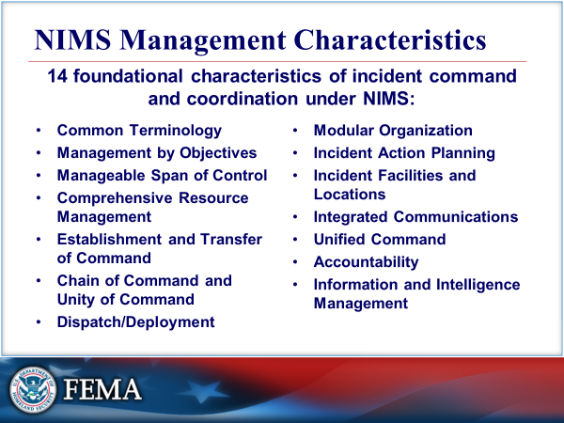  Visual 2.7 | NIMS management characteristics  The following characteristics are the foundation of incident command and coordination under NIMS and contribute to the strength and efficiency of the overall system:  - Common Terminology  - Management by Objectives  - Manageable Span of Control  - Comprehensive Resource Management  - Establishment and Transfer of Command  - Chain of Command and Unity of Command  - Dispatch/Deployment  - Modular Organization  - Incident Action Planning  - Incident Facilities and Locations  - Integrated Communications  - Unified Command  - Accountability  - Information and Intelligence Management
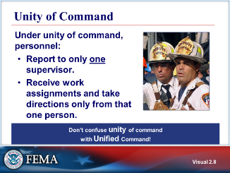  Visual 2.8 | UNITY OF COMMAND  Unity of command means that personnel:  - Report to only one supervisor.  - Receive work assignments and take directions only from that one person.  Do not to confuse unity of command with Unified Command. We discuss the differences in the next visual.
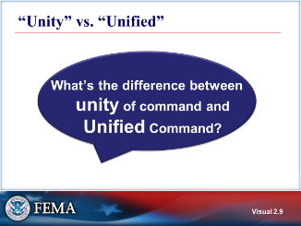  Visual 2.9 | “UNITY” VS. “UNIFIED”
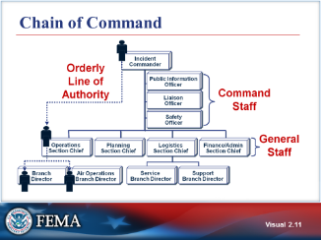  Visual 2.10 | CHAIN OF COMMAND  Chain of command is used to communicate direction and maintain management control. Chain of command, however, does not apply to the exchange of informal information. Although orders must flow through the chain of command, members of the organization may directly communicate with each other to ask for or share informal information.
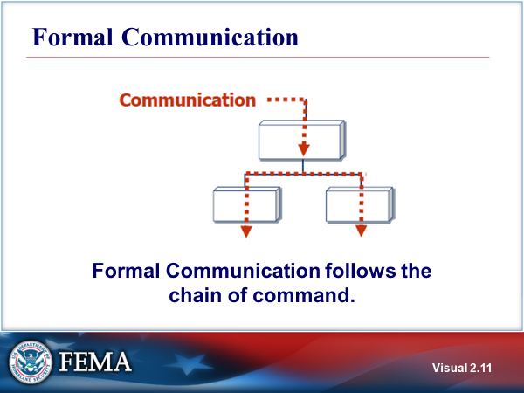  Visual 2.11 | FORMAL COMMUNICATION  Formal communication follows the chain of command and as the incident organization grows to meet the needs of the incident, care must be taken to ensure that information transfer is handled effectively.  Formal communication requires that orders, directives, resource requests, and status changes must follow the hierarchy of command unless otherwise directed.
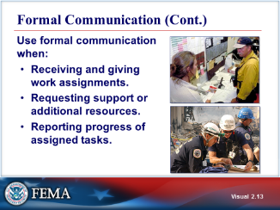  Visual 2.12 | FORMAL COMMUNICATION (CONT.)  Use formal communication when:  - Receiving and giving work assignments.  - Requesting support or additional resources.  - Reporting progress of assigned tasks.
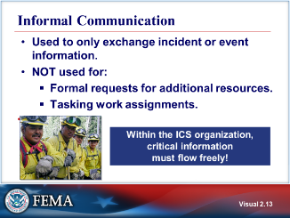  Visual 2.13 | INFORMAL COMMUNICATION  - Used when exchanging incident or event information.  - Not used for formal requests for additional resources or for tasking working assignments.  There is ongoing communication within the organization to exchange information among and between personnel. However, it is important to note that some information such as classified, sensitive or personally identifiable information, has limitations on how and with whom it can be shared.
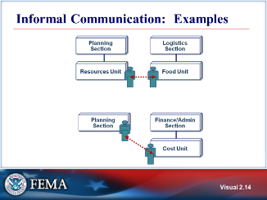  Visual 2.14 | INFORMAL COMMUNICATION: EXAMPLES  Examples of informal communication:  - Operations talking directly to Safety.  - Liaison talking to Operations.  - Logistics may directly contact Resources to determine the number of persons requiring feeding.  - Finance/Admin may directly discuss and share information on alternative strategies with Planning.
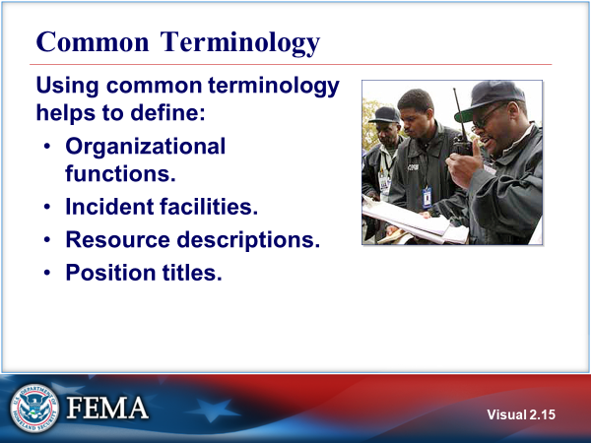  Visual 2.15 | COMMON TERMINOLOGY  Using common terminology helps to define:  - Organizational functions.  - Major functions and functional units with incident responsibilities are named and defined. Terminology for the organizational elements is standard and consistent  - Incident facilities.  - Incident Command Post – The field location at which the primary tactical-level, on-scene incident command functions are performed.  - Staging Area – The location where resources can be placed while awaiting a tactical assignment.  - Incident Base – The location where primary logistics functions are coordinated. There is only one incident base per incident. The Incident Command Post may be collocated with the incident base.  - Camp – A location where food, water, rest, and sanitary services are provided to incident personnel.  - Resource descriptions.  - Major resources—including personnel, equipment, teams, and facilities,—are given common names and are "typed" with respect to their capabilities, to help avoid confusion and to enhance interoperability.  - Position titles.  - At each level within the ICS organization, individuals with primary responsibility have distinct titles. Titles provide a common standard for all users, and also make it easier to fill ICS positions with qualified personnel. ICS titles often do not correspond to the titles used on a daily basis.  Using common terminology requires plain english (no jargon) and clear text (no code).
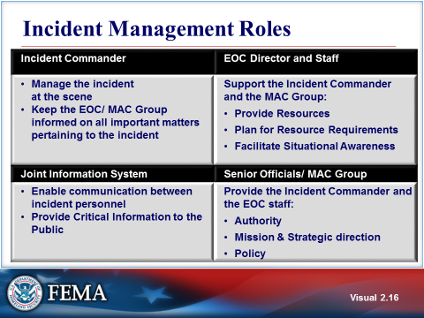  Visual 2. | INCIDENT MANAGEMENT ROLES  The Incident Commander (IC) is the primary person in charge at the incident. In addition to managing the incident scene, he or she is trained to keep the Agency Executives/Senior Officials informed and up to date on all important matters pertaining to the incident. The IC is delegated has overall authority and assigned responsibility for conducting incident operations.  The Agency Executives/Senior Officials have overall responsibility within the Jurisdiction. They delegate authority and assign responsibility to the Incident Commander. They often act as members of the Multiagency Coordination Group (may also be called a Policy Group) to set policy for an agency or jurisdiction, establish the mission to be accomplished, shape the overall strategic direction, and give the trained responders the authority to accomplish the incident objectives.
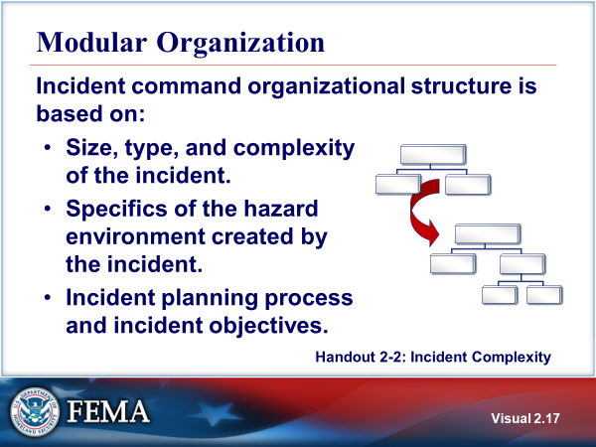  Visual 2. | MODULAR ORGANIZATION  This modular concept is based on the following considerations:  - The organization matches the function or task to be performed and the Resources that must be managed to perform these tasks and functions;  - Staffing is made only for those functional elements required to perform the task;  - Span of control guidelines are maintained;  - The function of any non-activated organizational element is performed at the next highest level; and  - Organizational elements are deactivated if they are no longer required.  Refer to Handout 2-2: Incident Complexity.  Span of control is an ICS concept that describes the ratio of individuals supervised to the number of supervisors. Span of control is accomplished by organizing resources into Teams, Divisions, Groups, Branches, or Sections.  Effective incident management frequently necessitates ratios significantly different from the guideline 1:5 ratio of supervisors to subordinates. The type of incident, nature of the task, hazards and safety factors, experience of the supervisor and subordinates, and communication access between the subordinates and the supervisor are all factors that influence manageable span of control. Incident personnel should use their best judgment to determine the actual distribution of subordinates to supervisors for a given incident or operations.
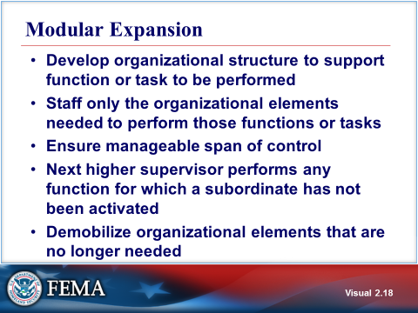  Visual 2. | modular EXPANSION  The complexity of the incident and the type and number of resources managed will drive organizational structure requirements.
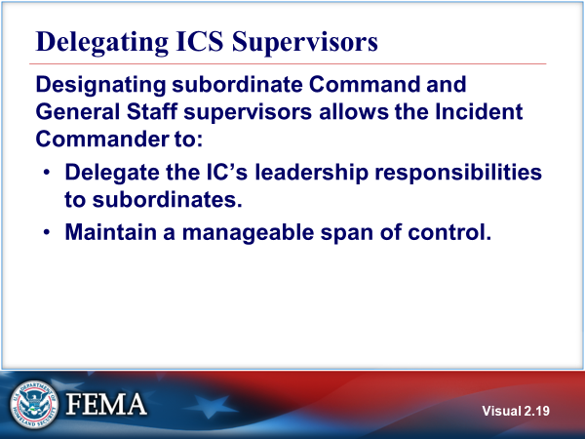  Visual 2. | DELEGATIng ics supervisors  Responsibility for every function defaults to the next higher supervisory position until that supervisor delegates those responsibilities.  A basic ICS operating guideline is that the person at the top of the organization is responsible for a task until that responsibility is delegated to a subordinate position. For this reason, it is important for the IC to designate subordinate leaders and delegate portions of his or her responsibilities to these supervisors.
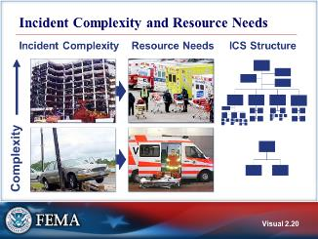  Visual 2. | INCIDENT COMPLEXITY AND RESOURCE NEEDS  As complexity increases, resources must increase, requiring an organization with additional levels of supervision. In addition, resources should match the incident complexity (type).  The visual shows how the Incident Command System can expand according to the needs of the incident (modular organization).
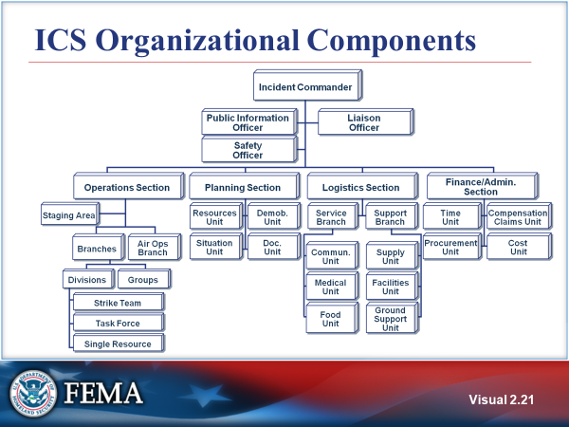  Visual 2. | ICS ORGANIZATIONAL COMPONENTS  - Typically structured to facilitate activities in five major functional areas: command, operations, planning, logistics, and finance and administration.  - Adaptable to any emergency or incident to which domestic incident management agencies would be expected to respond.  - Scalable organizational structure that is based on the size and complexity of the incident. However, this flexibility does NOT allow for the modification of the standard, common language used to refer to organizational components or positions.  Refer to Handout 2-4: ICS Organizational Structure and Elements.
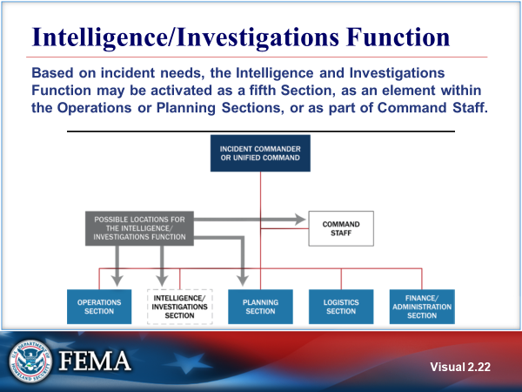  Visual 2. | INTELLIGENCE/INVESTIGATIONS FUNCTION  Intelligence/Investigations (I/I) is a sixth function of ICS that is only established when needed.  The purpose of the I/I function within ICS is to determine the source or cause of the incident, to control its impact and/ or help prevent the occurrence of similar incidents.  ICS allows for organizational flexibility; therefore, the Intelligence/Investigations Function can be embedded in several different places within the organizational structure:  - Within the Planning Section.  - As a Separate General Staff Section.  - Within the Operations Section. This  - Within the Command Staff.  Regardless of how the Intelligence/Investigations Function is organized, a close liaison will be maintained and information will be transmitted to Command, Operations, and Planning.  Additional information on the I/I function can be found in the NIMS Intelligence and Investigations Function Guidance and Field Operations guide www.fema.gov/nims-doctrine-supporting-guides-tools.
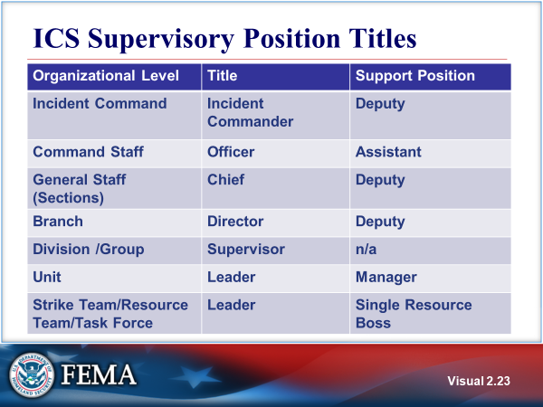  Visual 2. | ICS SUPERVISORY POSITION TITLES
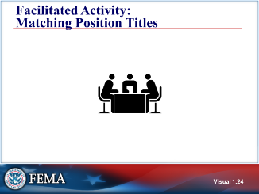  Visual 2. | facilitiated activity: matching position titles  The instructor will explain the facilitated activity.
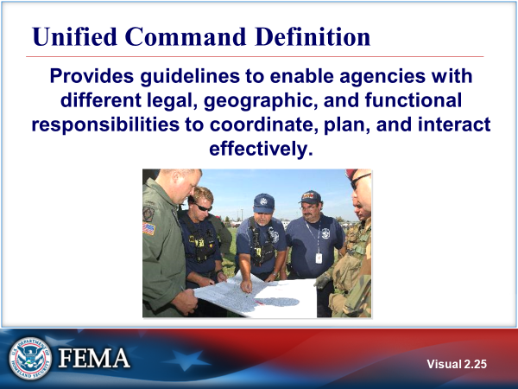  Visual 2. | UNIFIED COMMAND DEFINITION  When no one jurisdiction, agency or organization has primary authority and/or the resources to manage an incident on its own, Unified Command may be established. In Unified Command, there is no one “commander.” Instead, the Unified Command manages the incident by jointly approved objectives. A Unified Command allows these participating organizations to set aside issues such as overlapping and competing authorities, jurisdictional boundaries, and resource ownership to focus on setting clear priorities and objectives for the incident (one IAP). The resulting unity  of effort allows the Unified Command to allocate resources regardless of ownership or location.  Unified Command does not affect individual agency authority, responsibility, or accountability.
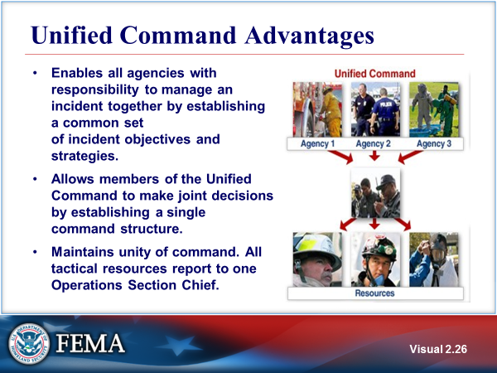  Visual 2. | UNIFIED COMMAND advantages  - Enables all agencies with responsibility to manage an incident together by establishing a common set of incident objectives and strategies.  - Allows the members of the Unified Command to make joint decisions by establishing a single command structure.  - Maintains unity of command. All tactical resources report to one Operations Section Chief.
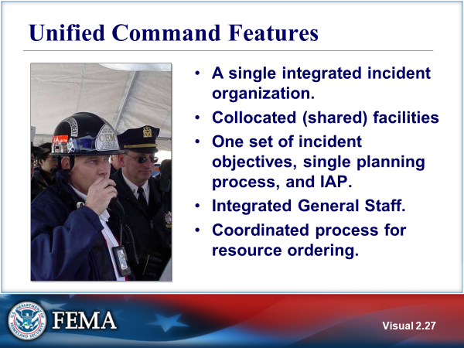  Visual 2. | UNIFIED COMMAND FEATURES  Five features of a Unified Command:  - A single integrated incident organization.  - Collocated (shared) facilities.  - One set of incident objectives, single planning process, and Incident Action Plan (IAP).  - Shared Operations, Planning, Logistics, and Finance/Administration Sections.  - A coordinated process for resource ordering.
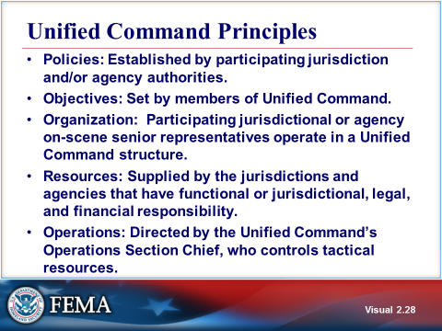  Visual 2. | UNIFIED COMMAND principles  Resources (personnel and equipment) stay under the administrative and policy control of their agencies. Operationally, personnel respond to tactical assignments under the coordination and direction of the Operations Section Chief.  An example of administrative and policy control may be agreements with a union that could affect overtime, compensable breaks, time in pay status, etc.
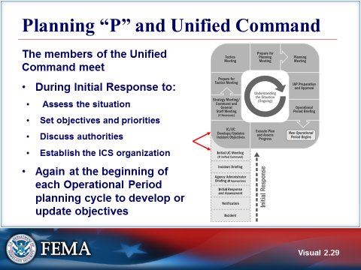  Visual 2. | PLANNING “P” AND UNIFIED COMMAND  As illustrated on the visual, the Unified Command conducts an initial Unified Command meeting early in the incident response. Then the Unified Command jointly establishes objectives for each Operational Period.
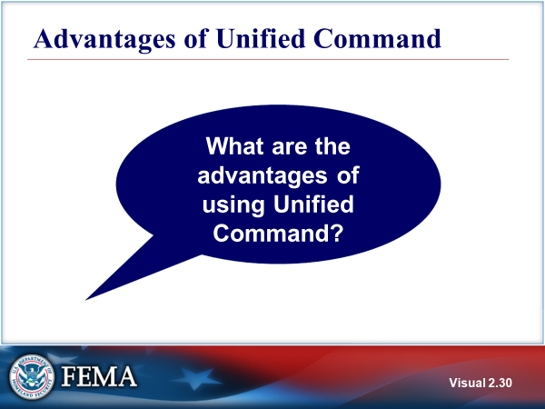  Visual 2. | ADVANTAGES OF UNIFIED COMMAND  Discuss the advantages of using Unified Command.
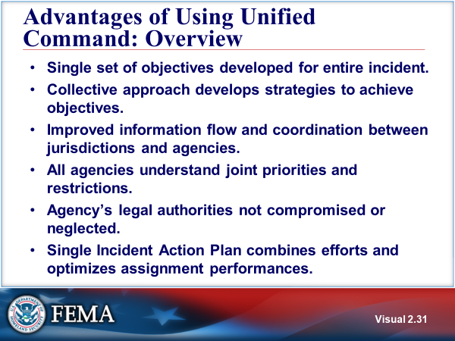  Visual 2. | ADVANTAGES OF Using UNIFIED COMMAND: OVERVIEW  - Single set of objectives developed for entire incident.  - Collective approach develops strategies to achieve objectives.  - Improved information flow and coordination between jurisdictions and agencies.  - All agencies understand joint priorities and restrictions.  - Agency’s legal authorities not compromised or neglected.  Single incident action plan combines efforts and optimizes assignment performances.
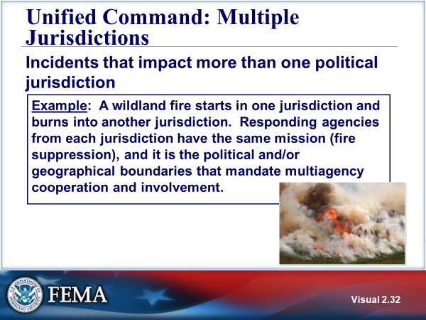  Visual 2. | UNIFIED COMMAND: MULTIPLE JURISDICTION  Unified Command may be used when incidents impact more than one political jurisdiction.  An example is a wildland fire starting in one jurisdiction and burning into another jurisdiction. Responding agencies from each jurisdiction have the same mission (fire suppression), and it is the political and/or geographical boundaries that mandate multiagency cooperation and involvement.
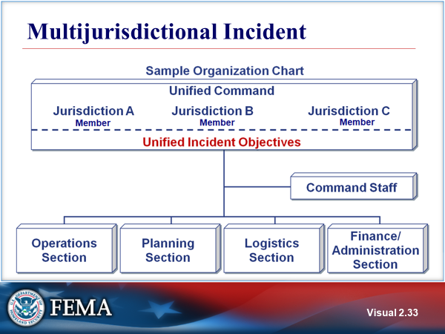  Visual 2. | MULTIJURISDICTIONAL INCIDENT  This visual presents an example of a Unified Command organization chart for a multijurisdictional incident. The chart includes the following elements:  - Unified Command: The Unified Command is composed of the representatives from the three jurisdictions. The Unified Command establishes a single set of unified objectives.  - Integrated Command and General Staff: The organization has an integrated Command Staff and Operations, Planning, Logistics, and Finance/Administration Sections.
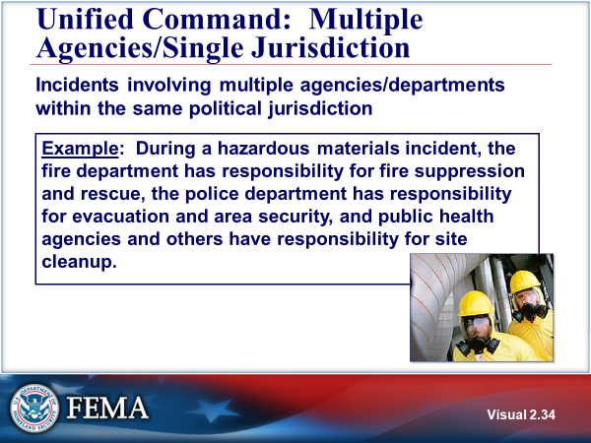  Visual 2. | UNIFIED COMMAND: MULTIPLE AGENCIES/SINGLE JURISDICTION  Unified Command may also be used when incidents involve multiple agencies or departments within the same political jurisdiction.  An example is a hazardous materials incident in which the fire department has responsibility for fire suppression and rescue, the police department has responsibility for evacuation and area security, and the public health agencies and others have responsibility for site cleanup.
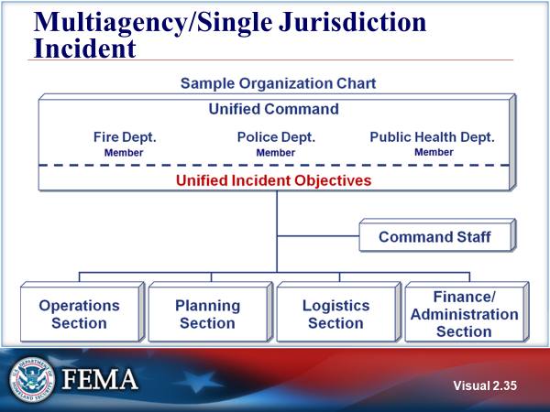  Visual 2. | MULTIAGENCY/SINGLE JURISDICTION INCIDENT  This visual presents an example of a Unified Command organization chart for a Multiagency/Single Jurisdiction incident. The chart includes the following elements:  - Unified Command: The Unified Command is composed of the representatives from the three departments of the single jurisdiction (fire department, police department, and public health agency). The Unified Command establishes a single set of unified objectives.  - Integrated Command and General Staff: The organization has an integrated Command Staff and Operations, Planning, Logistics, and Finance/Administration Sections.
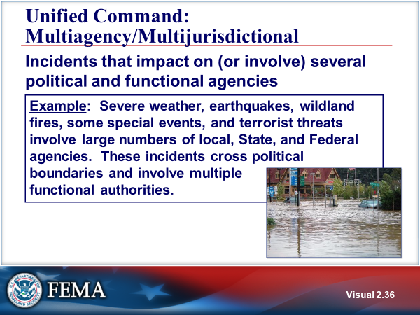  Visual 2. | UNIFIED COMMAND: MULTIAGENCY / MULTIJURISDICTION  A third instance in which Unified Command may be used involves incidents that impact on or involve several political and functional agencies.  Examples are severe weather, earthquakes, wildland fires, some special events, and terrorist threats that involve large numbers of local, State, and Federal agencies.  These incidents cross political boundaries and involve multiple functional authorities.
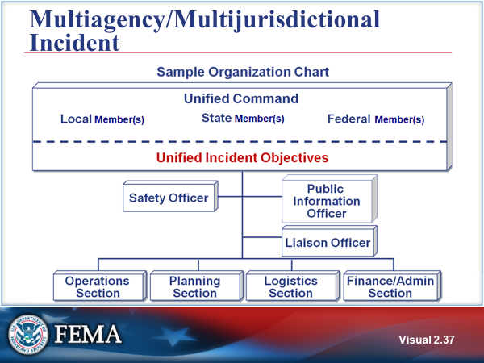  Visual 2. | MULTIAGENCY/MULTIJURISDICTIONal INCIDENT  This visual presents an example of a Unified Command organization chart for a multiagency/multijurisdiction incident. The chart includes the following elements:  - Unified Command: Representatives from local, State, and Federal agencies comprise the Unified Command and share responsibility for incident management.  - Integrated Command and General Staff: The organization has an integrated Command Staff (including Safety, Public Information, and Liaison functions) and Operations, Planning, Logistics, and Finance/Administration Sections.
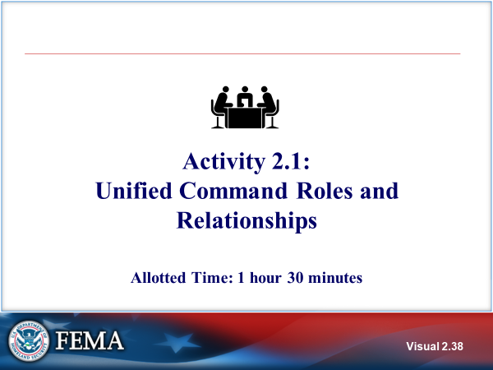  Visual 2. | ACTIVITY 2.1: Unified Command Roles and Relationships  The instructor will explain Applied Activity 2.1.  You will have 45 minutes to complete the activity and 45 minutes for an instructor-facilitated debrief (1 hour 30 minutes in total).  Refer to Unit 2 of the Applied Activity Materials document.
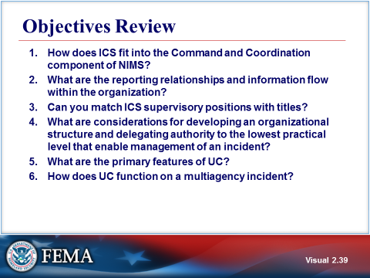  Visual 2. | OBJECTIVES REVIEW  Unit Enabling Objectives  - Explain how ICS fits into the Command and Coordination component of NIMS.  - Explain reporting relationships and information flow within the organization.  - Identify ICS supervisory positions and titles.  - Explain considerations for developing an organizational structure that supports the incident and delegating authority to the lowest practical level.  - Identify the primary features of Unified Command.  - Explain how Unified Command functions on a multijurisdictional or multiagency incident.

  - Supplemental Materials

This page intentionally left blank.

Handout 2-1: Operational Period Planning Cycle (Planning P)

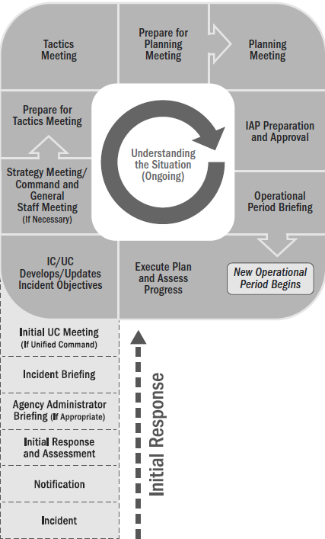

This page intentionally left blank.

Handout 2-2 - Incident Complexity

“Incident complexity” is the combination of involved factors that affect the probability of control of an incident. Many factors determine the complexity of an incident, including, but not limited to, area involved, threat to life and property, political sensitivity, organizational complexity, jurisdictional boundaries, values at risk, weather, strategy and tactics, and agency policy.

Incident complexity is considered when making incident management level, staffing, and safety decisions.

Various analysis tools have been developed to assist consideration of important factors involved in incident complexity. Listed below are the factors that may be considered in analyzing incident complexity:
- Community and responder safety
- Impacts to life, property, environment, and the economy
- Potential hazardous materials
- Weather and other environmental influences
- Likelihood of cascading events
- Potential crime scene (including terrorism)
- Political sensitivity, external influences, and media relations
- Area involved, jurisdictional boundaries
- Availability of resources
- Potential to extend into multiple Operational Periods

This page intentionally left blank.

Facilitated Activity: Matching Position Titles

Instructions: Using the list of terms below, fill in the blanks within the table to align organizational levels with titles and support positions.

Hint: Each term is used once.

Public Information Officer | Deputy
General Staff Section | Incident Command
Command Staff | Chief
Agency Representatives | Unit Leader
Supervisor | Strike (Resource) Team/Task Force

Organizational Element | Leadership Position Title | Support Positions
 | Planning Section Chief | Deputy, Assistant
Branch | Director
Division/Group |  | n/a
 | Safety Officer | Assistant
Command Staff | Liaison Officer
General Staff Section |  | Deputy, Assistant
Unit |  | Manager, Coordinator
 | Leader | Single Resource Boss
 | Incident Commander | Deputy
Command Staff |  | Assistant

This page intentionally left blank.

Unit 3: Initial Actions for Unified Command
Student Manual

This page intentionally left blank.

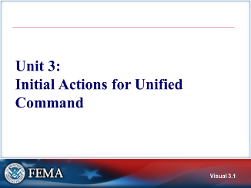 Visual 3.1 | UNIT 3: INITIAL ACTIONS FOR UNIFIED COMMAND  Unit 3 covers the steps in the Planning “P” that focus on the Incident Commander/Unified Command developing and updating incident objectives as well as establishing strategies at the Command and General Staff meeting.
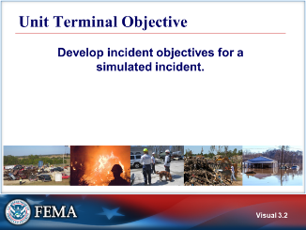  Visual 3.2 | UNIT TERMINAL OBJECTIVE  Develop incident objectives for a simulated incident.
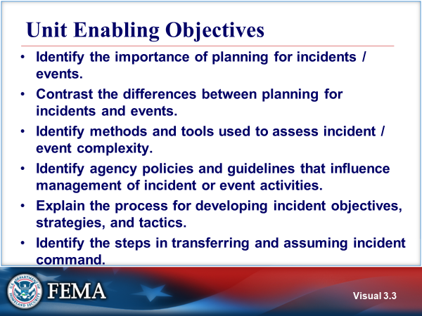  Visual 3.3 | UNIT ENABLING OBJECTIVES  - Identify the importance of planning for incidents/events.  - Contrast the differences between planning for incidents and events.  - Identify methods and tools used to assess incident/event complexity.  - Identify agency policies and guidelines that influence management of incident or event activities.  - Explain the process for developing incident objectives, strategies, and tactics.  - Identify the steps in transferring and assuming incident command.  The Final Exam is based on the Unit Enabling Objectives
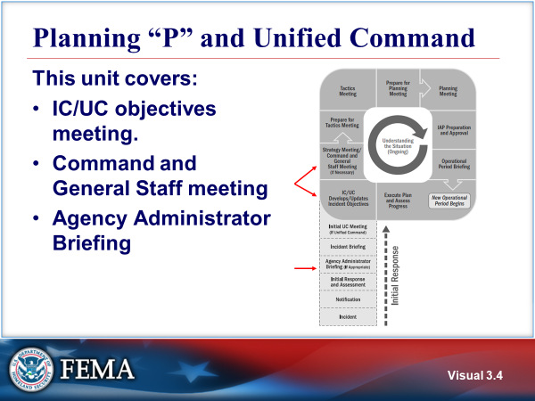  Visual 3.4 | PLANNING “P” AND UNIFIED COMMAND  This unit covers the steps in the Operational Period Planning Cycle (Planning “P”) that focus on the Incident Commander/Unified Command developing and updating incident objectives, establishing strategies at the Command and General Staff meeting, as well as conducting the Agency Administrator Briefing.
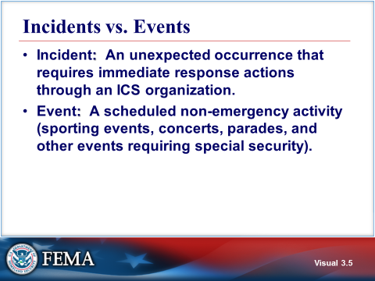  Visual 3.5 | INCIDENTS VS. EVENTS  Incident: An occurrence, natural or human-caused, that requires an ICS response to protect life or property. Incidents can, for example, include major disasters, emergencies, terrorist attacks, terrorist threats, civil unrest, wildland and urban fires, floods, hazardous materials spills, nuclear accidents, aircraft accidents, earthquakes, hurricanes, tornadoes, tropical storms, tsunamis, war-related disasters, public health and medical emergencies, and other occurrences requiring an emergency response.  Event: A scheduled, normally preplanned activity (e.g., sporting events, concerts, parades, and other events requiring special security).
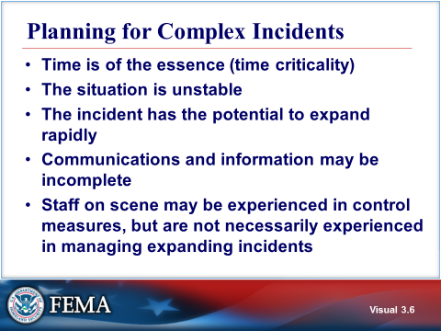  Visual 3.6 | PLANNING FOR complex INCIDENTS  This kind of situation requires immediate organizing actions that must be taken to ensure effective incident management and control. The number of considerations will increase as the situation deteriorates and the incident grows.  The first responding units to the incident must take the initial steps to provide organization for the incident. These initial decisions are important and will impact the long term management of the incident.
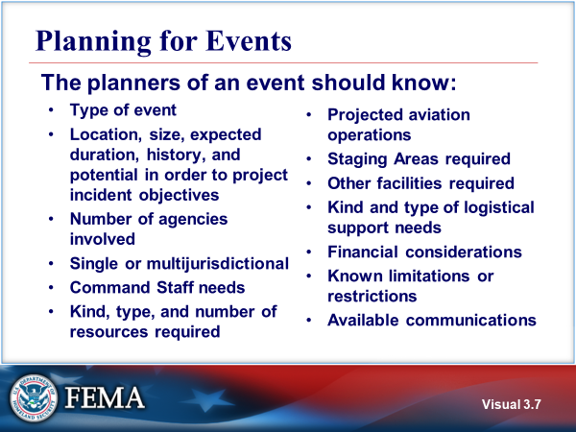  Visual 3.7 | PLANNING FOR EVENTS  Event planners should know the following:  - Type of event  - Location, size, expected duration, history, and potential in order to project incident objectives  - Number of agencies involved  - Single or multijurisdictional  - Command Staff needs (public information, safety, and liaison)  - Kind, type, and number of resources required  - Projected aviation operations  - Staging Areas required  - Other facilities required  - Kind and type of logistical support needs (e.g., communications, food, medical)  - Financial considerations  - Known limitations or restrictions  - Available communications  Use the ICS incident action planning process to plan for scheduled events as well as emergencies/incidents. In doing so, it reinforces ICS concepts and makes implementation during emergencies much easier.
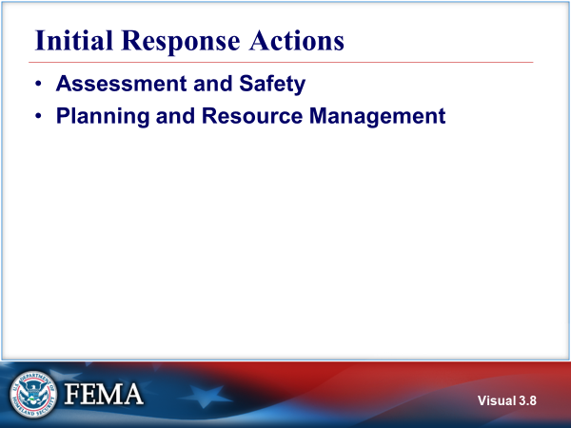  Visual 3.8 | INITIAL RESPONSE ACTIONS  For a Unified Command in a complex incident, these are actions that will normally preceed the establishment of the unified command and the agency Administrator briefing.  - Assessment and Safety  - Sizeup the situation.  - Determine if life is at immediate risk.  - Ensure that personnel safety factors are taken into account.  - Determine if there are any environmental issues that need to be addressed.  - Planning and Resource Management  - Assume command and establish the Incident Command Post.  - Establish immediate incident objectives, strategies, and tactics..  - Determine if there are enough resources of the right kind and type on scene or ordered. The incident objectives will drive resource requirements.  - Establish the initial organization that maintains span of control.  Requesting an Incident Management Team (IMT) may be necessary depending on the size or complexity of the incident, or existing policies and laws.
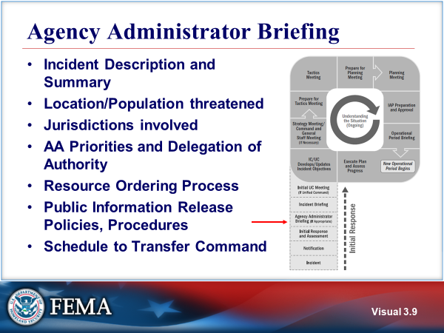  Visual 3.9 | AGENCY ADMINISTRATOR (AA) BRIEFING  The Agency Administrator’s (AA) Briefing is used to convey critical information that the incoming Incident Commander (IC) needs to safely and efficiently assume command of the incident and achieve the management goals and objectives of the Agency Administrator(s).  This meeting is only necessary when the IC assumes incident management duties outside their normal position description or are from a jurisdiction that does not possess authority to manage the incident they are being  assigned.  In those cases the incoming IC must be delegated that authority from an official responsible for administering policy for the agency, jurisdiction.  During the briefing, the agency administrator or a designee provides information, guidance, and direction—including priorities and constraints—necessary for the successful management of the incident. The briefing is intended to ensure a common understanding between the jurisdiction, agency, or organization and the incident personnel regarding such things as the environmental, social, political, economic, and cultural issues relevant to the incident and its location.
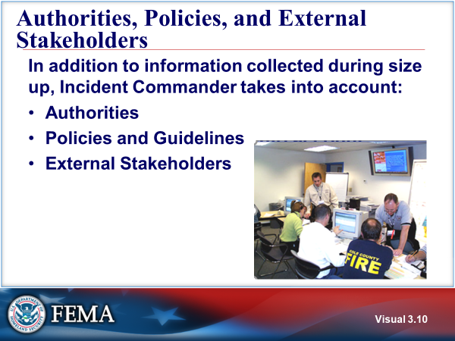  Visual 3.10 | AUTHORITIES, POLICIES, AND EXTERNAL STAKEHOLDERS  The Incident Commander must also be aware of authorities, policies, and external stakeholders as part of the incident size up.  Agency policy can affect the incident objectives. All agencies develop policies and guidelines for accomplishing their responsibilities. The Incident Commander must be fully aware of agency policy including any limits of authority.  On the majority of incidents, agency policy is known by the Incident Commander because the incident occurs in his/her jurisdiction. These guidelines and policies may be for routine activities or for emergency activities, or both. These policies and guidelines may come to bear in the management of an incident or a planned event based upon the jurisdiction of an agency. For larger incidents, some agencies will require agency policies in writing.  These policies, guidelines, and authorities may give direction on the following:  - Safety  - Control objectives  - Cleanup and rehabilitation guidelines  - Spending  - Resource sharing  External stakeholders are those parties not directly affected by the incident who, nonetheless, could be affected by decisions that are made in conjunction with the incident. External stakeholders can usually be identified when the question is asked, “Who else could be affected by this decision?”
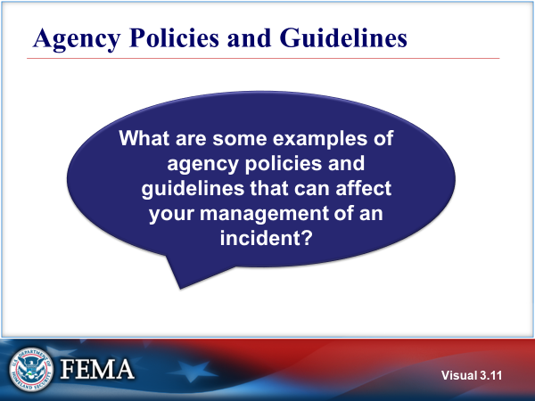  Visual 3.11 | AGENCY POLICIES AND GUIDELINES
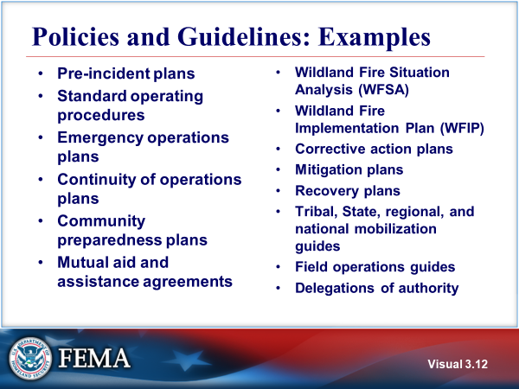  Visual 3.12 | POLICIES AND GUIDELINES: EXAMPLES  The following are examples of agency policies and guidelines that can affect management of an incident:  - Pre-incident plans  - Standard operating procedures  - Emergency operations plans  - Continuity of operations plans  - Community preparedness plans  - Mutual aid and assistance agreements  - Wildland Fire Situation Analysis (WFSA)  - Wildland Fire Implementation Plan (WFIP)  - Corrective action plans  - Mitigation plans  - Recovery plans  - Tribal, State, regional, and national mobilization guides  - Field operations guides  - Delegations of authority
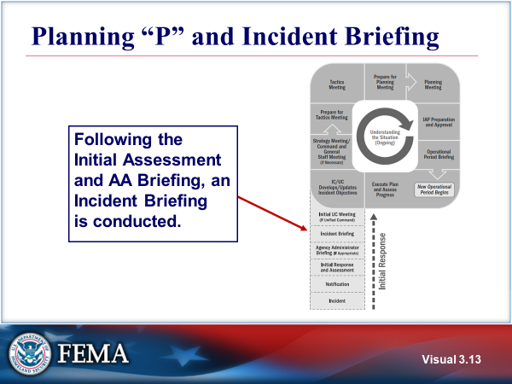  Visual 3.13 | PLANNING “P” AND INCIDENT BRIEFING  the Planning “P” illustrates the incident planning cycle. Following the initial response and assessment, and the agency administrator briefing, an incident briefing is conducted using ICS Form 201, the Incident Briefing form.
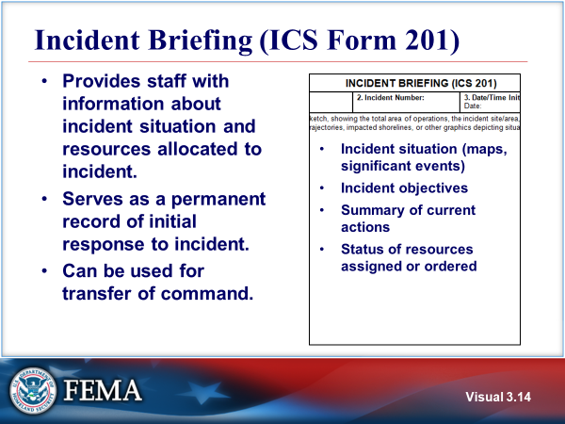  Visual 3.14 | INCIDENT BRIEFING (ICS FORM 201)  The ICS Form 201 Incident Briefing form:  - Provides staff with information about the incident situation (to include complexity) and the resources allocated to the incident. This should include objectives, tactics, organization, facilities, communications and notifications completed.  - Serves as a permanent record of the initial response to the incident.  - Can be used for transfer of command.  As the visual shows, the ICS Form 201 is used to communicate the incident situation (maps), objectives, current actions, and resource status.  Refer to Handout 3-1: ICS Form 201.
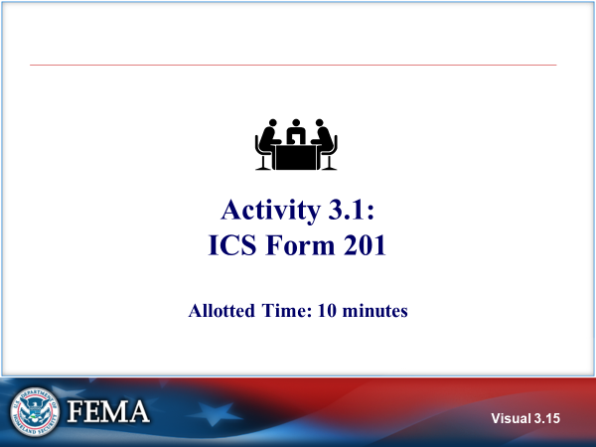  Visual 3.15 | ACTIVITY 3.1: ICS form 201  The instructor will explain Activity 3.1.  You will have 10 minutes to complete Activity 3.1.
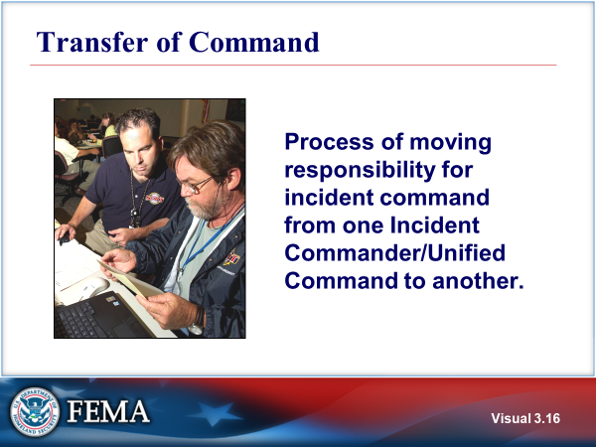  Visual 3.16 | TRANSFER OF COMMAND  Transfer of command is the process of moving the responsibility for incident command from one Incident Commander/Unified Command to another. It can be incident command to unified command or unified command to unified command.
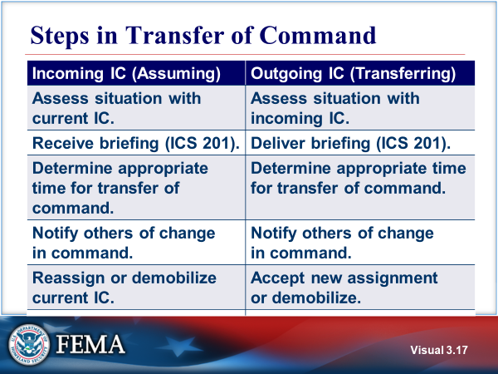  Visual 3.17 | STEPS IN TRANSFER OF COMMAND  Incoming Incident Commander (Assuming)  - Assess situation with current IC.  - Receive briefing, using the ICS Form 201.  - Determine appropriate time for transfer of command.  - Notify others of change in command.  - Reassign or demobilize current IC.  Outgoing Incident Commander (Transferring)  - Assess situation with incoming IC.  - Deliver briefing from the ICS Form 201.  - Determine appropriate time for transfer of command.  - Notify others of change in command.  - Accept new assignment or demobilize.
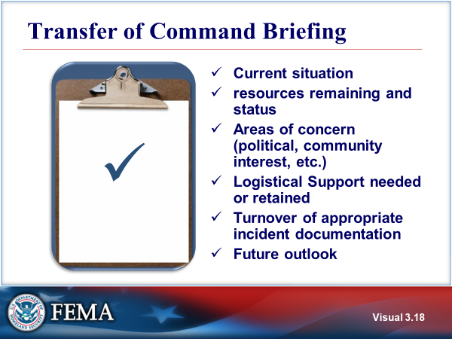  Visual 3.18 | TRANSFER OF COMMAND BRIEFING  The briefing of the receiving Incident Commander will contain the following information that will be recorded on the ICS Form 201:  - Current situation to include objectives, tactics and organization.  - Resources available and status to include facilities, communications, and notifications completed.  - Particular areas of concern (political, community interest, etc.). Include a discussion of complexities associated with the incident.  - Logistical Support needed or retained.  - Turnover of appropriate incident documentation  - Future outlook
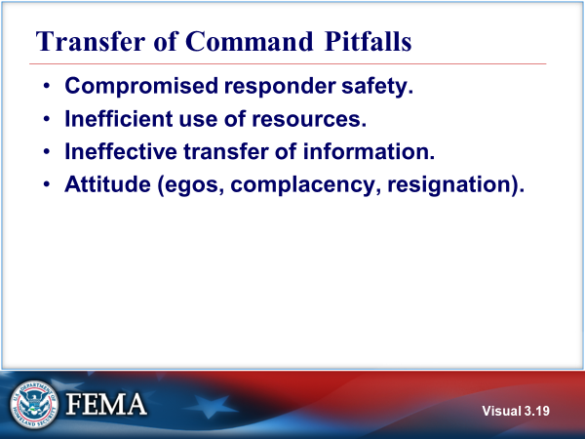  Visual 3.19 | TRANSFER OF COMMAND PITFALLS  Pitfalls often associated with transfer of command:  - Compromised responder safety.  - Inefficient use of resources.  - Ineffective Transfer of Information – key information needed to manage the incident is not transferred to the incoming command.  - Attitudes:  - Egos – positional or personality conflicts that interfere with transfer of command.  - Complacency – lack of proactive approach to get ahead of the expanding incident.  - Resignation – giving up.
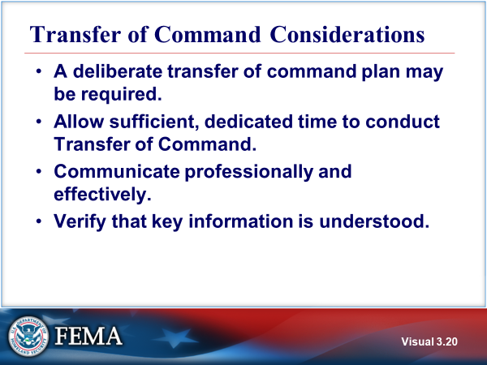  Visual 3.20 | TRANSFER OF COMMAND CONSIDERATIONS  To mitigate the potential pitfalls, consider these suggestions:  - A written plan outlining the tasks associated with the command transfer can be an effective method to ensure key information is transferred.  - Allow sufficient dedicated time for the transfer of command. This may require stepping away from hands on management of the incident in order to effectively complete the transfer of command.  - Engage in active listening skills and positve communications.  - It is critical to verify that key information is transferred to the incoming Unified Command.
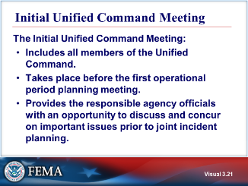  Visual 3.21 | INITIAL UNIFIED COMMAND MEETING  An important aspect of planning under Unified Command is the need for all jurisdictional or functional agency members of the Unified Command to participate in a command meeting early in the incident response.  The command meeting provides the responsible agency officials with an opportunity to discuss and concur on important issues prior to joint incident planning. Requirements for the Initial Unified Command meeting include:  - Prior to the meeting, the members of the Unified Command should have reviewed the purposes and agenda items and be prepared to discuss them.  - The command meeting should only include the members of the Unified Command.Select staff may be required to brief key information to the Unified Command for this meeting.  - The meeting should be brief, and important points, to include Unified Command decisions should be documented.  - The results of this meeting will guide the overall rtesponse effort.  Refer to Handout 3-2: Sample Initial Unified Command Meeting Agenda.
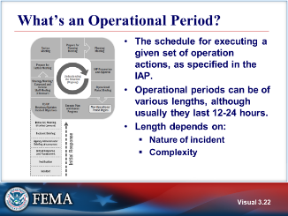  Visual 3.22 | WHAT’S AN OPERATIONAL PERIOD?  The NIMS definition of an operational period is the time scheduled for executing a given set of operation actions, as specified in the incident action plan.  All ICS incident action planning is designed around identifying accomplishments expected over a set period of time called the Operational Period.  The specific length of time of the Operational Period varies based on a list of factorse:  - Safety conditions – Safety of responders, victims, and others is always the first priority on any response.  - Condition of resources – Planning must be done far enough in advance to ensure that additional resources needed for the next Operational Period are available.  - The length of time necessary or available to achieve the tactical assignments.  - Availability of fresh resources.  - Future involvement of additional jurisdictions or agencies.  - Environmental conditions – Factors such as the amount of daylight remaining and weather and wind conditions can affect decisions about the length of the Operational Period.  The Incident Commander will determine the length of the Operational Period with input from staff. In some cases, the Operational Period length may change from day to day based on operational and incident needs.  The length of an Operational Period depends on the nature and complexity of the incident. Common lengths of Operational Periods are:  - 4, 8, 12, or 24 hours depending on the nature and complexity of the incident and the working conditions such as weather, safety, and anticipated fatigue.  - 2 to 4 hours for hazardous materials incidents.  - Multiple days for relatively stable situations and recovery actions such as debris removal.  The initial determination of the operational period may change later in the planning cycle based on development of the incident, but the initial determination is made in the Unified Command meeting.
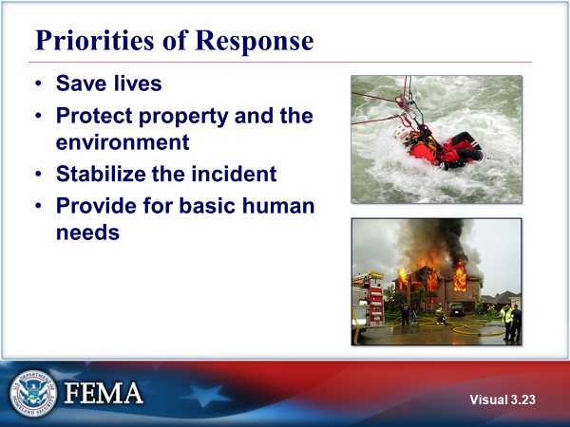  Visual 3.23 | PRIORITIES of response  The overall response priorities guide, but are not identical to the priorities established during an incident by the IC/UC. For example, saving lives is a priority for response, but in an incident, the safety of responders is commonly prioritized above saving lives of those affected by the incident,  It is also important to understand that priorities are not mutually exclusive. You do not have to complete one priority before you can begin another. It is normally possible to support multiple priorities simultaneously.
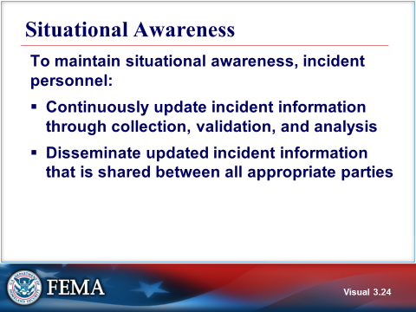  Visual 3.24 | SITUATIONAL AWARENESS  To maintain situational awareness, incident personnel:  - Continuously update incident information through collection, validation, and analysis  - Disseminate updated incident information that is shared between all appropriate parties
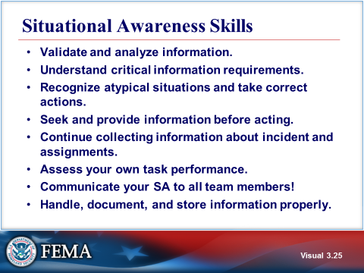  Visual 3.25 | SITUATIONAL AWARENESS SKILLS  Situational awareness requires critical thinking skills.  - Validate and analyze information.  - Understand critical information requirements.  - Recognize the correct actions to take with information. Look for the unusual, information that deviates from the expected. Recognize and analyze information discrepancies before proceeding.  - Seek and provide information before acting. Ensure that you have verified the information is accurate and sufficient to support operational decisions. Inaccurate or incomplete information can result in poor operational decisions.  - Continue collecting information about incident.  - Assess your own task performance.  - Communicate your SA to all team members!  - Properly handle, document, and store information.
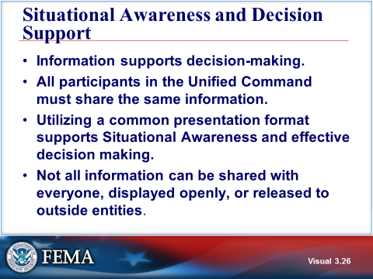  Visual 3.26 | situational awareness and decision support  Situational Awareness and Decision Support means that all participants in the Unified Command share the same information in a common presentation format that supports effective decision making. Normally this is accomplished through a single, identical summary of critical incident information that is shared by all responders and organizations. In the ICS courses, this is referred to as a Shared Situational Picture. Some organizations may refer to this as common operating picture.  Share as much verified information as possible with other agencies, organizations, jurisdictions, and the public; however, understand that not all information can be shared with everyone, displayed openly, or released to outside entities.
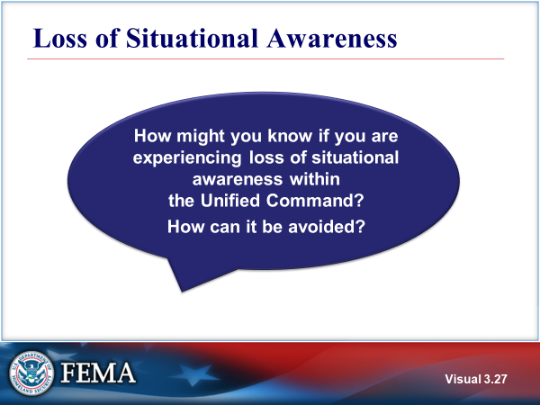  Visual 3.27 | Loss of situational awareness
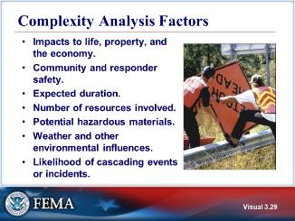  Visual 3.28 | COMPLEXITY ANALYSIS FACTORS  Complexity analysis involves that combination of factors that affect the probability of control of an incident.  Cascading events or incidents occur as a direct or indirect result of an initial event or incident. For example, as the result of a hazardous materials spill a neighborhood must be evacuated and a local stream is contaminated. Taken together, the effect of cascading events or incidents can be crippling to a community.
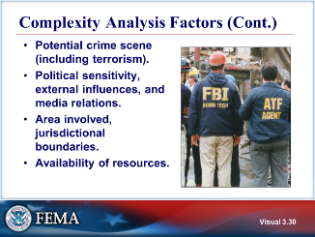  Visual 3.29 | COMPLEXITY ANALYSIS FACTORS (CONT.)  Additional factors that can affect incident complexity:  - Potential crime scene (including terrorism).  - Political sensitivity, external influences, and media relations.  - Area involved and jurisdictional boundaries.  - Availability of resources.
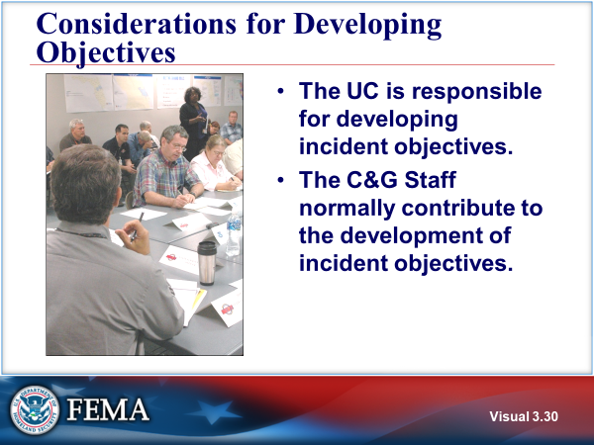  Visual 3.30 | CONSIDERATIONS FOR DEVELOPING OBJECTIVES  The Unified Command is responsible for developing incident objectives. The Command and General Staff normally contribute to the development of incident objectives. However, the Unified Command is still responsible for the incident objectives.
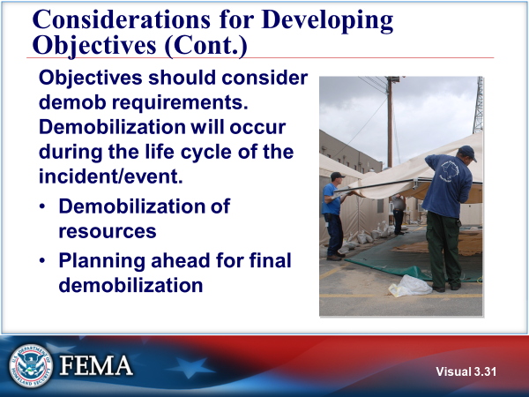  Visual 3.31 | CONSIDERATIONS FOR DEVELOPING OBJECTIVES (CONT.)  Demobilization will occur during the life cycle of the incident/event.  The IC/UC should demobilize resources no longer required or reassigned to other incidents. This may include individuals demobilized due to personal emergencies.  Plan ahead for final demobilization.
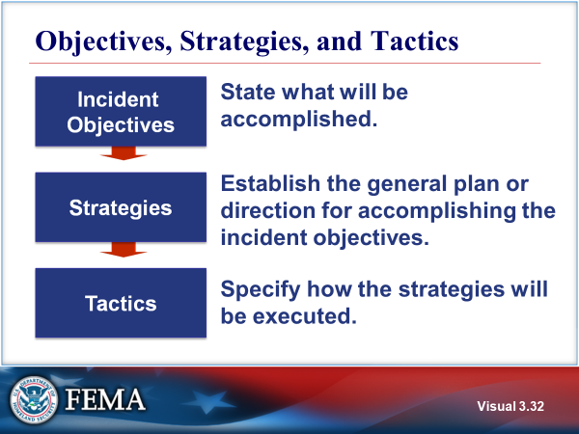  Visual 3.32 | OBJECTIVES, STRATEGIES, AND TACTICS  - Incident objectives state what will be accomplished.  - Strategies establish the general plan or direction for accomplishing the incident objectives.  - Tactics specify how the strategies will be executed.  Life safety is the first priority, followed by incident stabilization, and then property conservation.
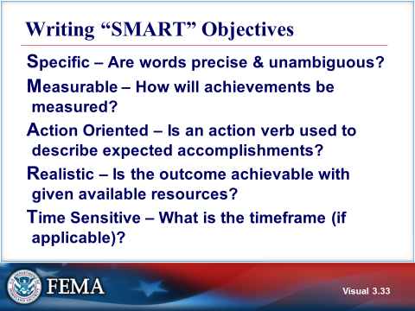  Visual 3.33 | WRITING “SMART” OBJECTIVES  Incident objectives should have the following SMART characteristics:  - Specific – The wording must be precise and unambiguous in describing the objective.  - Measurable – The design and statement of objectives should make it possible to conduct a final accounting as to whether objectives were achieved.  - Action Oriented – The objective must have an action verb that describes the expected accomplishments.  - Realistic – Objectives must be achievable with the resources that the agency (and assisting agencies) can allocate to the incident, even though it may take several Operational Periods to accomplish them.  - Time Sensitive – The timeframe should be specified (if applicable).
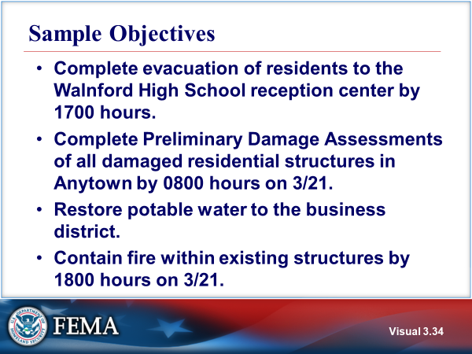  Visual 3.34 | SAMPLE OBJECTIVES  Read the following objectives:  - Complete evacuation of residents to the Walnford High School reception center by 1700 hours.  - Complete Preliminary Damage Assessments of all damaged residential structures in Anytown by 0800 hours on 3/21.  - Restore potable water to the business district.  - Contain fire within existing structures by 1800 hours on 3/21.
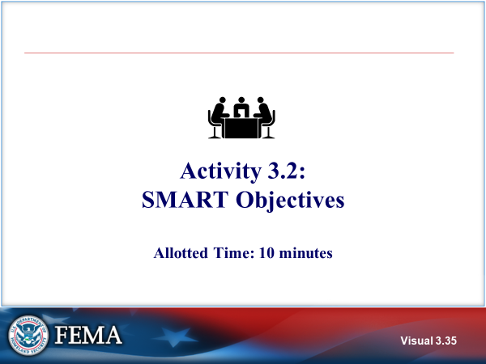  Visual 3.35 | ACTIVITY 3.2: SMART OBJECTIVES  The instructor will explain Activity 3.2.  You will have 10 minutes to complete Activity 3.2.
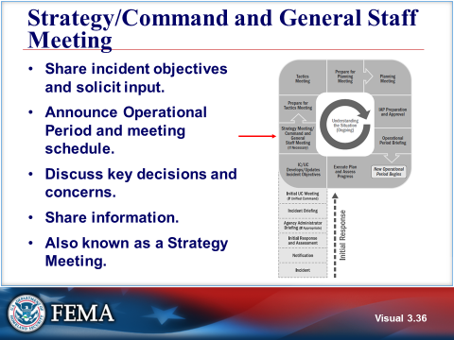  Visual 3.36 | Strategy/COMMAND AND GENERAL STAFF MEETING  After developing or revising the incident objectives, the Incident Commander or Unified Command typically meets with the Command and General Staff, and sometimes others, to discuss the incident objectives and provide direction.  This meeting may be called the Strategy Meeting or the Command and General Staff Meeting and is held as needed to determine how best to meet the incident objectives.  The initial Strategy Meeting, which is held the first time through the planning cycle, is particularly important, because it allows team members to share information and jointly determine the initial approach to response operations.
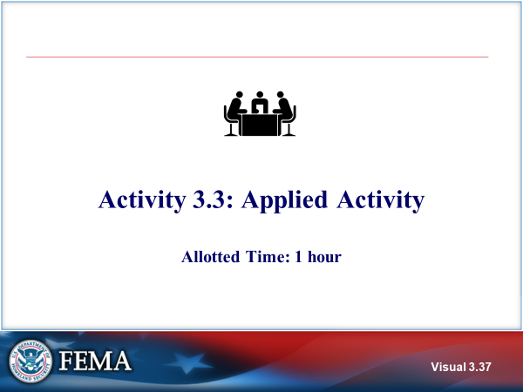  Visual 3.37 | Activity 3.3 - APPLIED ACTIVITY  The instructor will explain Activity 3.3.  You will have 30 minutes to complete the activity and 30 minutes for an instructor-facilitated debrief (1 hour total).  Refer to Unit 3 of the Applied Activity Materials document.
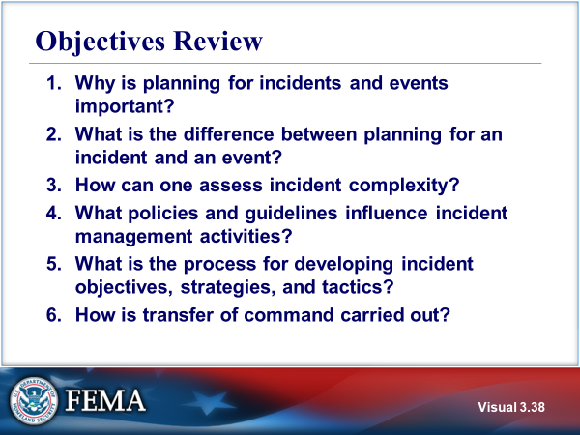  Visual 3.38 | OBJECTIVES REVIEW  Unit Enabling Objectives  - Identify the importance of planning for incidents/events.  - Contrast the differences between planning for incidents and events.  - Identify methods and tools used to assess incident/event complexity.  - Identify agency policies and guidelines that influence management of incident or event activities.  - Explain the process for developing incident objectives, strategies, and tactics.  - Identify the steps in transferring and assuming incident command.

  - Supplemental Materials

This page intentionally left blank.

Handout 3-1: ICS Form 201

Refer to Appendix for ICS Form 201.

This page intentionally left blank.

Handout 3-2: Sample Initial Unified Command Meeting Agenda

- Statement of specific jurisdictional/agency goals, based on the overarching response priorities.
- Presentation of jurisdictional limitations, concerns, and restrictions.
- Establishment of and agreement on acceptable priorities.
- Adoption of an overall strategy or strategies to accomplish objectives.
- Agreement on the basic organization structure for the Unified Command. (note that the Operations Section normally defines their section structure in the Tactics meeting based on objectives, requirements and resources).
- Designation of the best qualified and acceptable Operations Section Chief.
- Agreement on General Staff personnel designations.
- Agreement on planning, logistical, and finance agreements and procedures.
- Agreement on resource ordering process to be followed.
- Agreement on cost-sharing procedures.
- Agreement on informational matters.
- Designation of one the members of the Unified Command to act as the Unified Command spokesperson.

This page intentionally left blank.

Unit 4: Implementing an Operational Planning Process
Student Manual

This page intentionally left blank.

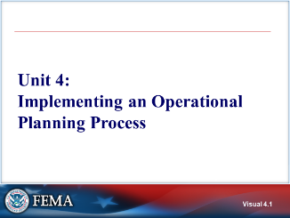 Visual 4.1 | UNIT 4: IMPLEMENTING AN OPERATIONAL PLANNING PROCESS
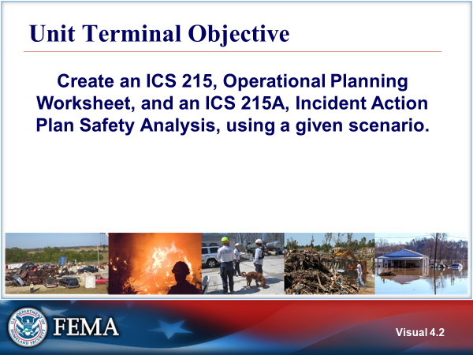  Visual 4.2 | UNIT TERMINAL OBJECTIVE  Create an ICS Form 215, Operational Planning Worksheet, and an ICS Form 215A, Incident Action Plan Safety Analysis, using a given scenario.
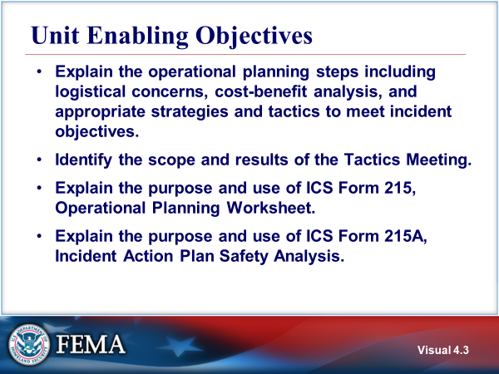  Visual 4.3 | UNIT ENABLING OBJECTIVES  - Explain the operational planning steps including logistical concerns, cost-benefit analysis, and appropriate strategies and tactics to meet incident objectives.  - Identify the scope and results of the Tactics Meeting.  - Explain the purpose and use of ICS Form 215, Operational Planning Worksheet.  - Explain the purpose and use of ICS Form 215A, Incident Action Plan Safety Analysis.  The Final Exam is based on the Unit Enabling Objectives.
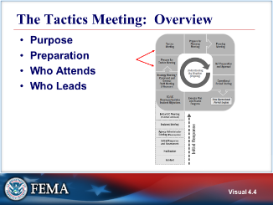  Visual 4.4 | THE TACTICS MEETING: OVERVIEW  Purpose - The purpose of the Tactics Meeting is to review the proposed strategy and tactics developed by the Operations Section. This includes:  - Determining how the selected strategy or strategies will be accomplished to achieve the incident objectives.  - Assigning resources to implement the tactics.  - Identifying methods for monitoring tactics and resources to determine if adjustments are required (e.g., different tactics, different resources, or new strategy).  Preparation - Once the incident objectives are determined, the Operations Section Chief and staff prepare for the Tactics Meeting by developing tactics and determining the resources that will be applied during the operational period. Note that this is a distinct step in the planning cycle “Preparing for the Tactics Meeting.” It is not a meeting; It is a period of time in which key preparation activities occur that will enable final decisions to be made during the Tactics Meeting.  Attendees - The Operations Section Chief, Safety Officer, Planning Section Chief or a planning representative (Resource Unit Leader), Logistics Section Chief, and other technical specialists or invited team members attend the Tactics Meeting.  Leaders - The Operations Section Chief leads the Tactics Meeting. The ICS Form 215, Operational Planning Worksheet, and the ICS Form 215A, Incident Action Plan Safety Analysis, are used to facilitate and document decisions made during the Tactics Meeting.
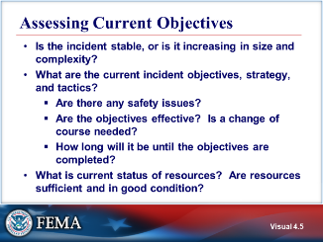  Visual 4.5 | ASSESSING CURRENT OBJECTIVES  Starting at the beginning of the Operational Period, before the tactics meeting, the incident objectives were assessed by the IC/UC and updated as needed.  Below are questions to ask when assessing objectives:  - Is the incident stable, or is it increasing in size and complexity?  - What are the current incident objectives, strategy, and tactics?  - Are there any safety issues?  - Are the objectives effective? Is a change of course needed?  - How long will it be until the objectives are completed?  - What is the current status of resources? Are resources in good condition? Are there sufficient resources?  When immediate action is required, changes may be implemented prior to the issuance of the next written IAP.
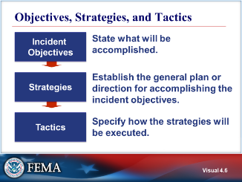  Visual 4.6 | OBJECTIVES, STRATEGIES, AND TACTICS  - Incident objectives state what is to be accomplished in the Operational Period.  The incident objectives can be found on the ICS Form 201 or ICS Form 202. The Incident Command/Unified Command establishes the incident objectives and overall strategies.  - Strategies establish the general plan or direction for accomplishing the incident objectives.  The IC has created and briefed the incident objectives. Now it is time for the Operations Section Chief to translate the objectives and strategies into tactics.  - Tactics specify how the strategies will be executed.
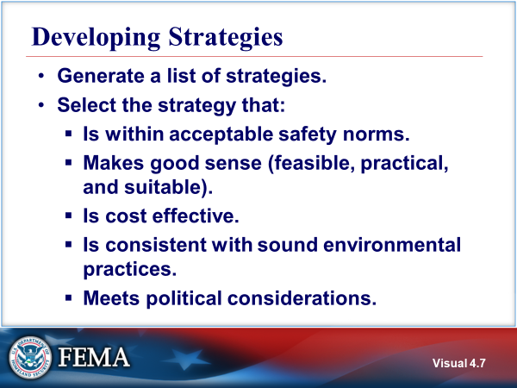  Visual 4.7 | developing strategies  Guidelines when developing an appropriate strategy:  - First, the Operations Section Chief generates strategies to meet the incident objectives.  - Next, the Operations Section Chief selects a strategy (or strategies) that:  - Is within acceptable safety norms.  - Makes good sense (feasible, practical, and suitable).  - Is cost effective.  - Is consistent with sound environmental practices.  - Meets political considerations.
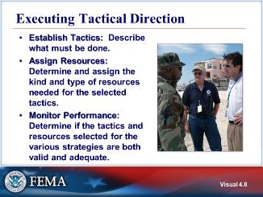  Visual 4.8 | EXECUTING TACTICAL DIRECTION  Tactical direction is developed based on the Incident Objectives. It describes what must be accomplished within the selected strategy or strategies in order to achieve the incident objectives. Tactical direction is the responsibility the Operations Section Chief (if an OSC has not been assigned then the Incident Commander/ Unified Command takes responsibility).  Gathering input is particularly important when the incident involves personnel from multiple disciplines. Jointly developed tactics can ensure understanding and enhance commitment. To accomplish this, the Operations Section Chief gathers input from the Branch Directors and Division and/or Group Supervisors.  Tactical direction consists of the following steps:  - Establish Tactics:  - Assign Resources:  - Monitor Performance:
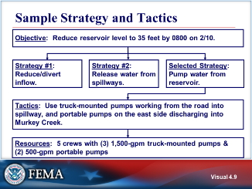  Visual 4.9 | SAMPLE STRATEGY AND TACTICS  - The objective is: Reduce reservoir level to 35 feet by 0800 on 2/10.  - Three possible strategies are identified and one is selected: Pump water from reservoir.  - The tactics for the selected strategy are: Use truck-mounted pumps working from the road into spillway, and portable pumps on the east side discharging into Murkey Creek.  Once the tactics have been selected, the next step is to determine what and how many resources will be needed to accomplish the tactics.
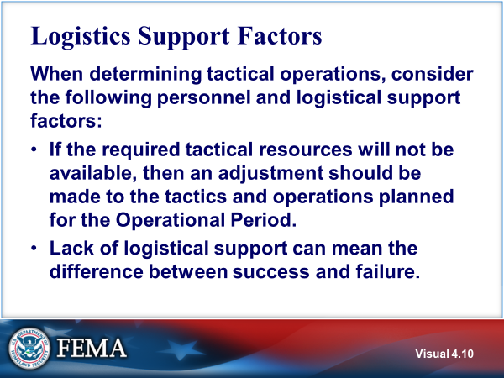  Visual 4.10 | LOGISTICS SUPPORT FACTORS  When determining tactical operations, consider the following personnel and logistical support factors:  - If the required tactical resources will not be available, then an adjustment should be made to the tactics and operations planned for the Operational Period.  - The lack of logistical support can mean the difference between success and failure. Lack of available resources could require a reassessment of tactics and perhaps the overall strategy.  It is very important that tactical resource availability and other needed support are determined prior to investing time on strategies and tactical operations that realistically cannot be achieved.  Tactical planning is dependent on resource availability and may affect accomplishment of objectives.
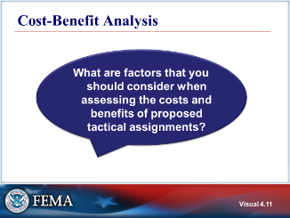  Visual 4.11 | COST-BENEFIT ANALYSIS
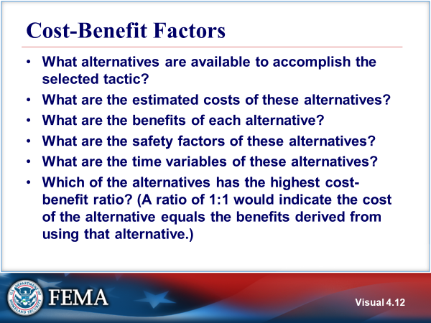  Visual 4.12 | COST-BENEFIT factors  - What alternatives are available to accomplish the selected tactic?  - What are the estimated costs of these alternatives?  - What are the benefits of each alternative?  - What are the safety factors of these alternatives?  - What are the time variables of these alternatives?  - Which of the alternatives has the highest cost-benefit ratio? (A ratio of 1:1 would indicate the cost of the alternative equals the benefits derived from using that alternative.)
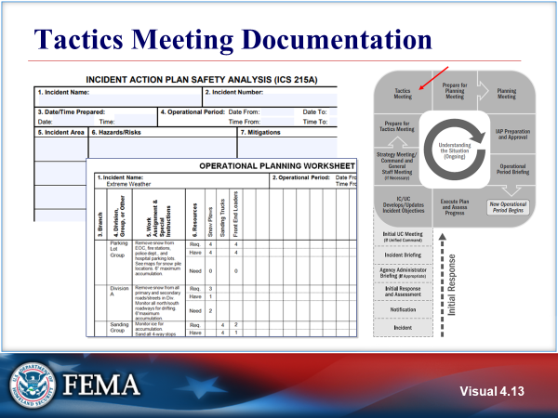  Visual 4.13 | TACTICS MEETING DOCUMENTATION  The Operational Planning Worksheet (ICS Form 215) and Incident Action Plan Safety Analysis (ICS Form 215A) are designed to document the results of the Tactics Meeting.  Refer to Handout 4-1: ICS Form 215, Operational Planning Worksheet and Handout 4-2: ICS Form 215A, Incident Action Plan Safety Analysis.  Tactical planning is dependent on resource availability and may affect accomplishment of objectives.
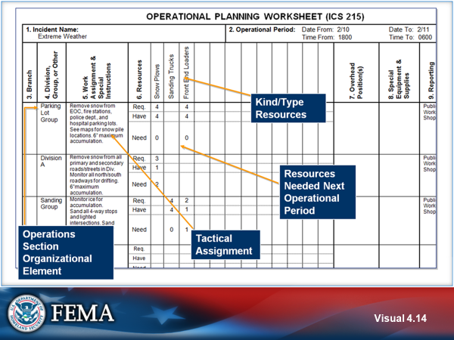  Visual 4.14 | OPERATIONAL PLANNING WORKSHEET  The ICS Form 215, Operational Planning Worksheet is a planning tool used to assist in establishing resource needs for an Operational Period. It communicates the decisions made during the Tactics Meeting concerning resource assignments to the Resources Unit. The Resources Unit uses the worksheet to complete Assignment Lists (ICS Form 204s) and the Logistics Section Chief uses the worksheet for ordering resources for the incident.  The ICS Form 215 is initiated prior to the Planning Meeting by the Incident Commander or the Operations Section Chief, who uses the worksheet to plan resource requirements for the next Operational Period. The ICS Form 215 reflects resources available for assignment during the next Operational Period (information provided by Resources Unit in Planning Section) and it is used as a display during the Planning Meeting where it is finalized based on contributions from the Command and General Staffs.  Provides information on:  - Work assignments (Branch, Division, Group, or other).  - Kind of resources needed, required, and/or already have.  - Any specialized equipment or supplies that may be needed.  - Reporting location.  - Requested arrival time for additional resources.  - Total number of resources that need to be ordered for the next Operational Period.  By using the worksheet, planners can:  - Determine total resources required (for example: 25 personnel).  - Subtract the number on hand (for example: -12).  - Determine additional resources needed (for example: 13).  The ICS Form 215 can show graphically that span of control is appropriate. It can also help to identify surplus resources that may be released. Some agencies that regularly use the Planning Worksheet have prepared it in a larger format on a whiteboard or have developed electronic versions for display on a large screen. This makes the worksheet visible to a larger audience at planning meetings.  Although agencies and jurisdictions may have their own systems for tracking resources, the ICS Form 215 should be used to ensure that there is shared awareness by all participants in the Unified command of what tactical resources are needed.
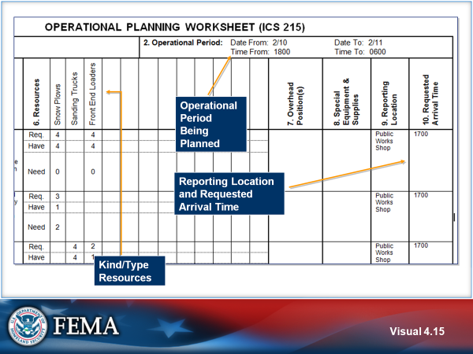  Visual 4.15 | OPERATIONAL PLANNING WORKSHEET (CONT.)  The worksheet provides an area to indicate:  - Operational period being planned, incident name, and the name and position of the person preparing the ICS Form 215.  - Kind of resources.  - Reporting location for resources.  - Requested arrival time of resources.  Resource typing is defining and categorizing incident resources by capability. Typed resources are identified by capability, category, kind and type. The Resource Typing Library Tool (RTLT) is an online catalog of NIMS resourcing typing definitions. Resource typing is discussed in Unit 6 of this course.
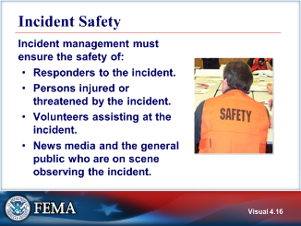  Visual 4.16 | INCIDENT SAFETY  Before the planning meeting, either the Safety Officer or Incident Commander must complete an analysis of the safety concerns related to the tactics and resources being deployed through the use of the Incident Action Plan Safety Analysis (ICS Form 215A).
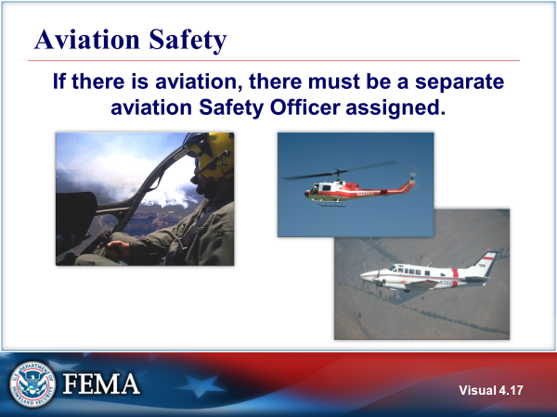  Visual 4.17 | AVIATION SAFETY  When aviation is used, there are specific aviation policies, procedures and requirements.  Most agencies do not conduct routine major air operations, so it is unlikely that they will have personnel trained to manage aviation tactical and support operations. Part of the resource pre-incident planning should include the identification of where you can acquire aviation management expertise when needed.  Contact your State Aviation Officer and refer to the State and Regional Disaster Airlift (SARDA) plan for assistance. Other sources of expertise include the U.S. Coast Guard, National Guard Aviation Units, and State and Federal wildland management agencies.
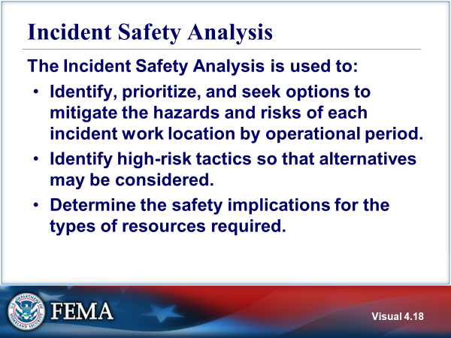  Visual 4.18 | INCIDENT SAFETY ANALYSIS  Purpose of the Incident Safety Analysis:  - Identify, prioritize, and seek options to mitigate the hazards and risks of each incident work location by Operational Period.  - Identify high-risk tactics so that alternatives may be considered.  - Determine the safety implications for the types of resources required.
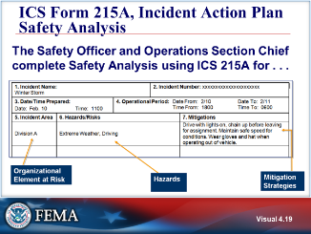  Visual 4.19 | ICS FORM 215A, INCIDENT ACTION PLAN SAFETY ANALYSIS  The purpose of the Incident Action Plan Safety Analysis (ICS Form 215A) is to aid the Safety Officer in completing an operational risk assessment to prioritize hazards, safety, and health issues, and to develop appropriate controls.  This worksheet can assist Planning and Operations in their assessment of risk associated with tactics. It is used in the planning process and during the Operations Briefing to communicate risk, hazards, and mitigations.  The form provides information on:  - Incident work location(s). This is based on the Operations Section Organization as developed by the OSC (Branches, Divison or Groups).  - Risks such as weather, biohazard, hazardous materials, communications, flooding, special hazard areas, fatigue, driving hazards, dehydration, and critical incident stress.  - Mitigation measures. The mitigation measures identified may have implications for the resources entered on the ICS Form 215.  - Other logistical information such as date and time of the Operational Period, incident name, and the name and position of the person(s) preparing the form.  The objective of the Incident Action Plan Safety Analysis is to identify, prioritize, and mitigate the hazards and risks of each incident work location by Operational Period. The mitigation methods selected may affect the resources required for the incident work location. The Safety Analysis may also reveal that the proposed tactic is too hazardous to attempt and another tactic must be developed. The completed ICS Form 215A is displayed during the planning meeting.  When the Safety Analysis is completed, the form is used by the Resources Unit to add specific hazard/risk mitagation information to the specific ICS Form 204 Assignment List. All completed original forms must be given to the Documentation unit. Refer to Handout 4-2: ICS Form 215A, Incident Action Plan Safety Analysis.  The Safety Officer or the Incident Commander/Unified Command should coordinate, develop, and approve an ICS Form 215A, Incident Action Plan Safety Analysis, for each Operational Period with the Operations Section Chief.  ICS Form 215A is a tool used by the Safety Officer as a concise way of identifying hazards and risks present in different areas of the incident and specific ways of mitigating those issues during an Operational Period.  The objective of the Incident Action Plan Safety Analysis is to identify and mitigate the hazards and risks of each incident work location by Operational Period. The mitigation methods selected may affect the resources required for the incident work location. The Safety Analysis may also reveal that the proposed tactic is too hazardous to attempt and another tactic must be developed.  ICS Form 215A is used as a display during the Planning Meeting. It provides information on:  - Incident work location(s)  - Risk mitigations  - Date (daily) prepared by Operation Section Chief/Safety Officer and approved by Safety Officer  Techniques for Identifying Hazards  - Personal observation and/or experience  - Checklist  - Communication with incident personnel  - Personnel  Types of Risks  - Traffic  - Driving hazards  - Dehydration  - Fatigue  - Confined space  - Downhill fireline construction  - Air operations  - Hazardous materials (chemical, biological, and radiation)  - Secondary devices/explosive  - Slip, trip, and fall  - Weather  - Limited visibility  - Structural instability  - Civil unrest  - Criminal intent with hostile acts  - Critical incident stress  Locations  - Divisions  - Groups  - Helibase  - Staging Area  - Emergency Operations Center  - Others  Mitigation of Hazards  - L - Use lookouts  - C - Maintain communications with personnel  - E - Identification of escape routes  - S - Use of safety zones  - Use of personal protective equipment (PPE)  - Proper clothing for inclement weather  - Reflective clothing and lights for nighttime or low-light operations  - Maintain awareness of landing zones  - Monitoring personnel well-being
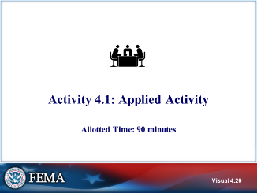  Visual 4.20 | ACTIVITY 4.1: applied activity  The instructor will explain Activity 4.1.  You will have 60 minutes to complete Activity 4.1 and 30 minutes of an instructor feedback.  Refer to Unit 4 of the Applied Activity Materials document.
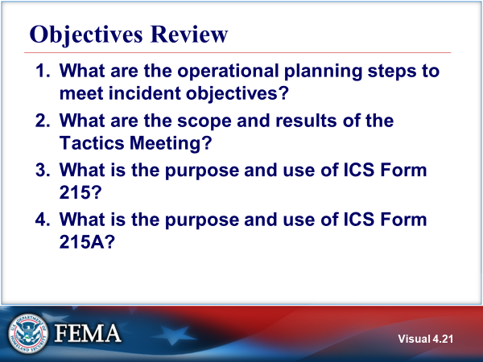  Visual 4.21 | OBJECTIVES REVIEW  Unit Enabling Objectives  - Explain the operational planning steps including logistical concerns, cost-benefit analysis, and appropriate strategies and tactics to meet incident objectives.  - Identify the scope and results of the Tactics Meeting.  - Explain the purpose and use of ICS Form 215, Operational Planning Worksheet.  - Explain the purpose and use of ICS Form 215A, Incident Action Plan Safety Analysis.

This page intentionally left blank.

  - Supplemental Materials

This page intentionally left blank.

Handout 4-1: ICS Form 215, Operational Planning Worksheet

Refer to the Appendix for a sample form.

Handout 4-2: ICS Form 215A, Incident Action Plan Safety Analysis

Refer to the Appendix for a sample form.

This page intentionally left blank

Unit 5: Planning Process, IAP, and Operations Briefs
Student Manual

This page intentionally left blank.

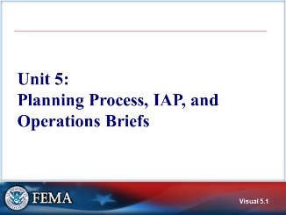 Visual 5.1 | UNIT 5: PLANNING PROCESS, IAP, AND OPERATIONS BRIEFS  The IAP is the central tool for planning during a response. ICS Forms provide a mechanism for the staff to complete the IAP. Using the ICS forms ensures the responsible staff member does not omit important incident-related information.  This unit will continue with the incident action planning process and IAP development.
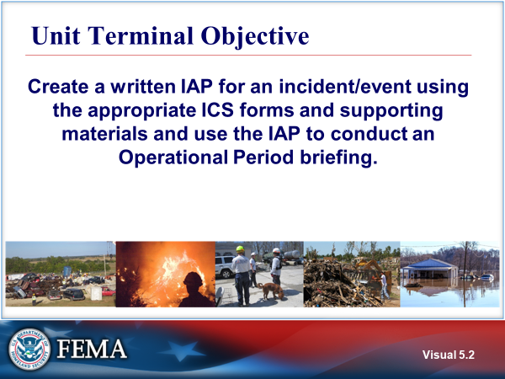  Visual 5.2 | UNIT TERMINAL OBJECTIVE  Create a written IAP for an incident/event using the appropriate ICS forms and supporting materials and use the IAP to conduct an Operational Period briefing.
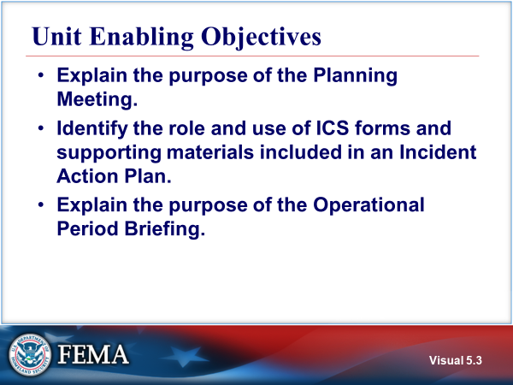  Visual 5.3 | UNIT ENABLING OBJECTIVES  - Explain the purpose of the Planning Meeting.  - Identify the role and use of ICS forms and supporting materials included in an Incident Action Plan.  - Explain the purpose of the Operational Period Briefing.  The Final Exam is based on the Unit Enabling Objectives. Additionally, performance of the activities in this unit is a key part of the evaluation of your performance for this course.
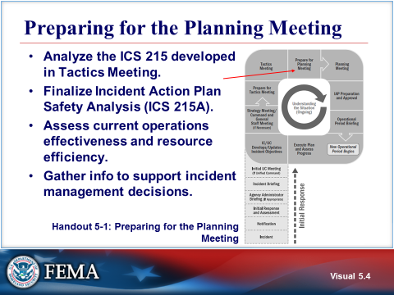  Visual 5.4 | PREPARING FOR THE PLANNING MEETING  The next step in the incident action planning process is to prepare for the Planning Meeting. Following the Tactics Meeting, the Planning Section coordinates preparations for the Planning Meeting.  It is very important to complete the ICS Form 215A after the ICS Form 215 so that any safety concerns that are identified can be successfully mitigated.  Refer to Handout 5-1: Preparing for the Planning Meeting.
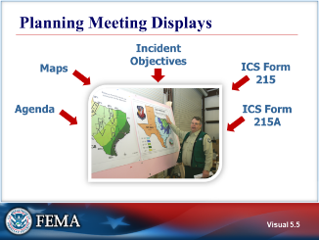  Visual 5.5 | PLANNING MEETING DISPLAYS  Displays should include the Planning Meeting agenda, Incident Objectives, large versions of the ICS Forms 215 and 215A, maps/charts, the schedule for forms submission and additional meetings, and any other props needed to illustrate the IAP.
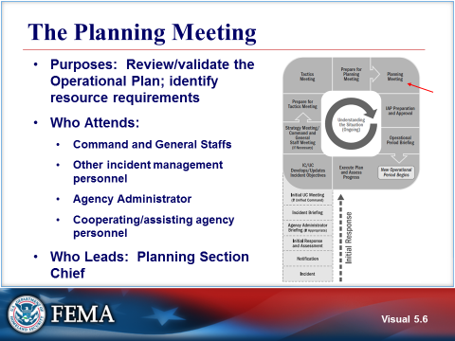  Visual 5.6 | THE PLANNING MEETING  The Planning Meeting provides the final opportunity for the Command and General Staffs, as well as other incident management personnel, agency officials, and cooperating/assisting agencies and organizations, to review and validate the Operational Plan and resource assignments as proposed by the Operations Section Chief.  The Operations Section Chief presents the tactical plan using the ICS Form 215. The ICS Form 215 delineates operations section organization, work assignments the amount and kind/type of resources he or she will need to accomplish the plan as well as reporting ;ocation and time. The Planning Section’s Resources Unit will have to work with the Logistics Section to fulfill the resource needs.  The Planning Chief facilitates the meeting following a fixed agenda to ensure that the meeting is efficient while allowing each organizational element represented to assess and acknowledge the plan.  At the conclusion of the meeting, the Planning Section Chief indicates when all elements of the plan and support documents must be submitted so the plan can be collated, reviewed, approved, duplicated, and made ready for the operations briefing.
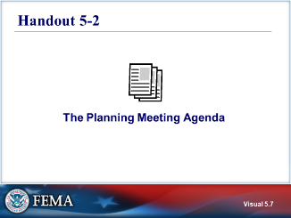  Visual 5.7 | Handout 5-2: THE PLANNING MEETING AGENDA  Refer to Handout 5-2: Planning Meeting Agenda.
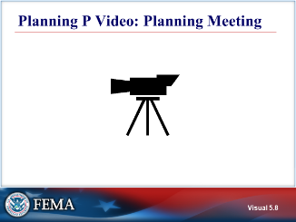  Visual 5.8 | PLANNING P VIDEO: Planning Meeting
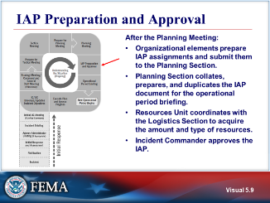  Visual 5.9 | IAP PREPARATION AND APPROVAL  After the Planning Meeting is held, the following actions are taken to prepare the Incident Action Plan (IAP):  - ICS Staff Sections prepare their components of the IAP and submit them to the Planning Section.  - The Planning Section collates, prepares, and duplicates the IAP document for distribution at the operations briefing. The Planning Section will:  - Set the deadline for completing IAP attachments.  - Obtain plan attachments and review them for completeness and approvals.  - Review the IAP to ensure it is up to date and complete prior to the operations briefing and plan distribution.  - Provide the IAP briefing plan, as required, and distribute the plan prior to the beginning of the new Operational Period.  - The Documentation Unit will normally be responsible for reproducing the IAP  - The Resources Unit coordinates with the Logistics Section to acquire the amount and type of resources needed.  - The Incident Commander/Unified Command reviews and approves the IAP.
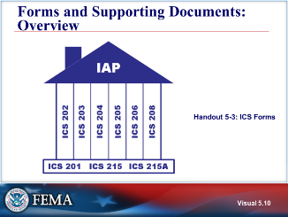  Visual 5.10 | FORMS AND SUPPORTING DOCUMENTS: OVERVIEW  The written IAP is a series of standard forms and supporting documents that convey the Incident Commander’s and the Operations Section’s directions for the accomplishment of the plan for that Operational Period.  - ICS Form 202 Incident Objectives - what is to be done  - ICS Form 203 Organization Assignment List - who is assigned  - ICS Form 204 Assignment List - what they are assigned to do  - ICS Form 205 Incident Radio Communications Plan - how we talk to each other  - ICS Form 205A Communications List – all methods of non-radio contact informaton for personnel assigned (optional)  - ICS Form 206 Medical Plan - how to treat medical/ injured responders  - ICS Form 207 Incident Organizational Chart – visual chart depicting organizational positions and who is assigned to each(optional)  - ICS Form 208 Safety Message/Plan - how to keep people safe.  It is a best practice to include a cover sheet to indicate which forms and supporting documents are included in the IAP. An alternate approach is to list the contents of the IAP on the bottom of the ICS Form 202 Incident Objectives. The key concept is that an IAP may not contain all ICS forms. Use of a checklist to indicate which forms and supporting documents are enclosed as part of the IAP will ensure that IAP users understand what forms were included in the IAP.  It is also important to understand that an IAP will change over time in an incident. Initial IAPs may be shorter and response action focused. Later IAPs may be longer, contain more forms, and include recovery and mitigation objectives. Again, listing the components included in the IAP will help IAP users.  For a more indepth explanation of the ICS forms, refer to Handout 5-3: ICS Form Descriptions and review.
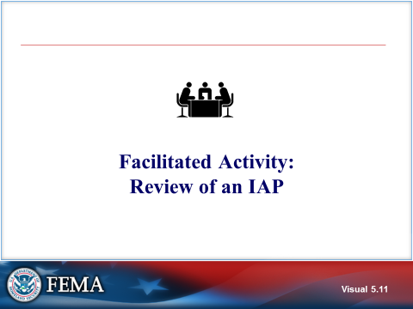  Visual 5.11 | Facilitated Activity: Review of an IAP  The instructor will explain this facilitated activity.
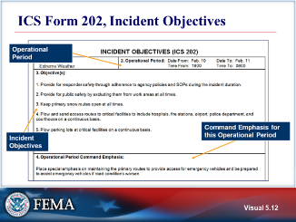  Visual 5.12 | ICS FORM 202, INCIDENT OBJECTIVES  The Incident Objectives, ICS Form 202, includes incident information, a listing of the incident objectives for the Operational Period), and a brief summary of the command emphasis/priorities.  The ICS Form 202 is completed by the Incident Commander or Unified Command (with the support of the Planning Section) following each Command and General Staff Meeting.
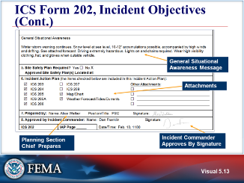  Visual 5.13 | ICS FORM 202, INCIDENT OBJECTIVES (cont.)  - A Situational Awareness message is included with pertinent weather information.  - Identifies if a Site Safety Plan is required.  - The Planning Section Chief signs the ICS Form 202 indicating completion of the form and Incident Commander(s) sign indicating approval of the written IAP.  - A list of attachments is included (table of contents for the IAP). Note that some organizations will use a separate IAP cover sheet for this purpose.
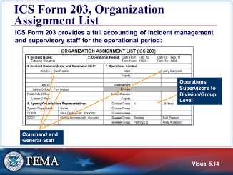  Visual 5.14 | ICS FORM 203, ORGANIZATION ASSIGNMENT LIST  The Organization Assignment List, ICS Form 203, provides a full accounting of incident management and supervisory staff currently activated for the Operational Period of the IAP.  The Resources Unit prepares and maintains the list. The Planning Section Chief is responsible for ensuring the most current ICS Form 203 is placed in the IAP.
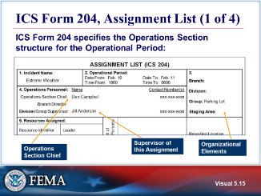  Visual 5.15 | ICS FORM 204, ASSIGNMENT LIST (1 OF 4)  The Assignment List, ICS Form 204, is based on the organizational structure of the Operations Section for the Operational Period.  The ICS Form 204 is normally prepared by the Resources Unit, It must be approved by the IC, but may first also be reviewed and initialed by the Planning Section Chief and Operations Section Chief to ensure they understand and concur with the assignments.  Each Division or Group will have its own page. This page will list who is supervising the Division or Group, to include Branch Director if assigned.
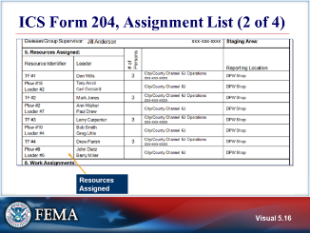  Visual 5.16 | ICS FORM 204, ASSIGNMENT LIST (2 OF 4)  The Assignment List includes specific assigned resources with leader name and number of personnel assigned to each resource.
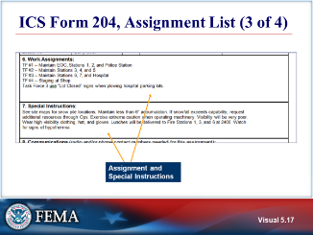  Visual 5.17 | ICS FORM 204, ASSIGNMENT LIST (3 OF 4)  The Work Assignment section describes in detail the specific actions that the Division or Group will be taking in support of the overall incident objectives. Any special instructions will be included as well as the elements of the Communications Plan that apply to that Division or Group.
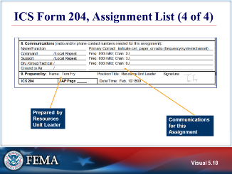  Visual 5.18 | ICS FORM 204, ASSIGNMENT LIST (4 OF 4)  Communications assignments are specified on the Assignment List. Summarize by noting that information from several forms is integrated on the Assignment List in order to inform members of the Operations Section about assignments, instructions, and communication protocols/frequencies.
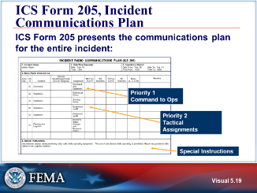  Visual 5.19 | ICS FORM 205, INCIDENT COMMUNICATIONS PLAN  The Incident Communications Plan, ICS Form 205, summarizes the communications plan for the entire incident.  The ICS Form 205A is a second communications-related form that may also be used in an IAP.  The ICS Form 205 is prepared by the Communications Unit Leader and given to the Planning Section Chief for inclusion in the Incident Action Plan.  The plan is a summary of information obtained about available radio frequencies or talkgroups and the assignments of those resources by the Communications Unit Leader for use by incident responders.  Information from the Incident Radio Communications Plan on frequency or talkgroup assignments is normally placed on the Assignment List (ICS Form 204).
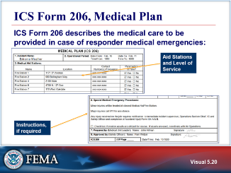  Visual 5.20 | ICS FORM 206, MEDICAL PLAN  The Medical Plan, ICS Form 206, presents the plan for providing care in the case of responder medical emergencies. In addition, provides information on incident medical aid stations, ground and air transportation services, and hospitals. The ICS Form 206 is normally prepared by the Medical Unit Leader and reviewed by the Safety Officer to ensure ICS coordination.  If aviation assets are used for rescue, coordinate with Air Operations.
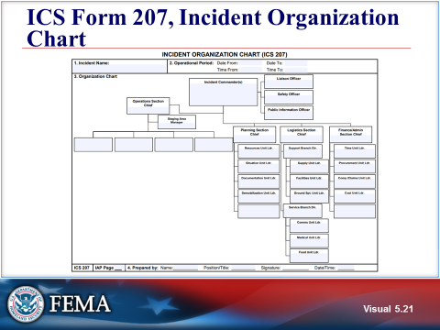  Visual 5.21 | ICS FORM 207, incident organization chart  The ICS Form 207 provides a visual chart depicting the ICS organization position assignments for the incident. May be used as a wall chart during meetings and briefing.  The ICS Form 207 is prepared by the Resources Unit Leader and reviewed by the IC.
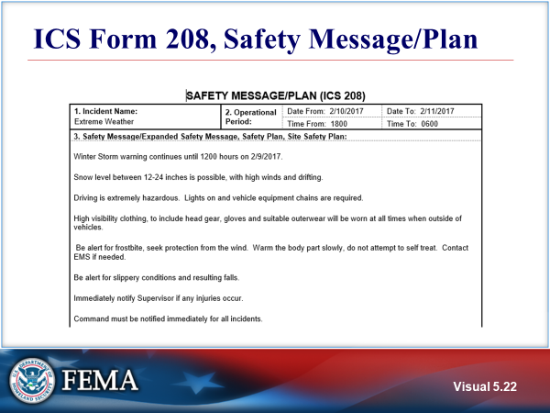  Visual 5.22 | ICS FORM 208, SAFETY MESSAGE/Plan  The ICS Form 208 is completed by the Safety Officer. The form outlines safety message(s), priorities, key command emphasis/decisions/directions, safety hazards and specific precautions to be observed during the Operational Period for the IAP.  Identifies if a Site Safety Plan is required and the location of the Site Safety Plan.
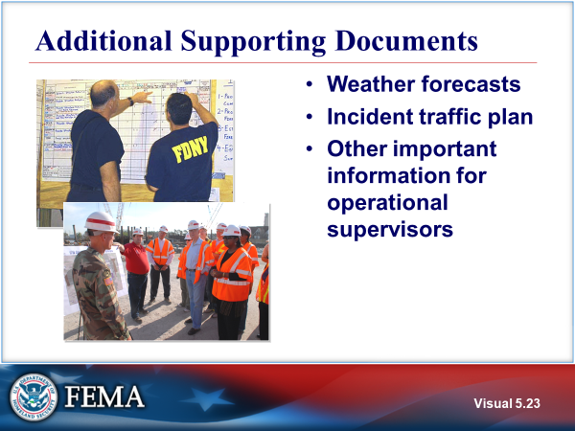  Visual 5.23 | ADDITIONAL SUPPORTING DOCUMENTS  Refer to Handout 5-3: ICS Form Descriptions.
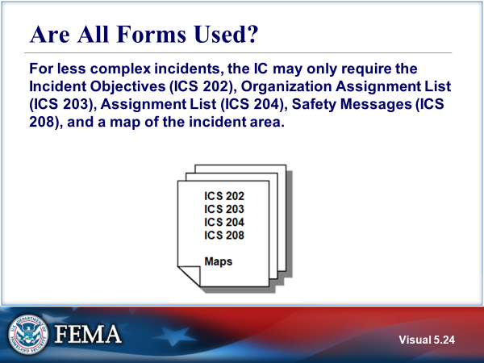  Visual 5.24 | ARE ALL FORMS USED?  The Incident Commander makes the final determination regarding which ICS forms, documents, and attachments will be included in the IAP.
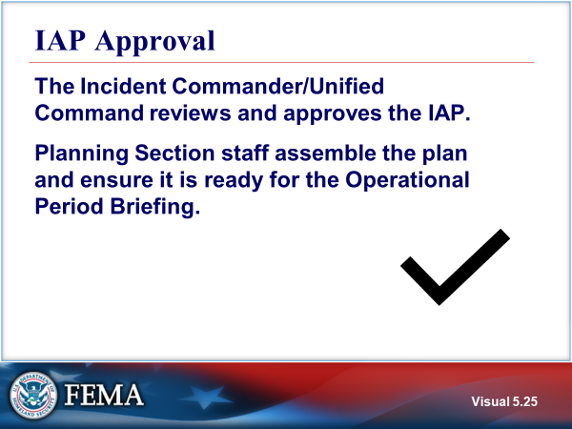  Visual 5.25 | Iap Approval  Based on concurrence from all elements at the end of the Planning Meeting, the Incident Commander or Unified Command approves the plan.  After this final approval, the Planning Section staff assemble the plan and ensure that it is ready for use during the Operational Period Briefing.
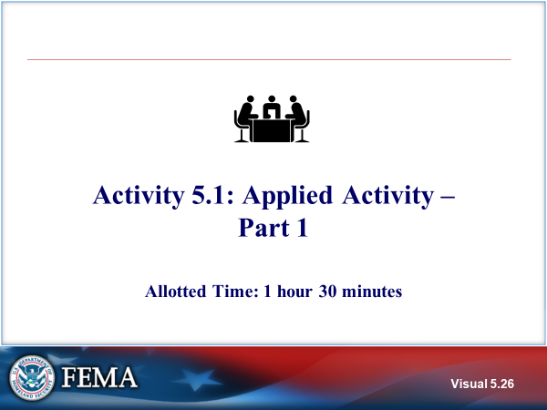  Visual 5.26 | activity 5.1: APPLIED ACTIVITY – Part 1  The instructor will explain Activity 5.1 Part 1  You wil have 1 hour 15 minutes to complete the activity with 15 minutes of individual feedback/debrief.  Refer to Unit 5 of the Applied Activity Materials document.
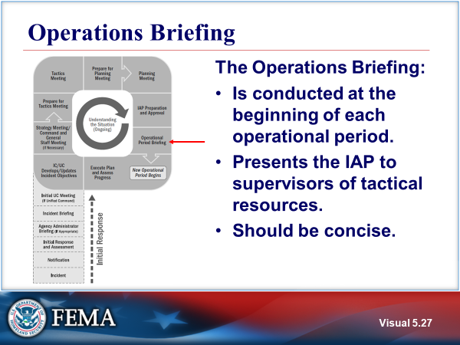  Visual 5.27 | OPERATIONS BRIEFING  The Operations Briefing is conducted at the beginning of each Operational Period, immediately prior to the start of the new Operational Period. Supervisors of the tactical resources to be employed during that period attend the operations briefing. Normally this will include Branch, Group and Division level supervisors. Unit leaders may participate in this briefing, but they will more often be briefed on the IAP in a later, separate Group/ Division briefing. In some cases, all of the tactical personnel may attend the Operations Briefing if this meets an operational need and they can be accommodated.  The Operations Briefing presents the IAP to supervisors of tactical resources. Following the Operational Period Briefing, supervisors brief their assigned personnel on their respective assignments as documented in the IAP. Staff members are briefed on the operational elements of the plan to ensure they are aware of whom they will work for, and what it is that must be accomplished. In this briefing, staff members will have a chance to ask questions regarding the plan, any critical safety issues, and specific logistical information.  The Operations Briefing should be concise. The Planning Section Chief facilitates the briefing, following a concise agenda
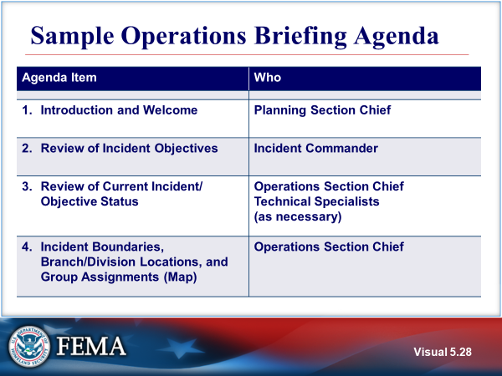  Visual 5.28 | SAMPLE OPERATIONS BRIEFING AGENDA
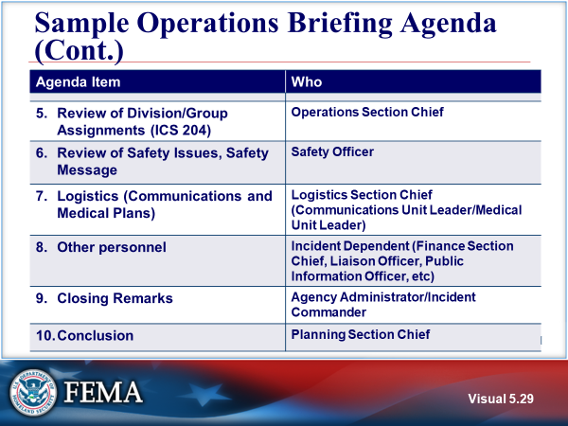  Visual 5.29 | SAMPLE OPERATIONS BRIEFING AGENDA (CONT.)  - The Operations Section Chief reviews all Division/Group Assignments (ICS Form 204), ensuring that the Division and Group Supervisors thoroughly understand the tactical assignment, resources, communications, special instructions, and safety issues associated with the Division or Group. It is not unusual for incident conditions to have changed between the time the IAP is duplicated and the operations briefing. The Operations Section Chief may dictate last-minute changes to the IAP. The IAP is the primary focus of the briefing.  - Safety Officer discusses safety issues such as accidents and injuries to date, continuing and new hazards, and mitigation efforts. Reviews Safety Message.  - Logistics Section Chief covers supply, transportation, food, and facilities-related issues. The Logistics Section Chief will also cover (or may have staff discuss) the following:  - Medical Unit Leader discusses the Medical Plan (ICS Form 206), ensuring that all supervisors understand the procedures to follow if a responder is injured on the incident.  - Communications Unit Leader reviews the overall Incident Communications Plan (ICS Form 205 and ICS Form 205A).  - Other Personnel may review additional IAP elements as needed. These may include:  - Air Operations Summary – Air Operations Branch Director  - Fiscal or Compensation/Claims issues – Finance/Administration Section Chief  - Issues associated with cooperating or assisting agencies – Liaison Officer  - Media and incident information issues – Public Information Officer  - Other issues (may include presentations by Training Specialist, the Demobilization Unit Leader, etc.)  - Incident Commander provides closing remarks.  - Planning Section Chief provides housekeeping information such as times of next meetings, etc., and concludes the meeting.  Refer to Handout 5-4: Sample Operations Briefing Agenda.
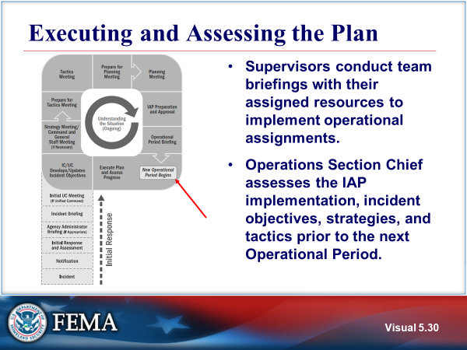  Visual 5.30 | EXECUTING AND ASSESSING THE PLAN  The Operations Section directs the implementation of the plan. The supervisory personnel within the Operations Section are responsible for implementation of the plan for the specific Operational Period.  Once the Incident Action Plan has been approved, any change or modification to the plan identifed at the Operational Period Briefing should be written in red ink on the original document. This original document serves as the incident’s official document to be retained.  - The plan is evaluated at various stages in its development and implementation:  - First, all members of the Command and General Staff review the final plan document and correct any discrepancies.  - Next, during the implementation of the plan, all incident supervisors and managers must continually assess the effectiveness of the plan based upon the original measurable objectives for the Operational Period. This evaluation of the plan keeps responders on track and on task and ensures that the next Operational Period plan is based on a reasonable expectation of success of the current plan.  - Finally, the Operations Section Chief may make the appropriate adjustments during the Operational Period to ensure that the objectives are met and effectiveness is assured.  Operations Section Chief assesses the IAP implementation, incident objectives, strategies, and tactics prior to the next Operational Period.
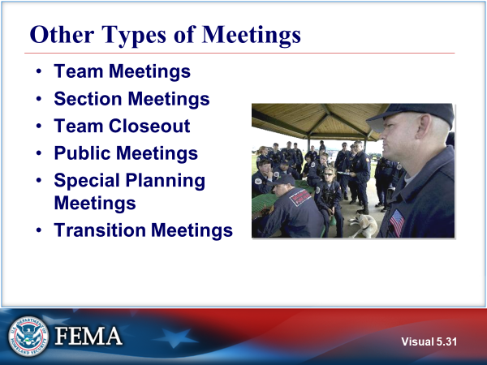  Visual 5.31 | OTHER TYPES OF MEETINGS  - Team Meetings – The Incident Commander can call a meeting of the Command and General Staffs to assess general morale, ensure groupwork and communication, or provide additional direction. These meetings are not planning meetings and do not have a set agenda.  - Section Meetings – Following the Operational Period Briefing, Section Chiefs will need to brief section personnel not in attendance at the Operational Period Briefing on the IAP. Section Chiefs may also call meetings of their staff at any time and for the same reasons.  - Team Closeout – The Incident Management Tam may want to hold a closeout meeting to discuss lessons learned, performance issues, changes in team practices, etc.  - Public Meetings – The Incident Commander may find it useful to hold general public meetings or focus group meetings to brief the public or special interest groups on incident activities. Such meetings should be carefully planned in advance and have a formal agenda. Usually the Public Information Officer is also involved in advertising, organizing, and facilitating such meetings.  - Special Planning Meetings – Special planning meetings may be useful to discuss proposed specialty plans such as the Demobilization Plan or specific contingency plans. Such meetings may be convened by the Planning Section Chief (Demobilization Plan) and/or the Operations Section Chief (contingency plans).  - Transition Meetings – A transition meeting can be seen as an expanded transfer of command meeting when one Incident Management Team replaces another Incident Management Team. Transition meetings are a good way to ensure that all information is shared between members of incoming and departing Incident Management Teams.
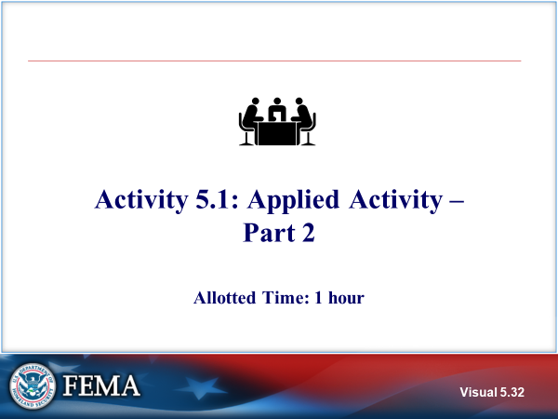  Visual 5.32 | activity 5.1: APPLIED ACTIVITY – Part 2  Introduce  The instructor will explain Activity 5.1 Part .  You will have 45 minutes to complete the activity with 15 minutes of individual feedback/debrief.
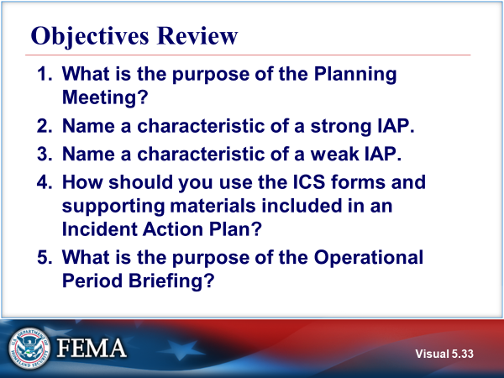  Visual 5.33 | OBJECTIVES REVIEW  Unit Enabling Objectives  - Explain the purpose of the Planning Meeting.  - Identify the role and use of ICS forms and supporting materials included in an Incident Action Plan.  - Explain the purpose of the Operational Period Briefing.

  - Supplemental Materials

This page intentionally left blank.

Handout 5-1: Preparing for the Planning Meeting

Incident Commander/Unified Command Responsibilities:
- Gives direction.
- Communicates.
- Manages.
- Avoids getting unnecessarily involved in details.
Safety Officer Responsibilities:
- Identifies incident risks and hazards.
- Completes ICS Form 215A developed at the tactics meeting.
- Works with the Operations Section Chief on tactical safety issues.
- Identifies safety issues associated with incident facilities and nontactical activities, such as transportation and food service.
Liaison Officer Responsibilities:
- Identifies cooperating and assisting agencies.
- Identifies special agency needs.
- Determines capabilities of cooperating and assisting agencies.
- Determines restrictions on participation of cooperating and assisting agencies.
- Confirms name and contact location of agency representatives.
Public Information Officer Responsibilities:
- Assesses general media coverage to date.
- Identifies incident-related information issues that need to be explained or corrected with the media.
- Determines what Joint Information System (JIS) elements and procedures are in place.
- Determines process for development and approval of media releases and visits.

Operations Section Chief Responsibilities:
- Continues to obtain good incident resource and status information.
- Communicates current information.
- Considers alternate strategies and determines probable tactics.
- Calculates resource requirements.
- Works with the Safety Officer and Planning Section staff to complete ICS Forms 215 and 215A developed at the tactics meeting.
Planning Section Chief Responsibilities:
- Prepares incident maps and displays, as necessary.
- Develops information for the lAP.
- Develops situation status and predictions.
- Acquires information and ICS forms for the IAP.
Logistics Section Chief Responsibilities:
- Determines service and support needs for the incident.
- Determines responder medical and rehabilitation needs.
- Determines incident communications needs.
- Confirms resource ordering process.
Finance/Administration Section Chief Responsibilities:
- Collects information on rental agreements and contracts.
- Determines potential and actual claims.
- Calculates incident costs to date.
- Develops cost-benefit analyses as requested.

Handout 5-2: Sample Planning Meeting Agenda

- Planning - Introduction (Brings meeting to order, covers ground rules, and refers to agenda)
- Incident Commander/Unified Command – Opening Remarks
- Situation Unit Leader (and any needed Technical Specialists) Current Situation, Weather, and Incident Projections
- Planning - Incident Objectives and Priorities (Reads the Incident Objectives for the group)
- Operations – Current Operations and Proposed Plan (Provides overview of the current operations and the proposed operations plan. This includes strategies, tactics/ work assignments, resource commitments, Ops Section organization, facilities, using the Operational Planning Worksheet (ICS Form 215).
- Logistics -Communications, Medical, Supply Approval (Validates that Communications, Medical, transportation, and Supply units concur with and capable of supporting the proposed plan
- Finance - Indicates fiscal constraints and verifies proposed plan fits with financial constraints)
- PIO - Provides public information plan and methodologies to meet objectives. Verifies that public information outreach meets objectives)
- Liaison - Confirms interagency issues are being addressed
- Other Staff or Technical specialists as needed
- Safety Officer- Mitigation Measures/Safety Plan Using wall-sized Incident Action Plan Safety Analysis (ICS Form 215A) discusses hazards/risks, and measures employed to mitigate and manage risks.
- Planning- Final Confirmation and Support (Polls Command and General Staff members to solicit their final input and commitment to the proposed plan)
- IC/UC - Approval of the Plan (Provides approval as presented and committed to by C&GS.
- IC/UC Closing Comments (Provides any final or closing comments)
- Planning - Assignments and Deadlines (Issues assignments and deadlines to appropriate IMT members for developing IAP components)
- Planning - Meeting/Briefing Reminders (Reminds students of upcoming schedule and adjourns meeting)

This page intentionally left blank.

Handout 5-3: ICS Form Descriptions

ICS uses a series of standard forms and supporting documents that convey directions for the accomplishment of the objectives and distributing information. Listed below are the standard ICS form titles and descriptions of each form:
- Incident Briefing ICS Form 201: Provides the Incident Commander (and the Command and General Staffs) with basic information regarding the incident situation and the resources allocated to the incident. In addition to a briefing document, the ICS Form 201 also serves as an initial action worksheet. It serves as a permanent record of the initial response to the incident.
- Incident Objectives ICS Form 202: Describes the basic incident strategy, incident objectives, command emphasis/priorities, and safety considerations for use during the next operational period.
- Organization Assignment List ICS Form 203: Provides ICS personnel with information on the units that are currently activated and the names of personnel staffing each position/unit. It is used to complete the Incident Organization Chart (ICS Form 207) which is posted on the Incident Command Post display. An actual organization will be incident or event-specific. Not all positions need to be filled. Some blocks may contain more than one name. The size of the organization is dependent on the magnitude of the incident, and can be expanded or contracted as necessary.
- Assignment List ICS Form 204: Informs Division and Group supervisors of incident assignments. Once the Command and General Staffs agree to the assignments, the assignment information is given to the appropriate Divisions and Groups.
- Incident Radio Communications Plan ICS Form 205: Provides information on all radio frequency or trunked radio system talkgroup assignments for each operational period. The plan is a summary of information obtained about available radio frequencies or talkgroups and the assignments of those resources by the Communications Unit Leader for use by incident responders. Information from the Incident Radio Communications Plan on frequency or talkgroup assignments is normally placed on the Assignment List (ICS Form 204).
- Communications List ICS Form 205A: Records methods of contact for incident personnel. While the Incident Radio Communications Plan (ICS Form 205) is used to provide information on all radio frequencies down to the Division/Group level, the ICS Form 205A indicates all methods of contact for personnel assigned to the incident (radio frequencies, phone numbers, pager numbers, etc.), and functions as an incident directory.
- Medical Plan ICS Form 206: Provides information on incident medical aid stations, transportation services, hospitals, and medical emergency procedures.
- Incident Organization Chart ICS Form 207: Provides a visual wall chart depicting the ICS organization position assignments for the incident. The ICS Form 207 is used to indicate what ICS organizational elements are currently activated and the names of personnel staffing each element. An actual organization will be event-specific. The size of the organization is dependent on the specifics and magnitude of the incident and is scalable and flexible. Personnel responsible for managing organizational positions are listed in each box as appropriate.
- Safety Message/Plan ICS Form 208: Outlines safety message(s), priorities, and key command emphasis/decisions/directions, safety hazards and specific precautions to be observed during this Operational Period.
- Incident Status Summary ICS Form 209: Summarizes incident information for staff members and external parties, and provides information to the Public Information Officer for preparation of media releases. The ICS Form 209 is designed to provide a “snapshot in time” to effectively move incident decision support information where it is needed. It should contain the most accurate and up-to-date information available at the time it is prepared.
- Resource Status Change ICS Form 210: Used by the Incident Communications Center Manager to record status change information received on resources assigned to the incident. This information could be transmitted with a General Message (ICS Form 213). The form could also be used by Operations as a worksheet to track entry, etc.
- Incident Check-In List ICS Form 211: Personnel and equipment arriving at the incident can check in at various incident locations. Check-in consists of reporting specific information, which is recorded on the Check-In List (ICS Form 211). The ICS Form 211 serves several purposes, as it: (1) records arrival times at the incident of all overhead personnel and equipment, (2) records the initial location of personnel and equipment to facilitate subsequent assignments, and (3) supports demobilization by recording the home base, method of travel, etc., for resources checked in.
- General Message ICS Form 213: Used by the incident dispatchers to record incoming messages that cannot be orally transmitted to the intended recipients. The ICS Form 213 is also used by the Incident Command Post and other incident personnel to transmit messages (e.g., resource order, incident name change, other ICS coordination issues, etc.) to the Incident Communications Center for transmission via radio or telephone to the addressee. This form is used to send any message or notification to incident personnel that requires hard-copy delivery.
- Activity Log ICS Form 214: Records details of notable activities at any ICS level, including single resources, equipment, Task Forces, etc. These logs provide basic incident activity documentation, and a reference for any After Action Report.
- Operational Planning Worksheet ICS Form 215: Communicates the decisions made by the Operations Section Chief during the Tactics Meeting concerning resource assignments and needs for the next operational period. The ICS Form 215 is used by the Resources Unit to complete the Assignment Lists (ICS Form 204) and by the Logistics Section Chief for ordering resources for the incident.
- Incident Action Plan Safety Analysis ICS Form 215A: Aids the Safety Officer in completing an operational risk assessment to prioritize hazards, safety, and health issues, and to develop appropriate controls. This worksheet addresses communications challenges between planning and operations, and is best utilized in the planning phase and for Operations Section briefings.
- Support Vehicle/Equipment Inventory ICS Form 218: Provides an inventory of all transportation and support vehicles and equipment assigned to the incident. The information is used by the Ground Support Unit to maintain a record of the types and locations of vehicles and equipment on the incident. The Resources Unit uses the information to initiate and maintain status/resource information
- Air Operations Summary ICS Form 220: Provides the Air Operations Branch with the number, type, location, and specific assignments of helicopters and air resources.
- Demobilization Check-Out ICS Form 221: Ensures that resources checking out of the incident have completed all appropriate incident business, and provides the Planning Section information on resources released from the incident. Demobilization is a planned process and this form assists with that planning.

Component | Normally Prepared By ICS
Incident Command | Incident Commander
Command Staff | Officer
Section | Deputy
Branch | Director
Divisions/Groups | Supervisors
Unit | Unit Leader
Strike Team/Task Force | Leader
Single Resource | Boss, Leader
Technical Specialist | Specialist

Other Potential Components (Incident Dependent) | Normally Prepared By ICS
Air Operations Summary | Air Operations
Traffic Plan | Ground Support Unit
Decontamination Plan | Technical Specialist
Waste Management or Disposal Plan | Technical Specialist
Demobilization/Deactivation Plan | Demobilization Unit
Site Security Plan | Law Enforcement, Technical Specialist, or Security Manager
Investigative Plan | Intelligence/Investigations Function
Evacuation Plan | As needed
Meeting Schedule (ICS Form 230) | Situation Unit
Sheltering/Mass Care Plan | As needed
Other (as needed) | As needed

Handout 5-4: Sample Operations Briefing Agenda

Agenda Item | Who Performs Action
- Introduction and Welcome | Planning Section Chief
- Review of Incident Objectives | Incident Commander
- Review of Current Incident/Objective Status | Operations Section Chief  Technical Specialists  (as necessary)
- Incident Boundaries, Branch/Division Locations, and Group Assignments (Map) | Operations Section Chief
- Review of Division/Group Assignments (ICS Form 204) | Operations Section Chief
- Review of Safety Issues, Safety Message | Safety Officer
- Logistics (Communications and Medical Plans) | Logistics Section Chief (Communications Unit Leader/Medical Unit Leader
- Other personnel | Incident Dependent (Finance Section Chief, Liaison Officer, Public Information Officer, etc)
- Closing remarks | Agency Administrator/Incident Commander
- Conclusion | Planning Section Chief

This page intentionally left blank.

Unit 6: Incident Resource Management
Student Manual

This page intentionally left blank.

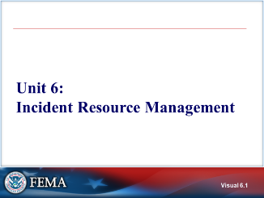 Visual 6.1 | UNIT 6: INCIDENT RESOURCE MANAGEMENT  This unit will cover the resource management process during an incident which includes standard methods to identify, order, mobilize, and track resources.
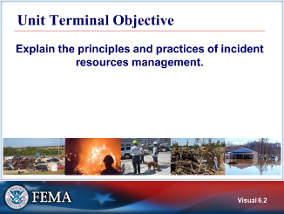  Visual 6.2 | UNIT TERMINAL OBJECTIVE  Explain the principles and practices of incident resources management.
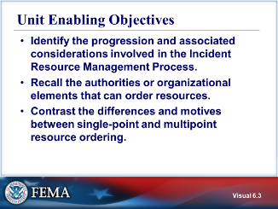  Visual 6.3 | UNIT ENABLING OBJECTIVES  - Identify the progression and associated considerations involved in the Incident Resource Management Process.  - Recall the authorities or organizational elements that can order resources.  - Contrast the differences and motives between single-point and multipoint resource ordering.
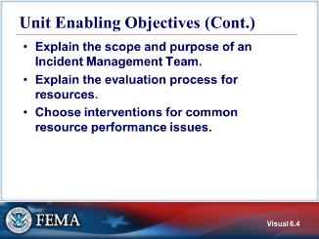  Visual 6.4 | UNIT ENABLING OBJECTIVES (CONT.)  - Explain the scope and purpose of an Incident Management Team.  - Explain the evaluation process for resources.  - Choose interventions for common resource performance issues.
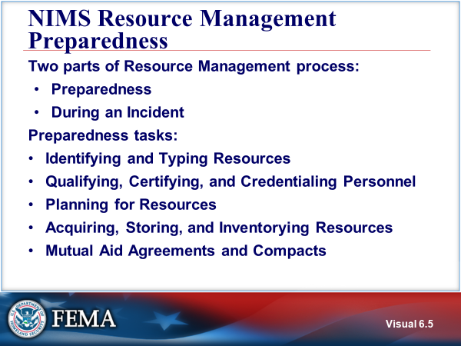  Visual 6.5 | NIMS RESOURCE MANAGEMENT preparedness  The resource management process can be separated into the following two parts:  - Preparedness: The preparedness activities (resource typing, credentialing, and inventory) are conducted on a continual basis to help ensure that resources are ready to be mobilized when called to an incident.  - During an Incident: Resource management during an incident is a finite process with a distinct beginning and ending specific to the needs of the particular incident.  The resource management tasks for preparedness.  Resource management preparedness involves those activities conducted prior to an incident response. This includes identifying and typing resources; qualifying, certifying, and credentialing personnel; planning for resources; and acquiring, storing, and inventorying resources.  The National Incident Management System (NIMS) includes the following preparedness tasks related to resource management:  - Identifying and Typing Resources  Resource typing is defining and categorizing incident resources by capability. Resource typing definitions establish a common language for discussing resources by defining minimum capabilities for personnel, teams, facilities, equipment, and supplies. Resource typing enables communities to plan for, request, and have confidence that the resources they receive have the capabilities they requested.  - Qualifying, Certifying, and Credentialing Personnel  Qualifying, certifying, and credentialing are the essential steps, led by an AHJ, that help ensure that personnel deploying through mutual aid agreements have the knowledge, experience, training, and capability to perform the duties of their assigned roles. These steps help to ensure that personnel across the Nation are prepared to perform their incident responsibilities based on criteria that are standard nationwide.  Qualification is the process through which personnel meet the minimum established criteria—training, experience, physical and medical fitness, and capability—to fill specific positions.  Certification/Recertification is the recognition from the AHJ or a third party stating that an individual has met and continues to meet established criteria and is qualified for a specific position.  The National Qualification System (NQS) provides the tools for jurisdictions and organizations to share resources seamlessly. Using the NQS approach to qualify, certify, and credential incident management and support personnel ensures personnel deploying through mutual aid agreements and compacts have the capabilities to perform the duties of their assigned roles.  The NIMS Guideline for the National Qualification System and all NQS Job Title/ Position Qualifications and Position Task Books can be found here: https://www.fema.gov/national-qualification-system.  - Planning for Resources  Jurisdictions and organizations work together before incidents occur to develop plans for identifying, managing, estimating, allocating, ordering, deploying, and demobilizing resources. The incident action planning process includes identifying resource requirements based on the threats to, and vulnerabilities of, the jurisdiction or organization. Planning also includes developing alternative strategies to obtain needed resources. Resource management personnel should consider resources necessary to support all mission areas (Prevention, Protection, Mitigation, Response, and Recovery).  Note: The National Preparedness Goal and the five National Planning Frameworks describe the mission areas in greater detail.  - Acquiring, Storing, and Inventorying Resources  Organizations acquire, store, and inventory resources for day-to-day operations, as well as additional resources that the organization has stockpiled for incidents. Those with resource management responsibilities should plan for periodic replenishments, preventive maintenance, and capital improvements. They should also plan for any ancillary support, supplies, or space that may be needed for large or complex resources. Effective resource management involves establishing a resource inventory and maintaining the currency and accuracy of the information. While a resource inventory can be as simple as a paper spreadsheet, many resource managers use information technology (IT)-based inventory systems to track the status of resources and maintain an accurate list of available resources. Accurate resource inventories not only enable organizations to resource incidents promptly, but also to support day-to-day resource management activities such as reconciliation, accounting, and auditing.  - Mutual Aid Agreements and Compacts  Mutual aid agreements establish the legal basis for two or more entities to share resources. Mutual aid agreements exist in various forms among and between all levels of government. These agreements support effective and efficient resource management. Mutual aid agreements may authorize mutual aid between two or more neighboring communities, among all jurisdictions within a state, between states, between Federal agencies, and/or internationally. Mutual aid also exists through formal and informal arrangements developed by tribal governments, NGOs, and in various forms within the private sector.  FEMA has published a NIMS Guideline for Mutual Aid available at: https://www.fema.gov/national-qualification-system
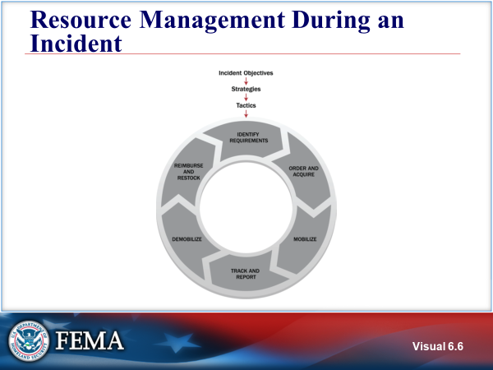  Visual 6.6 | RESOURCE MANAGEMENT during an incident  Incident resource management includes standardized procedures, methodologies, and functions. The following are the six primary tasks of resource management during an incident:  - Identify Requirements  - Order and Acquire  - Mobilize  - Track and Report  - Demobilize  - Reimburse and Restock
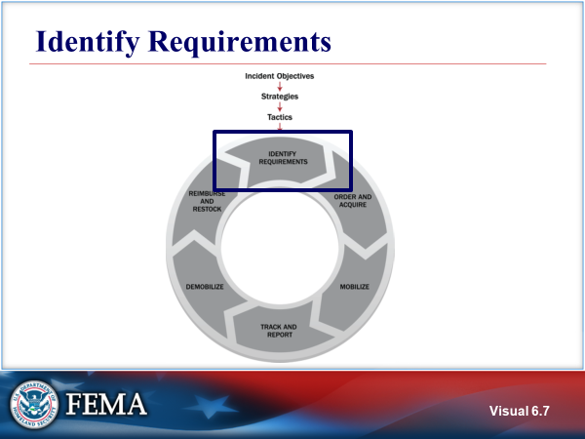  Visual 6.7 | IDENTIFY REQUIREMENTS  During an incident, personnel continually identify, validate, and refine resource needs. This process involves identifying the type and quantity of resources needed, the location where resources should be sent, and who will receive and use the resources.  When an incident occurs, those with resource management responsibilities should continually identify, refine, and validate resource requirements. This process involves accurately identifying:  - What and how much is needed,  - Where and when it is needed, and  - Who will be receiving or using it.
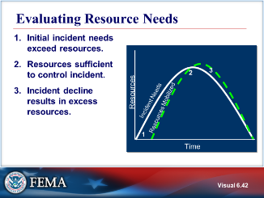  Visual 6.8 | EVALUATING RESOURCE NEEDS  On most incidents, resource needs follow a predictable arc that corresponds to the arc followed by the incident itself.
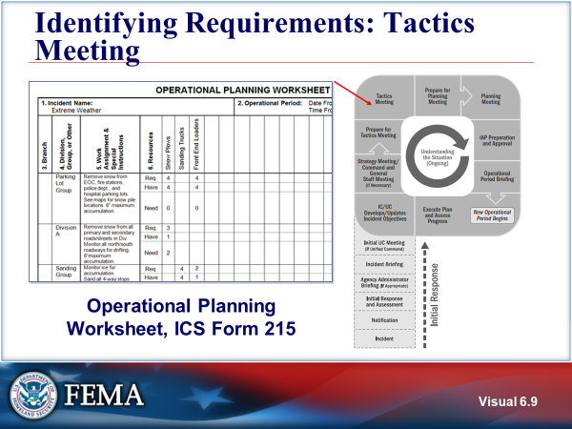  Visual 6.9 | IDENTIFYING REQUIREMENTS: TACTICS MEETING  The Operational Planning Worksheet, ICS Form 215, identifies the resources needed to achieve the incident objectives and tactics. It documents the results from the Tactics Meeting and serves the following functions:  - Assists in establishing requirements (resource needs) for an Operational Period.  - Communicates the decisions made during the Tactics Meeting.  - Provides information that is used for ordering resources for the incident.
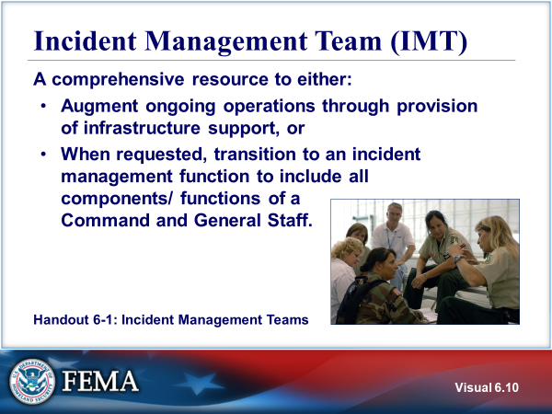  Visual 6.10 | Incident Management Team (IMT)  One specific resource that may be identified as a requirement for a complex incident is an IMT.  An Incident Management Team (IMT) is a rostered group of ICS-qualified personnel, consisting of an Incident Commander, other incident leadership, and personnel qualified for other key ICS positions. IMTs exist at local, regional, state, tribal, and national levels and have formal notification, deployment, and operational procedures in place.  These teams are typed based on team members’ qualifications and may be assigned to manage incidents or to accomplish supporting incident-related tasks or functions. When assigned to manage an incident or to support an incident-related task or function, IMTs are typically delegated the authority to act on behalf of the affected jurisdiction or organization.  A delegation of authority is a statement that the authorized jurisdiction/organization official provides to make such delegations to the Incident Commander. It assigns the Incident Commander specific responsibilities and authorities. The delegation of authority typically describes priorities, expectations, constraints, and other considerations or guidelines. Many agencies require the delegating authority to provide a written delegation of authority to the Incident Commander before the Incident Commander may assume command:  - Provide subject-matter expertise to advise operations and support during the incident, or  - Augment ongoing operations through supporting incident-related tasks or functions, or  - The IMT may be directed to transition to an incident management function. This includes filling all primary functions of a Command and General Staff.  The key aspects of IMTs:  - Include Command and General Staff members and support personnel.  - Pre-designated roles and responsibilities.  - Rostered and on-call (Types 1-4).  - Identified and able to be contacted (Type 5).  - Typed based on capability, the level of training and experience, and reasonably anticipated incident response requirements.  - Delegated statutory authority and/or formal response requirements and responsibilities.  - Available 24/7/365.  Refer to Handout 6-1: Incident Management Teams.
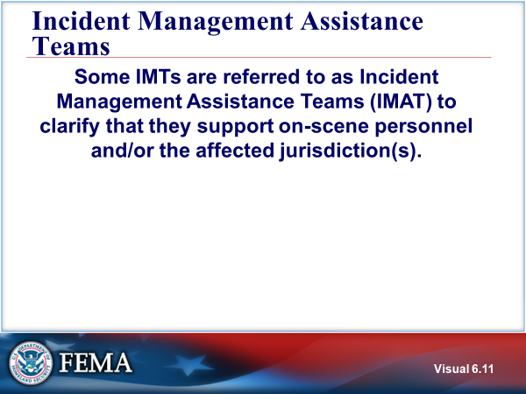  Visual 6.11 | incident management assistance teams  Some IMTs are referred to as Incident Management Assistance Teams (IMAT) to clarify that they support on-scene personnel and/or the affected jurisdiction(s).  IMATs may have command and control over certain aspects of response and recovery efforts (e.g., the use of state/Federal assets). Through participation in a Unified Command with representatives from local, state, and/or tribal government, they ensure that activities align with local priorities. IMATs exist at various levels of government and within the private sector. Regardless of who owns IMATs or their specific missions, IMATs operate using the principles and practices of ICS.
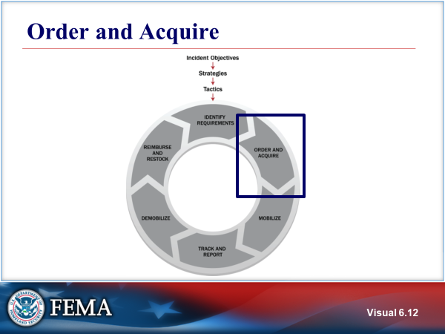  Visual 6.12 | ORDER AND ACQUIRE  Both incident and EOC staff make initial and ongoing assessments of resource requirements and either activate or request those resources. Incident personnel can order additional resources by executing contracts, implementing mutual aid agreements, or requesting assistance from another level of government (e.g., a local government to a state, or a state to the Federal Government).  Usually, all incidents will have an initial commitment of resources assigned. Resources can include key supervisory personnel (incident management) and personnel and equipment assigned as tactical resources.
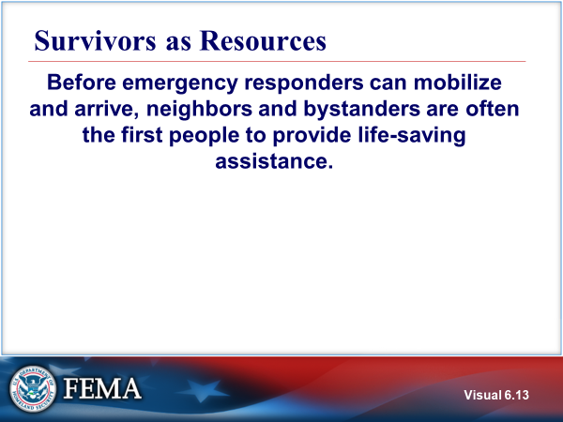  Visual 6.13 | survivors as resources  The natural desire to help does not disappear once responders arrive on the scene. Incident management personnel should anticipate this and have plans to use these volunteers’ capabilities safely and effectively.
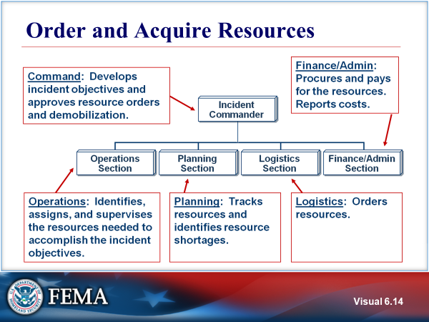  Visual 6.14 | ORDER AND ACQUIRE Resources  Resource ordering activities of the incident command organization include the following:  - Command develops incident objectives and approves resource orders and demobilization.  - Operations identifies, assigns, and supervises the resources needed to accomplish the incident objectives.  - Planning tracks resources and identifies resource shortages.  - Logistics orders resources.  - Finance and Administration procures and pays for the resources and reports costs.  This is the process for ordering resources that perform tactical operations. Planning, Logistics, and Finance can order non-operational resources for their respective sections.
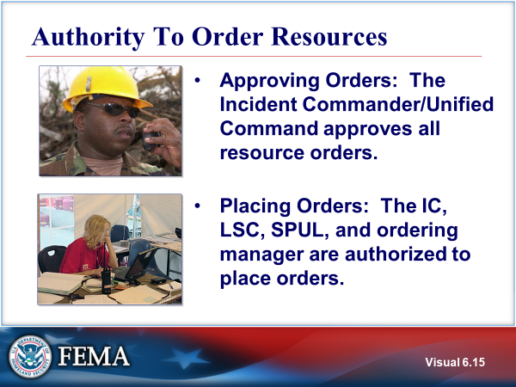  Visual 6.15 | AUTHORITY TO ORDER RESOURCES  Final approval for ordering additional resources, as well as releasing resources from an incident, is the responsibility of the Incident Commander/ Unified Command.  If the incident organization is small and General Staff positions have not been filled, then the Incident Commander will personally request the additional resources from the agency dispatch/ordering center.  Ordinarily, it is not efficient use of the Incident Commander/Unified Command’s time to review and approve all resource orders for routine supplies (e.g., food) on a major incident. The Incident Commander may delegate approval of certain orders while reviewing and approving any nonroutine requests, especially if they are expensive, require outside agency participation, or have potential political ramifications.  If the Logistics Section Chief (LSC) position has been filled, then the Logistics Section Chief has the delegated authority to place the resource order after the order has been approved by the Incident Commander or his/her designee.  On larger incidents, where the Logistics Section contains a Supply Unit, the Supply Unit Leader (SPUL) has the authority to place the approved resource order. Also the ordering manager has authority to place orders.
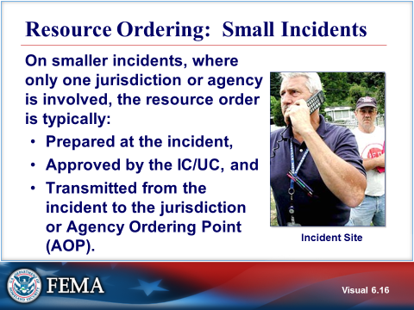  Visual 6.16 | RESOURCE ORDERING: SMALL INCIDENTS  During smaller incidents, where only one jurisdiction or agency is primarily involved, the resource order is typically prepared at the incident, approved by the Incident Commander/Unified Command, and transmitted from the incident to the jurisdiction or Agency Ordering Point (AOP). Resource ordering can be accomplished by:  - Single-point resource ordering.  - Multipoint resource ordering.
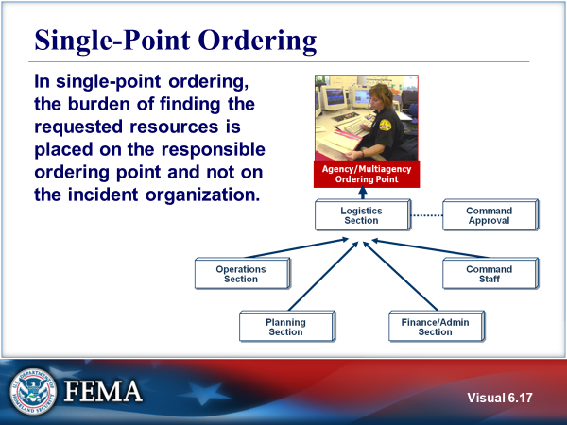  Visual 6.17 | SINGLE-POINT ORDERING  Single-point resource ordering (i.e., ordering all resources through one dispatch/emergency operations center or other multiagency coordination entity) is usually the preferred method. However, single-point resource ordering may not be feasible when:  - The dispatch/emergency operations center becomes overloaded with other activity and is unable to handle new requests in a timely manner.  - Assisting agencies at the incident have policies that require all resource orders be made through their respective dispatch/emergency operations center.  - Special situations relating to the order may necessitate that personnel at the incident discuss the details of the request directly with an offsite agency or private-sector provider.
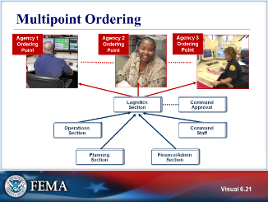  Visual 6.18 | MULTIPOINT ORDERING  Multipoint ordering is when the incident orders resources from several different ordering points. This can include orders from voluntary organizations and the private sector.  Voluntary organizations, such as the American Red Cross or Medical Reserve Corps, also mobilize and provide valuable assistance before, during, and after incidents. These groups provide a structure to integrate volunteers into incident activities. They also frequently have established relationships with the community, provide assistance that governmental organizations cannot, and support requests through formal resource-ordering processes.  - Multipoint ordering is used when:  - A certain kind of resource must be directly ordered through the owner agency or supplier (which may not be the home agency). For example, hazardous materials situations may require specialized private-sector cleanup equipment.  - Agency policy requires the direct ordering process.  - Most of the requested resources are not from agencies or organizations within the jurisdiction, and it is more convenient or effective to deal with resource providers directly from the incident.  - Multipoint ordering places a heavier load on incident personnel by requiring them to place orders through two or more ordering points. This method of ordering also requires coordination between and among ordering points, and increases the chances of lost or duplicated orders. An EOC may assist the resource ordering process. Advantages of involving the EOC include:  - A wider range of sources can be accessed.  - Priorities can be established, especially in large-scale incidents that have multiple Incident Command Posts.  - On-scene personnel can focus better on the response issues at hand.
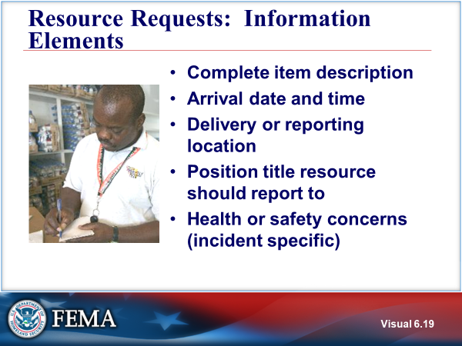  Visual 6.19 | RESOURCE requests: INFORMATION ELEMENTS  Organizations that request resources should provide enough detail to ensure that those receiving the request understand what is needed. Using NIMS resource names and types helps ensure that requests are clearly communicated and understood.
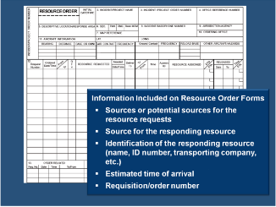  Visual 6.20 | RESOURCE requests: INFORMATION ELEMENTS (CONT.)  On more complex incidents, resource order forms may be used. In most jurisdictions there is an established format for resource requests. For the purposes of this course, a sample Form 213RR Resource Request Message is included. Note: this form is not included in the NIMS ICS Forms List, but is included in these course materials.  The following information is typically included on resource order forms:  - Source for the resource request  - Source for the responding resource  - Description of resource  - Approval by the requesting agency  - Estimated time of arrival and reporting location  - Resource request order number
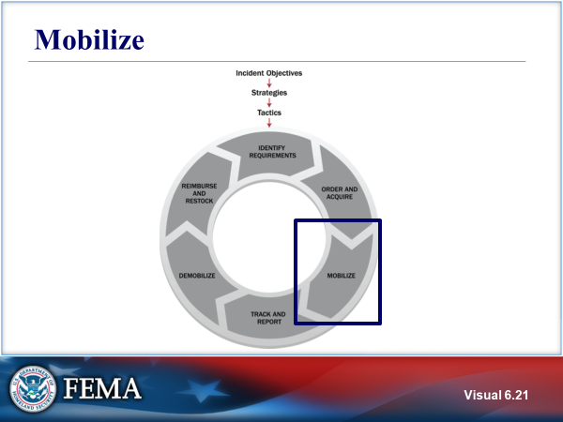  Visual 6.21 | MOBILIZE  Personnel and other resources begin mobilizing when notified by the requesting jurisdiction or by an intermediary acting on its behalf, such as the state Emergency Management Assistance Compact (EMAC) coordinator. At the time of notification, deploying personnel should be notified regarding:  - Date, time, and place of departure.  - Mode of transportation to the incident.  - Estimated date and time of arrival, reporting location (address, contact name, and phone number), and anticipated incident assignment.  - Reporting location (address, position title, and phone number or radio frequency).  - Anticipated incident assignment.  - Anticipated duration of deployment.  - Resource request number, incident number  - Applicable cost and funding codes.  The resource tracking and mobilization processes are directly linked.  Resource tracking occurs during an incident and includes the number and status of resources assigned to an incident, the organizational element to which they are assigned, and their progress against applicable work/rest ratios. Incident needs drive the numbers and types of resources tracked.  - The Logistics Section staff track resources that have been ordered but have not yet arrived at the incident.  - The Resources Unit tracks resources assigned to an incident.
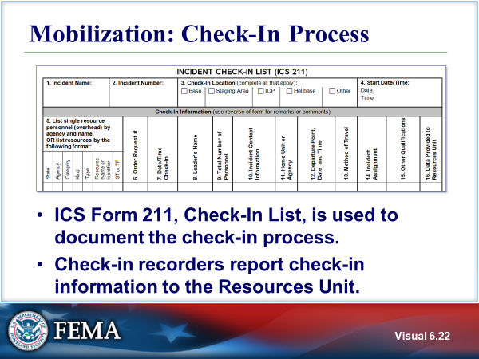  Visual 6.22 | mobilization: CHECK-IN PROCESS  The ICS Form 211, Incident Check-in List, is used for resource check-in. A Check-In Recorder will be assigned to each location where resources will check in. Check-In Recorders must have an adequate supply of check-in forms and be briefed on the frequency for reporting check-in information to the Resources Unit.  Limiting the number of check-in locations will greatly increase the reliability of resource information on the incident, thus improving future planning efforts.  Some organizations may use a system other than the ICS form 211 for check in. For example, some organizations use automated check in using scanners that record information from a Personal Identity Verification (PIV) card into a personnel database.  Refer to Handout 6-3: ICS Form 211.
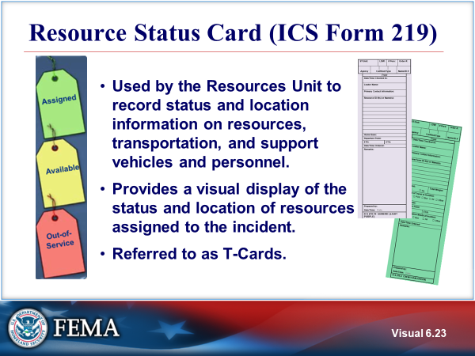  Visual 6.23 | Resource status card (ICS Form 219)  Resource Status Cards (ICS Form 219) are also known as “T-Cards,” and are used by the Resources Unit to record status and location information on resources, transportation, and support vehicles and personnel.  Information to be placed on the cards may be obtained from the Incident Check-In List (ICS Form 211).  T cards provide a visual display of the status and location of resources assigned to the incident:  - Assigned – Currently working on scene.  - Available – Ready for immediate assignment and has been issued all required equipment. Has completed check-in and has been briefed.  - Out of Service – Not available or ready to be assigned (e.g., maintenance issues, rest periods).
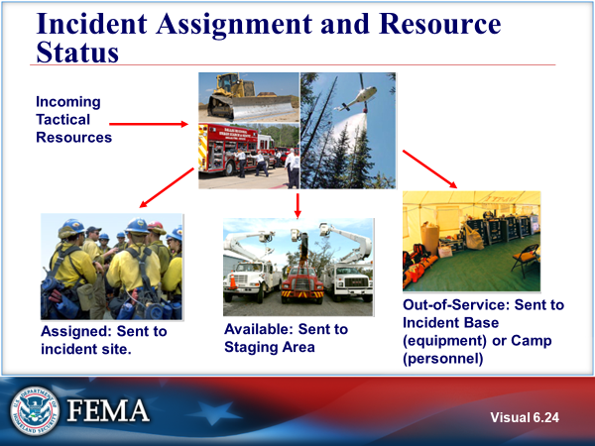  Visual 6.24 | incident ASSIGNMENT and resource status  Incident Assignment on the ICS Form 211 and Resource Status on the ICS Form 219 are based on where Tactical Resources are assigned.
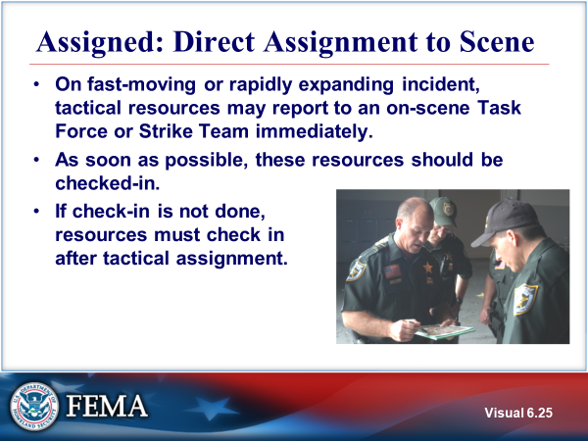  Visual 6.25 | Assigned: DIRECT ASSIGNMENT TO scene  The key is that every resource participating in the response must be tracked.  A Strike Team composed of Law Enforcement may be called a Resource team.
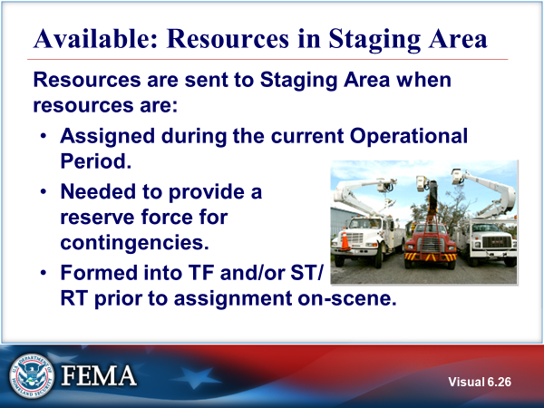  Visual 6.26 | available: resources in staging area  Incoming tactical resources are normally first assigned to Staging Areas prior to receiving their tactical assignments.  Staging Areas: The Operations Section Chief may establish staging areas to position and track for resources. A staging area can be any location in which personnel, supplies, and equipment await assignment. Staging areas may include temporary feeding, fueling, and sanitation services. The Operations Section Chief assigns a manager for each staging area who logs in all incoming resources, dispatches resources at a section chief’s request, and requests Logistics Section support, as necessary, for resources at the staging area.  As part of the planning process, the Operations Section Chief will decide quantity, kind, and type of resources to be kept in Staging Areas. These decisions are based on creating adequate reserves to meet expected contingencies.  The number of resources in a Staging Area can change dramatically during an Operational Period. It can be, and often is, a dynamic and fluid situation, with resources leaving the Staging Area for active assignments and new resources arriving.  The Staging Area Manager must maintain the status of resources in the Staging Area and inform the Operations Section Chief when minimum levels of resources are about to be reached.  The Operations Section Chief may delegate authority to the Staging Area Manager for placing additional resource orders to maintain minimum levels.
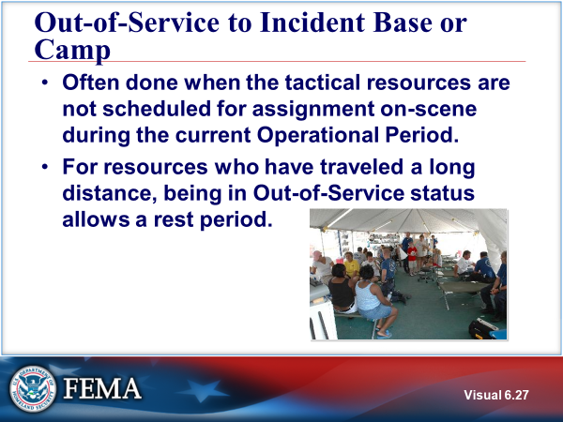  Visual 6.27 | out-of-service TO Incident BASE OR CAMP  Out-of-Service to the incident Base or Camp location is often done when the tactical resources are not scheduled for assignment on-scene during the current Operational Period.  For resources who have traveled long distance, the assignment to the Incident Base or Camps in an out-of-service status allows for a rest period prior to taking on an active assignment in the next Operational Period.  Personnel resources ordered to fill specific organizational assignments will report to their designated check-in location, which will usually be the Resources Unit at the Incident Command Post, the Incident Base, or another designated facility.  Tactical resources are not assigned to a Incident Base or to a Camp. Out-of-Service equipment may be sent to a Incident Base. Out-of-Service personnel may be sent to a Camp.
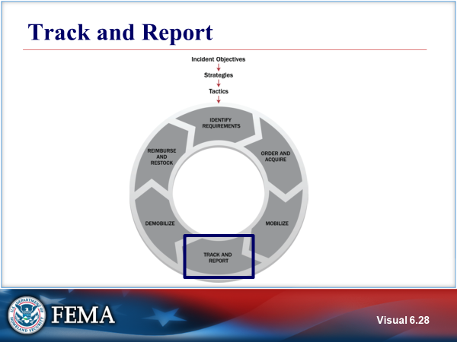  Visual 6.28 | track and report  Incident managers use established procedures to track resources from mobilization through demobilization. Resource tracking occurs prior to, during, and after an incident. This process helps staff prepare to receive and use resources; tracks resource location; facilitates the safety and security of personnel, equipment, teams, and facilities; and enables effective resource coordination and movement.
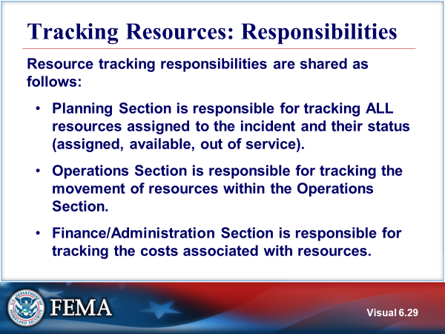  Visual 6.29 | TRACKING RESOURCES: RESPONSIBILITIES  The Logistics Section staff track resources that have been ordered but have not yet arrived at the incident. The Resources Unit tracks resources assigned to an incident.
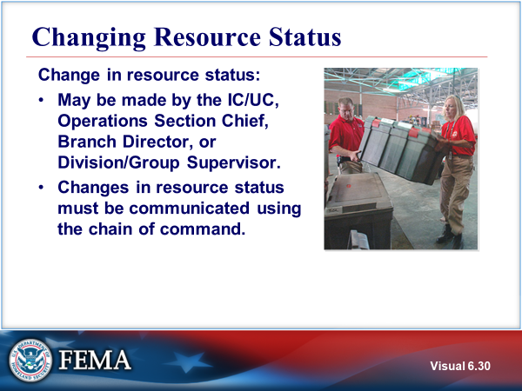  Visual 6.30 | changing RESOURCES STATUS  This is the NIMS characteristics of chain of command and unity of command. This communication of resource status enables situational awareness and decision support.
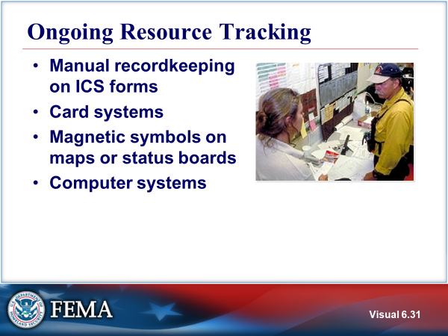  Visual 6.31 | Ongoing RESOURCE tracking  - Manual Recordkeeping on Forms. ICS forms can be used for resource tracking: ICS Form 201, ICS Form 211, and ICS Form 204.  - Card Systems. Several versions are available. One of these systems has different colored T-shaped cards for each kind of resource ICS Form 219-1 through 10 Resource Status Cards.  - Magnetic Symbols on Maps or Status Boards. Symbols can be prepared and placed on maps or boards indicating incident locations.  - Computer Systems. A laptop computer can be used to maintain information on resources.
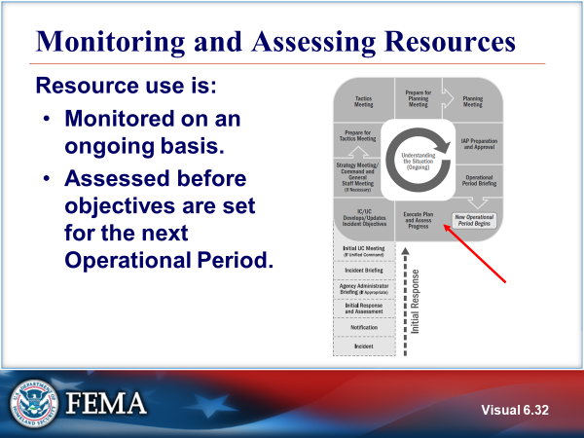  Visual 6.32 | MONITORING AND ASSESSING RESOURCES  The Planning “P” is used to illustrate the operational period planning cycle. Resource use is:  - Monitored on an ongoing basis.  - Assessed before objectives are set for the next Operational Period.
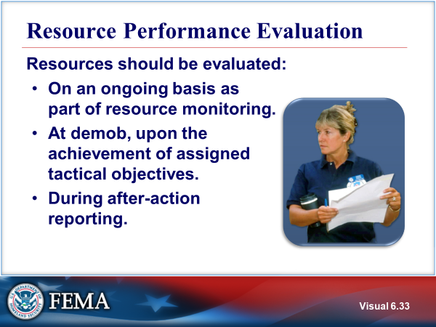  Visual 6.33 | RESOURCE performance EVALUATION  Evaluation of resource performance involves monitoring, evaluating, and adjusting the performance of the organization and its components to ensure that all efforts are directed toward achieving the specified objectives.
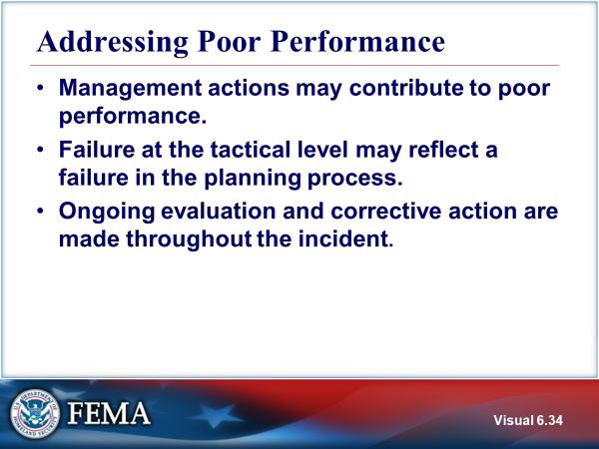  Visual 6.34 | Addressing POOR PERFORMANCE  Understand that management actions may have contributed to the poor performance. Management actions that may cause poor performance include the following:  - Incident objectives, strategies, or tactics are unrealistic or poorly defined.  - The wrong resource was allocated for the assignment.  - There are inadequate tactical resources, logistical support, or communications.  - The resource is not trained or properly equipped for the assignment.  - Conflicting agency policies or procedures prevent the resource from carrying out the assignment.
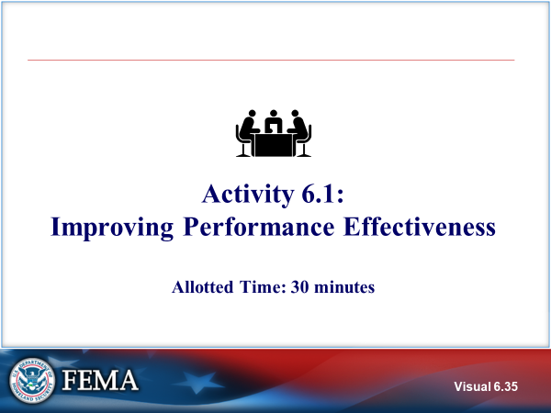  Visual 6.35 | ACTIVITY 6.1: IMPROVING PERFORMANCE EFFECTIVENESS  The instructor will explain Activity 6.1.  You will have 30 minutes for activity completion (15 minutes for group work and 15 minutes for collaborated discussion).
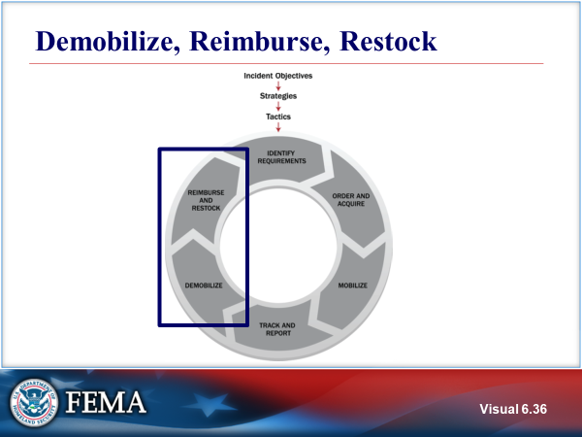  Visual 6.36 | DEMOBILIZE, REIMBURSE, restock  The goal of demobilization is the orderly, safe, and efficient return of a resource to its original location and status. Once resources are no longer needed on an incident, those responsible for resources should demobilize them. The resource requestor and provider may agree to reassign a resource rather than demobilize it. Prior to demobilization, incident staff responsible for the planning and logistics functions collaborate to plan how resources are rehabilitated, replenished, disposed of, and/or returned or restored to operational condition.  Reimbursement includes the payment of expenses incurred by resource providers for specific activities. Reimbursement processes are important for establishing and maintaining resource readiness and establishing the means to pay providers in a timely manner. Processes include mechanisms for collecting bills, validating costs against the scope of the work, replacing or repairing damaged equipment, and accessing reimbursement programs. Reimbursement procedures are often specified in mutual aid and assistance agreements.  Restocking is returning inventories to a predetermined minimum level.
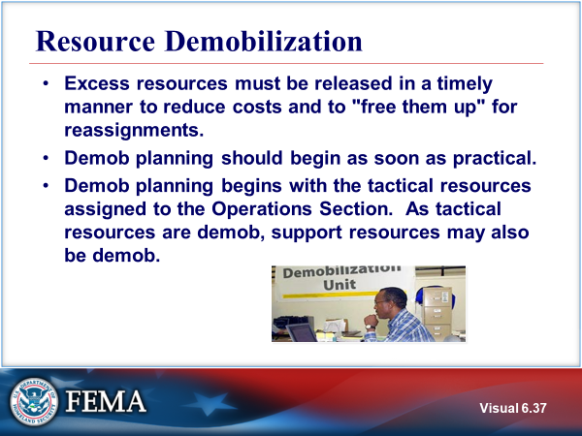  Visual 6.37 | RESOURCE DEMOBILIZATION  Excess resources must be released in a timely manner to reduce incident-related costs and to "free up" resources for other assignments.  The planning for demobilization should begin in the very early stages of the incident and certainly well in advance of when demobilization actually takes place.  The process of demobilizing resources begins at the Operations Section level, where the need for continued tactical resources will be determined.  When tactical resources are no longer needed, other support resources may also be demobilized.
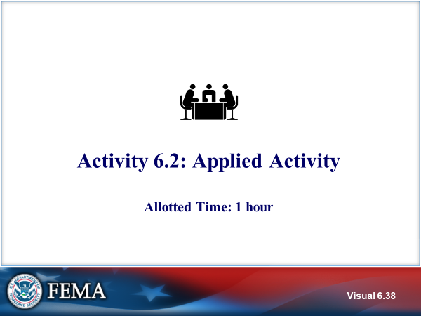  Visual 6.38 | Activity 6.2: APPLIED ACTIVITY  The instructor will explain Applied Activity 6.2.  You will have 30 minutes to complete the activity with an instructor-facilitated 30-minute debrief.  Refer to Unit 6 of the Applied Activity Materials document.
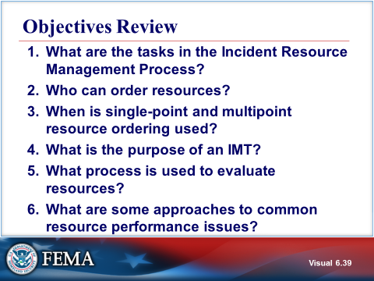  Visual 6.39 | OBJECTIVES REVIEW  Unit Enabling Objectives  - Identify the progression and associated considerations involved in the Incident Resource Management Process.  - Recall the authorities or organizational elements that can order resources.  - Contrast the differences and motives between single-point and multipoint resource ordering.  - Explain the scope and purpose of an Incident Management Team.  - Explain the evaluation process for resources.  - Choose interventions for common resource performance issues.

  - Supplemental Materials

This page intentionally left blank.

Handout 6-1: Incident Management Teams

Basic IMT Functions
Deployment | - Mobilization  - Staff roster  - Personnel accountability  - Coordination with other units  - Matching team to incident needs  - Self-sufficiency for appropriate time period
Transfer of Command | - Jurisdiction established  - Coordination with local agencies  - Ongoing communication with local agencies  - Delegation of authority
Coordination of  On-Scene Operations | - Management and coordination of efforts  - Procedures for assigned functional areas  - Development and modification of an Incident Action Plan (IAP)  - Oversight of the incident action planning process
Demobilization | - Demobilization requirements  - Personnel accountability  - Coordination with other units  - Returning resources to service
Documentation | - Incident files  - Financial claims  - Workers compensation issues  - Human resource, labor, and legal issues

Additional information on All Hazards IMTs can be found on the USFA website https://www.usfa.fema.gov/training/imt

This page intentionally left blank.

Handout 6-2: ICS Form 211

Refer to the Appendix for sample form.

This page intentionally left blank.

Activity 6.1: Improving Performance Effectiveness

Instructions:
- Working as a group, ask the students to review their assigned problem statement.
- Answer the following questions:
- What is the cause of the performance problem?
- Who in the Command and General Staff need to address the problem?
- What are some strategies for preventing or solving this problem?
- Select a spokesperson and be prepared to present your work in 15 minutes.

This page intentionally left blank.

Activity 6.1 Performance Issues

On a recent incident, the following performance issues have arisen.

Performance Issue #1: A local volunteer organization has personnel assigned to the Logistics Section to assist in providing meals to responders. One volunteer arrived for work visibly impaired, and informed his coworkers that he had “just a couple of drinks to relax” before coming to work.

Answer the following questions:
- What is the cause of the performance problem?
- Who in the Command and General Staff need to address the problem?
- What are some strategies for preventing or solving this problem?

This page intentionally left blank.

Performance Issue #2: Resource tracking is poor. Check-In Recorders are providing incomplete or inaccurate information from responding resources. Some resources have evidently responded, worked, and gone home without ever having checked in. Additionally, resources obtained through a mutual aid agreement that are no longer needed remain at the incident site.

Answer the following questions:
- What is the cause of the performance problem?
- Who in the Command and General Staff need to address the problem?
- What are some strategies for preventing or solving this problem?

This page intentionally left blank.

Performance Issue #3: Evacuation Division B is using non-uniformed personnel to deliver evacuation instructions door-to-door within the community. Compliance with the evacuation order is very poor, and 911 has been deluged with calls from the affected public asking if the evacuation order is official.

Answer the following questions:
- What is the cause of the performance problem?
- Who in the Command and General Staff need to address the problem?
- What are some strategies for preventing or solving this problem?

This page intentionally left blank.

Performance Issue #4: A police officer at a traffic control point was struck by a motorist and received minor injuries. She was taken to the hospital by a witness to the accident, treated, and released. The first that incident management staff hear of the problem is when asked by the media at a press conference.

Answer the following questions:
- What is the cause of the performance problem?
- Who in the Command and General Staff need to address the problem?
- What are some strategies for preventing or solving this problem?

This page intentionally left blank.

Performance Issue #5: Self-dispatched resources are arriving at the Staging Area. In the confusion, several of these resources who were assigned to Task Forces now appear to lack the skills needed to operate equipment or execute orders.

Answer the following questions:
- What is the cause of the performance problem?
- Who in the Command and General Staff need to address the problem?
- What are some strategies for preventing or solving this problem?

This page intentionally left blank.

Performance Issue #6: The 5 o’clock news features a prominent interview with an incident responder at the Staging Area. The responder is not a member of the Public Information staff and has not been given an active assignment (or even seen the actual scene of the train wreck), but is waxing eloquently about how poorly the incident is being managed.

Answer the following questions:
- What is the cause of the performance problem?
- Who in the Command and General Staff need to address the problem?
- What are some strategies for preventing or solving this problem?

This page intentionally left blank.

Unit 7: Demobilization, Transfer of Command, Closeout, and Transition to Recovery
Student Manual

This page intentionally left blank.

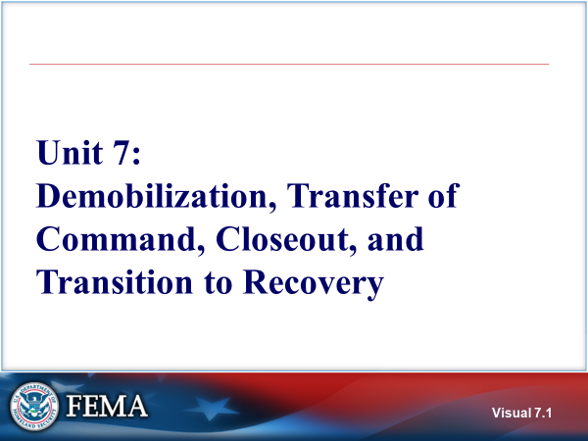 Visual 7.1 | UNIT 7: DEMOBILIZATION, TRANSFER OF COMMAND, CLOSEOUT, and Transition to Recovery
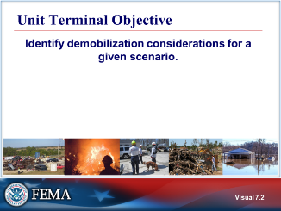  Visual 7.2 | UNIT TERMINAL OBJECTIVE  Identify demobilization considerations for a given scenario.
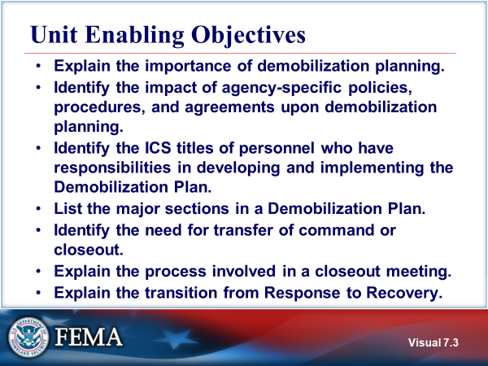  Visual 7.3 | UNIT ENABLING OBJECTIVES  - Explain the importance of demobilization planning.  - Identify the impact of agency-specific policies, procedures, and agreements upon demobilization planning.  - Identify the ICS titles of personnel who have responsibilities in developing and implementing the Demobilization Plan.  - List the major sections in a Demobilization Plan.  - Identify the need for transfer of command or closeout.  - Explain the process involved in a closeout meeting.  - Explain the transition from Response to Recovery.  The Final Exam is based on the Unit Enabling Objectives.
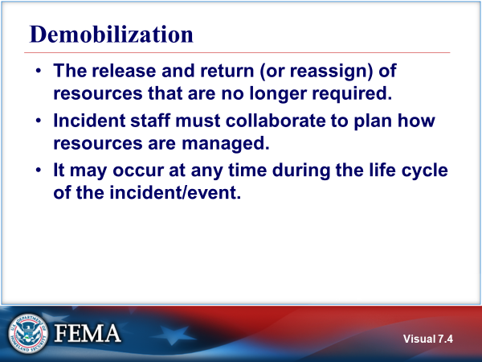  Visual 7.4 | DEMOBILIZATION  The goal of demobilization is the orderly, safe, and efficient release and return of an incident resource to its original location and status. Once resources are no longer needed on an incident, those responsible for resources should demobilize them. The resource requestor and provider may agree to reassign a resource rather than demobilize it.
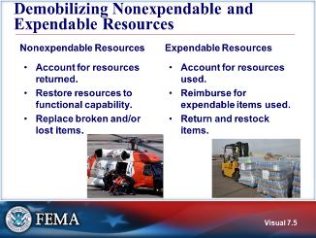  Visual 7.5 | DEMOBILIZing NONEXPENDABLE AND EXPENDABLE RESOURCES  Nonexpendable Resources: These resources (such as people, fire engines, and other durable equipment) are fully accounted for during the incident and again when they are returned to the organization that issued them. The issuing organization then restores the resources to fully functional capability and readies them for the next mobilization. Broken and/or lost items should be replaced through the appropriate resupply process, by the organization with invoicing responsibility for the incident, or as defined in pre-incident agreements.  It is critical that fixed facility resources also be restored to their full functional capability in order to ensure readiness for the next mobilization. In the case of human resources, such as Incident Management Teams, adequate rest and recuperation time and facilities should be provided. Important occupational health and mental health issues should also be addressed, including monitoring how such incidents affect emergency management/response personnel over time.  Expendable Resources: Expendable resources (such as water, food, fuel, and other one-time-use supplies) must be fully accounted for. The incident management organization bears the costs of expendable resources, as authorized in financial agreements executed by preparedness organizations.  Restocking normally occurs at the point from which a resource was issued. Waste management is of special note in the process of demobilizing resources. Resources that require special handling and disposition are handled according to established regulations and policies. These hazardous materials include hazardous waste, biological waste and contaminated supplies, debris, and equipment.  Reimbursement processes include mechanisms for collecting bills, validating costs against the scope of the work, replacing or repairing damaged equipment, and accessing reimbursement programs.
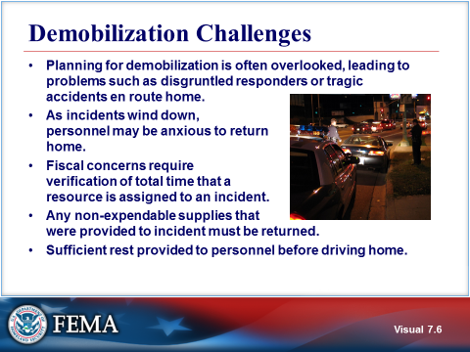  Visual 7.6 | DEMOBILIZATION CHALLENGES  - Planning for demobilization may be overlooked until the response operation has ended. This can cause hasty, incomplete planning and may contribute to problems such as disgruntled responders or tragic accidents en route home.  - As incidents wind down, personnel may be anxious to return home.  - Fiscal concerns require verification of the total time that a resource is assigned to an incident. It is difficult to collect this information once a resource is released.  - Any nonexpendable supplies that were provided to the incident must be returned.  - Sufficient rest should be provided to personnel before driving home.
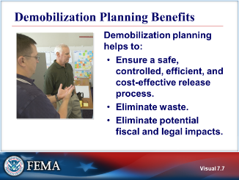  Visual 7.7 | DEMOBILIZATION PLANNING BENEFITS  Demobilization planning helps to:  - Ensure a controlled, safe, efficient, and cost-effective release process.  - Eliminate waste.  - Eliminate potential fiscal and legal impacts.
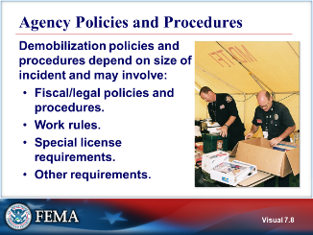  Visual 7.8 | AGENCY POLICIES AND PROCEDURES  On less complex incidents, resources are released to finish shifts or work periods. Because there is minimal staff, demobilization planning rests with the Incident Commander and be conducted IAW established agency protocols.  For more complex incidents, resources may have worked in excess of agreed-upon work schedules or have traveled well out of their jurisdiction. The Finance/Administration Section will require documentation prior to outside agencies departing the incident.  In some cases, a priority of release may be necessary if all resources cannot be processed for release at the same general time. Agency policy or work rules will impact this priority. Local, regional, or national concerns can affect release priorities for incident resources.  Agency policies, procedures, and agreements must be considered by the incident management prior to releasing resources. For example, if the drivers of large vehicles carry special licenses (commercial rating, for example), they are affected by State and Federal regulations for the amount of rest required before a driver can get back on the road.  Some agencies require that vehicles get inspected by incident personnel for damage caused by use on the incident and that damage claims be properly documented.  If an injury occurred while on the incident, worker’s compensation laws apply and documentation must be completed in a timely manner. Compensation and Claims Unit staff typically maintain files on injuries and illnesses associated with the incident and obtain written witness statements.
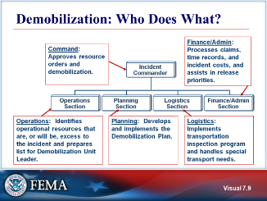  Visual 7.9 | Demobilization: WHO DOES WHAT?  Demobilization is not just an Operations function; all ICS functions should evaluate staffing needs and demobilize excess personnel.  The primary roles of the Incident Commander and the Sections in demobilization planning:  - Incident Commander: Approves resource orders and demobilization.  - Operations Section: Identifies operational resources that are, or will be, excess to the incident and prepares list for Demobilization Unit Leader.  - Planning Section: Develops and implements the Demobilization Plan.  - Logistics Section: Implements transportation inspection program and handles special transport needs.  - Finance/Administration Section: Processes claims, time records, and incident costs, and assists in release priorities.
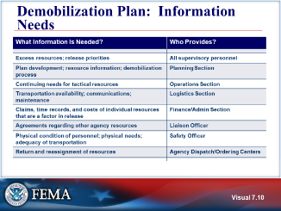  Visual 7.10 | DEMOBILIZATION PLAN: INFORMATION NEEDS  - All supervisory personnel: Identify excess resources and provide list and priorities to the Demobilization Unit.  - Planning Section: Coordinate the development of the Demobilization Plan. The Demobilization Unit Leader develops the specific, individual plan document and outline of the process. The Resources Unit Leader assists the Demobilization Unit Leader in determining total resources assigned, home units, length of assignment, and travel needs.  - Operations Section: Identifies continuing needs for operational resources and those that are, or will be, excess to the incident, and prepares the list for the Demobilization Unit Leader.  - Logistics Section: Handles special transportation and communications needs and implements vehicle inspection program. Ensures that incident assigned equipment is accounted for and returned.  - Finance/Administration Section: Processes claims, time records, and incident costs, and helps determine release priorities.  - Liaison Officer: Identifies terms of agreements with assisting agencies in regard to release of the resources and special needs.  - Safety Officer: Considers physical condition of personnel and ensures that supervisors assess their subordinates’ ability to travel.  - Agency Dispatch Centers and Ordering Points: Provide information for reassignment of released resources to other incidents.
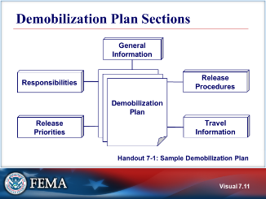  Visual 7.11 | DEMOBILIZATION PLAN SECTIONS  The Demobilization Plan should contain the following sections:  - General information about the demobilization process.  - Responsibilities for implementation of the Demobilization Plan.  - General release priorities.  - Specific release procedures.  - Travel information (procedures, maps, telephone listings, etc.).  Demobilization planning can be quite complex on large, multiagency incidents. Training and experience will help ensure that personnel with demobilization planning responsibilities perform their jobs accurately.  Refer to Handout 7-1: Sample Demobilization Plan.
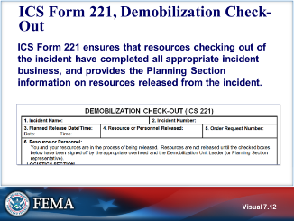  Visual 7.12 | ICS FORM 221, DEMOBILIZATION CHECK-OUT  ICS Form 221 ensures that resources checking out of the incident have completed all appropriate incident business, and provides the Planning Section information on resources released from the incident. Demobilization is a planned process and this form assists with that planning.  The Planning Section, or if designated a Demobilization Unit Leader, initiates the ICS Form 221. The Demobilization Unit Leader completes the top portion of the form and checks the appropriate boxes in Block 6 that may need attention after the Resources Unit Leader has given written notification that the resource is no longer needed. The individual resource will have the appropriate overhead personnel sign off on any checked box(es) in Block 6 prior to release from the incident.  After completion, the ICS Form 221 is returned to the Demobilization Unit Leader or the Planning Section. All completed original forms must be given to the Documentation Unit. Personnel may request to retain a copy of the ICS Form 221.
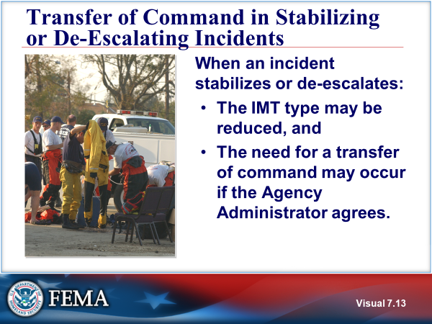  Visual 7.13 | transfer of command in STABILIZING OR DE-ESCALATING INCIDENTS  As the incident de-escalates, the size and complexity of the IMT may be reduced which would lead to a transfer of command.
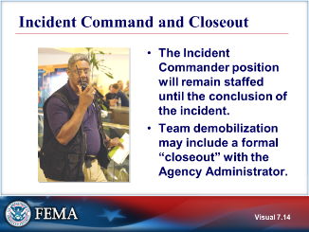  Visual 7.14 | INCIDENT COMMAND AND CLOSEOUT  There will be an Incident Commander for the incident until the conclusion and the close out of the incident. The person filling the position of Incident Commander may change, but there will always be an Incident Commander.  At some point, on-scene tactical operations will be completed, and members of the incident Command and general Staff will be demobilized. If a staff position is no longer required it can be demobilized. Remember that even if the position is demobilized, the function must still be performed as needed. Team demobilization may include a formal “closeout” with the responsible agency or jurisdiction or jurisdictions, and should include an incident debriefing.
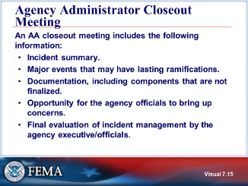  Visual 7.15 | Agency Administrator CLOSEOUT Meeting  Situations in which it would be important to conduct a closeout meeting.  - Major incidents that have attracted media interest.  - Incidents that have drawn public scrutiny.  - Incidents where there will be a need for longer term recovery efforts.  - Situations where there were important lessons learned for future responses.
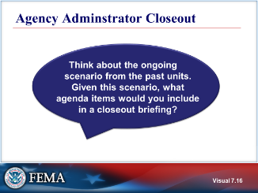  Visual 7.16 | Agency Administrator CLOSEOUT
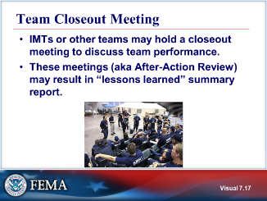  Visual 7.17 | TEAM CLOSEOUT MEETING  In some cases, teams will have a closeout meeting either prior to or after the agency briefing to discuss team performance and future enhancements to their performance.  These meetings, also known as an After-Action Review, are usually facilitated by the Planning Section Chief and result in a “lessons learned” listing.
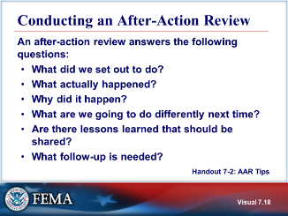  Visual 7.18 | CONDUCTING AN AFTER-ACTION REVIEW  Refer to Handout 7-2: After-Action Review Tips.
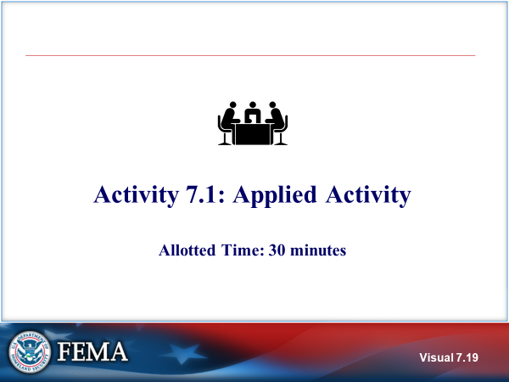  Visual 7.19 | Activity 7.1: APPLIED ACTIVITY  Introduce  The instructor will explain the Applied Activity 7.1.  You will have 30 minutes to complete the activity (15 minutes for group work; 15 minutes for debrief).  Refer to Unit 7 of the Applied Activity Materials document.
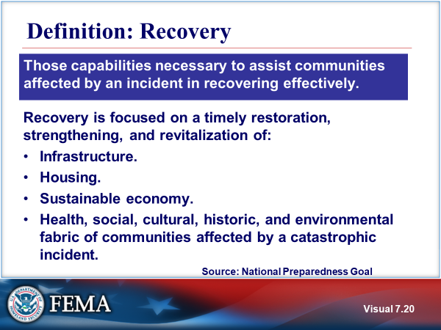  Visual 7.20 | DEFINITION: RECOVERY  The term recovery refers to those capabilities necessary to assist communities affected by an incident in recovering effectively.  It is focused on a timely restoration, strengthening, and revitalization of the infrastructure; housing; a sustainable economy; and the health, social, cultural, historic, and environmental fabric of communities affected by a catastrophic incident.
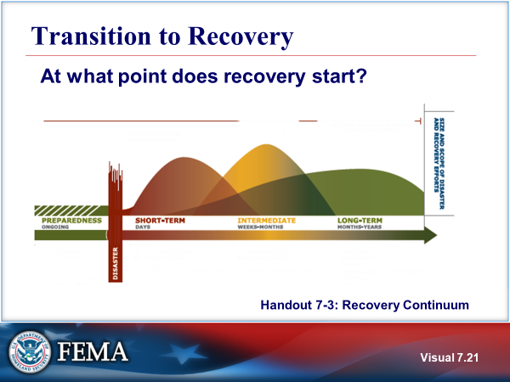  Visual 7.21 | Transition to recovery  The recovery process is a sequence of interdependent and often concurrent activities that progressively advance a community toward a successful recovery. However, decisions made and priorities set early in the recovery process by a community will have a cascading effect on the nature and speed of the recovery progress.  Five periods and their duration are shown in the visual:  - Preparedness (ongoing, before the disaster)  - Response to an incident (shown as disaster)  - Short-term recovery (days)  - Intermediate recovery (weeks to months)  - Long-term recovery (months to years)  In the visual,the height of each period shows the size and scope of disaster and recovery efforts. Note that these periods overlap each other – one does not end before the next begins.  Planning for the transition to Recovery is particularly critical in large-scale events where an organization such as an EOC must assume responsibility for Recovery once the Response has ended.  Many communities have a Post Disaster Redevelopment Plan (PDRP) to restore an incident–affected area or community.  Refer to Handout 7-3: The Recovery Continuum, which outlines the activities that occur during each period, and review.
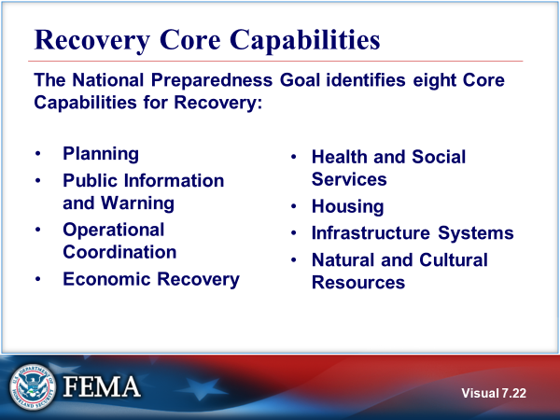  Visual 7.22 | RECOVERY core capabilities  The core capabilities are critical elements, which the whole community must be able to perform to achieve the National Preparedness Goal. They provide a common vocabulary describing the significant functions that must be developed and executed across the whole community to ensure national preparedness.  The Recovery core capabilities are designed to address the risks identified in the Strategic National Risk Assessment (SNRA). The National Preparedness Goal identifies eight Core Capabilities for Recovery:  - Planning  - Public Information and Warning  - Operational Coordination  - Economic Recovery  - Health and Social Services  - Housing  - Infrastructure Systems  - Natural and Cultural Resources
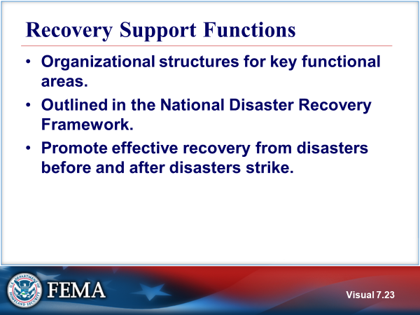  Visual 7.23 | recovery support functions  Recovery Support Functions (RSF) are organizational structures for key functional areas of assistance that are outlined in the National Disaster Recovery Framework.  RSF’s group capabilities of various government and private sector partner organizations to promote effective recovery from disasters before and after disasters strike.  The six RSFs and their coordinating Federal agencies are:  - Community Planning and Capacity Building (DHS/FEMA)  - Economic Recovery (Dept of Commerce)  - Health and Social Services (Dept of Health and Human Services)  - Housing (Dept of Housing and Urban Development)  - Infrastructure Systems (US Army Corps of Engineers)  - Natural and Cultural Resources (Dept of the Interior)  For more information go to https://www.fema.gov/national-disaster-recovery-framework.
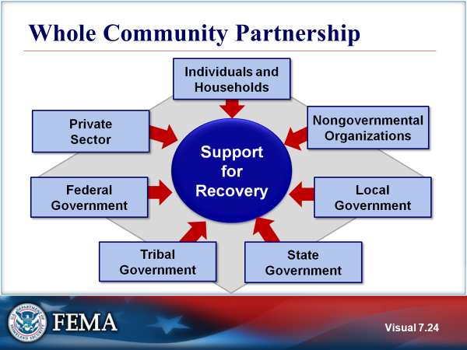  Visual 7.24 | WHOLE COMMUNITY PARTNERSHIP  The responsibility of preparing for disaster recovery begins with the individual and builds to the larger responsibility of the community and local government. Community planning efforts are supported by voluntary, faith-based, and community organizations; local, State, and tribal governments, the Federal Government; and the private sector.
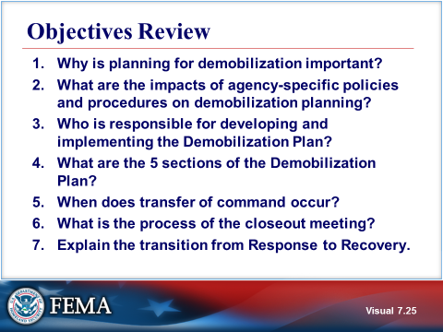  Visual 7.25 | OBJECTIVES REVIEW  Unit Enabling Objectives  - Explain the importance of demobilization planning.  - Identify the impact of agency-specific policies, procedures, and agreements upon demobilization planning.  - Identify the ICS titles of personnel who have responsibilities in developing and implementing the Demobilization Plan.  - List the major sections in a Demobilization Plan.  - Identify the need for transfer of command or closeout.  - Explain the process involved in a closeout meeting.  - Explain the transition from Response to Recovery.

  - Supplemental Materials

This page intentionally left blank.

Handout 7-1: Sample Demobilization Plan

SAMPLE DEMOBILIZATION PLAN (Page 1 of 5)
NORTH SMITHMAN INCIDENT

Prepared by
 | Demobilization Unit Leader |  | Date

Reviewed by
 | Planning Section Chief |  | Date

Reviewed by
 | Logistics Section Chief |  | Date

Reviewed by
 | Operations Section Chief |  | Date

Reviewed by
 | Finance Section Chief |  | Date

Reviewed by
 | Supervisor-Expanded Dispatch |  | Date

Approved by
 | Incident Commander |  | Date

SAMPLE DEMOBILIZATION PLAN

The Demobilization Plan contains five (5) sections:

- General Information
- Responsibilities
- Release Priorities
- Release Procedures
- Travel Information

- GENERAL INFORMATION

The demobilization process at the North Smithman Incident will require coordination with the Unified Command Team and the Dispatch function. All resources with their own transportation must meet rest/work guidelines prior to driving.

All releases from the Smithman Incident will be initiated in the Demob Unit after Incident Commander approval. The size and location of the Incident Base lends itself to the holding of surplus equipment and personnel during the time it takes to process all of the releases in a safe and efficient manner. No resources are to leave the Incident until authorized to do so. At this time, no off-Incident Demob Center will be activated. The Logistics Section will provide for all necessary transportation of released personnel and equipment. The Demob Unit will arrange for any needed flight arrangements through Dispatch.

The following are general guidelines to be followed for resources that are leaving the Incident.
- No person will be released without having a minimum of eight (8) hours rest, unless specifically approved by the IC.
- All Federal resources must be able to arrive at their home base prior to 2200 (10 PM). Other agencies and cooperators must meet individual agency regulations pertaining to rest and travel.
- All Party Chiefs, Crew Supervisors, and Strike Team (Resource Team) / Task Force Leaders will be thoroughly briefed prior to leaving the Incident. Briefing to include: 1. method of travel, 2. passengers (if any), 3. destination, 4. ETD Camp/ETA home base, and 5. transportation arrangements.

All personnel returning home on commercial aircraft will be showered and wear clean clothing.

To prevent delays and work overloads, Logistics and Finance will be notified as soon as possible when surplus resources are to be Demobed. (Demob will try to advise the two Units 24 hours in advance.) Notification of Incident personnel will be by posting of "Tentative Releases" 12 hours in advance. Crew Supervisors may also be paged when the Demob process is to begin.

If applicable, all oversize vehicles (e.g., transports) MUST have appropriate permits to comply with State vehicle codes.

Performance Ratings are required for:
- Trainees
- Outstanding performance
- Deficient performance
- By personal request

All firefighting apparatus, rental equipment, and crew transport will have a vehicle inspection (Safety Check) at Ground Support prior to returning to their home unit or new assignment location. Pickups, sedans, and vans will also have a safety check by the Ground Support Unit before departing the Incident Base.

- RESPONSIBILITIES

Functional heads (i.e., Section Chiefs and Unit Leaders) are responsible for determining resources surplus to their needs and submitting lists to the Demob Unit Leader.

The Demob Unit Leader is responsible for:

- Compiling "Tentative" and "Final" Release sheets. (Any Incident-formed Strike Teams (Resource Teams) and Task Forces must be disbanded before Incident Commander approval and release from the Incident.)
- Making all notifications to Incident and off-Incident personnel regarding tentative and final releases (includes Tanker and Helibases).
- Making sure that all signatures are obtained on the Demob Check-Out form.
- Monitoring the Demob process and making any adjustments in the process.

The Incident Commander is responsible for:

- Establishing the release priorities through consultation with Unified Command.
- Reviewing and approving all tentative release lists.

The Logistics Section Chief is responsible for ensuring through:

- Facilities—that all sleeping and work areas are cleaned up before personnel are released.
- Supply—that all non-expendable property items are returned or accounted for prior to release.
- Ground Support—that there will be adequate ground transportation during the release process and that vehicles are inspected.
- Communications—that all radios have been returned or are accounted for.
- Food Unit—that there will be adequate meals for those being released and for those remaining.

The Finance Section Chief is responsible for:

- Completion of all time and equipment reports for released personnel.
- Notification(s) for any ADO payoff(s).

The Planning Section Chief is responsible for managing duration of assignment policy for the Incident Commander.

Dispatch is responsible for:

- Reviewing tentative releases and notifying the Demob Unit Leader with release approvals, reassignments, and air travel information.
- Coordinating with the State Coordination Center.

- RELEASE PRIORITIES

The following release priorities have been established by the Unified Command Team:
- Initial attack or local cooperators
- Type 1 Crews
- Non-local engines, crews, and overhead
- Other local resources

Crews from other Regions will be grouped for demob when possible. Emergency situations will arise and will be handled expeditiously. Clearance for emergency demob is to be approved by the appropriate Section Chief, IC, or Agency Representative.

- RELEASE PROCEDURES

Critical resources will be identified in the IAP. These resources cannot be released from the Incident without Unified Command approval.

All resources requiring airline travel must be submitted to Dispatch 36 hours in advance of planned travel. All other resource surpluses should be forwarded to Dispatch 24 hours in advance of planned release. The Demobilization Unit will also give Ground Support lead time to arrange for ground transportation for crews and individuals needing transportation.

Section Chiefs or Deputies will identify surpluses within their units and submit a list (or lists) to the Demob Unit Leader in the Planning Section. The Demob Unit will combine lists and form a "Tentative Release" list to be submitted to the Incident Commander for review and approval. Demob will work with the Resources Unit so that the resource status board can be kept up to date.

After Incident Commander approval, Demob will notify Dispatch of the tentative releases for their concurrence. When concurrence is obtained from Dispatch, the Demob Unit Leader will:

- Prepare transportation manifests.
- Notify personnel to be released.
- Give crew leaders or individuals the final release form and briefing.

Crew leaders or individuals will take the ICS Form 221, Demobilization Check-Out form, to:

- Communications Unit Leader (if radio equipment has been issued)
- Facilities Unit Leader (to be sure sleeping area is clean)
- Supply Cache (to return all non-expendable property)
- Ground Support (for vehicle inspections)
- Finance (for time)
- Demob (last stop for final departure times and documentation)

The Demob Unit will:

- Notify the Resources Unit so that "T" card (ICS Form 219) information is complete.
- Notify Dispatch of Estimated Time of Departure (ETD), Estimated Time of Arrival (ETA), destination, and travel arrangements.
- Collect and send all Demob paperwork to the Documentation Unit.

- TRAVEL INFORMATION

All resources will meet work/rest requirements prior to being released from the incident. Crews should be given time for personal hygiene and should dress in clean clothes prior to departure. Any heavy or oversize equipment MUST have appropriate permits and follow any limitations on the movement of their equipment on public highways. All resources will meet any agency-specific requirements on hours of travel per day or other restrictions concerned with travel. Incident Demob will notify Dispatch when a resource is released, so the home Agency can be advised of ETA. It will then be up to the sending Agency to keep track of released resources and report back if there are any problems or if more information is needed.

Incident Phone Numbers

North Smithman Demob: XXX-XXX-XXXX Dispatch: XXX-XXX-XXXX

Individual resources are to notify either the North Smithman Incident or Dispatch at the above numbers and their home unit dispatcher if significant delays occur en route to their next destination.

Handout 7-2: After-Action Review Tips

Overall Tips
- Schedule an After-Action Review as soon after the incident as possible.
- Keep it short and focused.
- Focus on WHAT, not WHO.
- Establish clear ground rules: encourage candor and openness (this is dialog—not lecture or debate); focus on items that can be fixed; keep all discussions confidential.
- Use a skilled facilitator to conduct the After-Action Review.

After-Action Review Process Steps

Use the following questions to facilitate the After-Action Review process:
- What did we set out to do?
- Establish the facts.
- Determine purpose of the mission and definition of success:
- Identify key tasks involved.
- Specify conditions under which each task may need to be performed (weather, topography, time restrictions, etc.).
- Define acceptable standards for success (explain what “Right” looks like).
- What actually happened?
- Continue to establish the facts.
- Students should come to agreement on what actually happened.
- Pool multiple perspectives to build a shared picture of what happened.
- Why did it happen?
- Analyze cause and effect.
- Focus on WHAT, not WHO.
- Provide progressive refinement for drawing out explanations of what occurred. This will lead into developing possible solutions.
- What are we going to do differently next time?
- Solutions will arise naturally once problems are identified and understood.
- Focus on items you can fix, rather than external forces outside of your control.
- Identify areas where groups are performing well and that should be sustained. This will help repeat success and create a balanced approach to the After-Action Review.

Areas To Sustain/Maintain Strengths:

Areas To Improve:

- Are there lessons learned that should be shared immediately?
- Identify the process for sharing lessons learned.
- Option 1: Document the Issue, Discussion, Recommendation
- Option 2: Document the Concept of the Operation, Results, Trends, Recommendation
- Determine and describe the most notable successes from the incident.
- Determine and describe the most difficult challenges faced and how they were overcome.
- What followup is needed?
- Be specific about actions, timelines, and responsibilities.
- What changes, additions, or deletions are recommended to SOPs, plans, or training?
What issues were not resolved to your satisfaction and need further review?

Handout 7-3: Recovery Continuum

Prediaster Preparedness Examples:
- Predisaster recovery planning.
- Mitigation planning and implementation.
- Community capacity and resilience building.
- Conducting disaster preparedness exercises.
- Partnership building.
- Articulating protocols in disaster plans for services to meet the emotional and health care needs of adults and children

Short-Term Recovery Examples:
- Mass Care/Sheltering
  - Provide integrated mass care and emergency services.
- Debris
  - Clear primary transportation routes.
- Utility Infrastructure
  - Re-establish electrical distribution system.
  - Re-establish potable water system.
  - Re-establish sanitary waste water system.
- Business
  - Establish temporary or interim infrastructure to support business reopenings.
  - Reestablish cash flow.
- Emotional/Psychological
  - Identify adults and children who would benefit from counseling or behaviorial health servcies and begin treatment.
- Public Health and Health Care
  - Provide emergency and temporary medical care and establish appropriate surveillance protocols.
- Mitigation Activities
  - Assess and understand risks and vulnerabilities.

Intermediate Recovery Examples:
- Housing
  - Provide accessible interim and housing solutions.
- Debris/Infrastructure
  - Initiate debris removal.
  - Plan immediate infrastructure repair and restoration.
- Business
  - Support reestablishmnent of businesses where appropriate.
  - Support the establishment of business recovery one-stop centers.
- Emotional/Psychological
  - Engage suport networks for ongoing care.
- Public Health and Health Care
  - Ensure continuity of care through temporary facilities.
- Mitigation Activities
  - Inform community members of opportunities to build back stronger.
Long-Term Recovery
- Housing
  - Develop permanent housing solutions.
- Infrastructure
  - Rebuild infrastructure to meet future community needs.
- Business
  - Implement economic revitalization strategies.
  - Facilitate funding to business rebuilding.
- Emotional/Psychological
  - Followup for ongoing counseling, behaviorial health, and case management services.
- Public Health and Health Care
  - Reestablishment of disrupted health care facilities.
- Mitigation Activities
  - Implement mitigation strategies.

Unit 8: Course Summary
Student Manual

This page intentionally left blank.

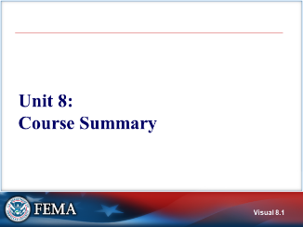 Visual 8.1 | UNIT 8: COURSE SUMMARY  The purpose of this unit is to review the course contents and ensure that everyone has mastered the key learning points.
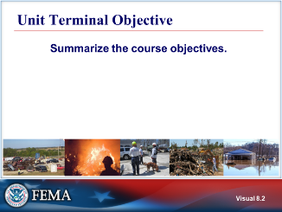  Visual 8.2 | UNIT TERMINAL OBJECTIVE  Summarize the course objectives.
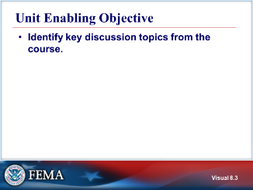  Visual 8.3 | UNIT ENABLING OBJECTIVE  - Identify the key discussion topics from the course.
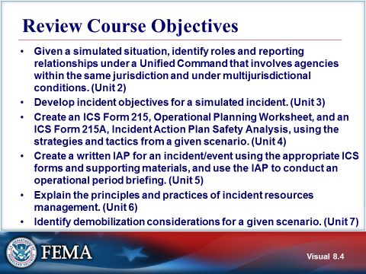  Visual 8.4 | REVIEW COURSE OBJECTIVES  - Given a simulated situation, identify roles and reporting relationships under a Unified Command that involves agencies within the same jurisdiction and under multijurisdictional conditions. (Unit 2)  - Develop incident objectives for a simulated incident. (Unit 3)  - Create an ICS Form 215, Operational Planning Worksheet, and an ICS Form 215A, Incident Action Plan Safety Analysis, using the strategies and tactics from a given scenario. (Unit 4)  - Create a written IAP for an incident/event using the appropriate ICS forms and supporting materials, and use the IAP to conduct an operational period briefing. (Unit 5)  - Explain the principles and practices of incident resources management. (Unit 6)  - Identify demobilization considerations for a given scenario. (Unit 7)
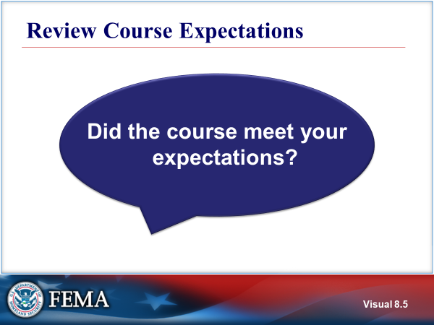  Visual 8.5 | Review course expectations
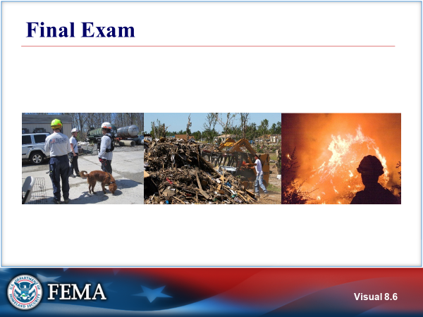  Visual 8.6 | FINAL EXAM
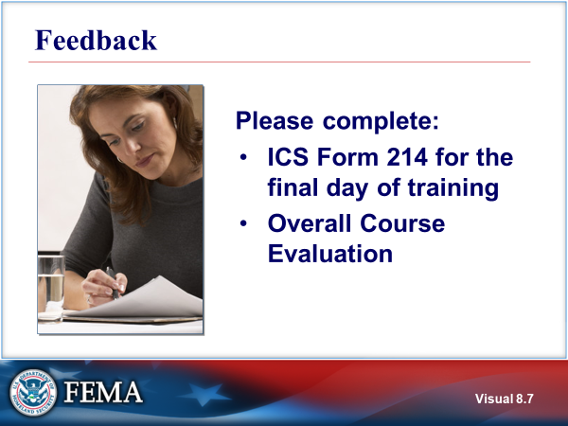  Visual 8.7 | FEEDBACK  END OF COURSE

This page intentionally left blank.

